CURRICULUM VITAE
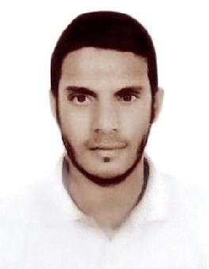

NAZEER
Email: nazeer-397424@gulfjobseeker.com

CAREER OBJECTIVE

To be associated with a progressive organization that provides opportunity to contribute towards the growth of the organization also to apply my knowledge which I have trough my education.

EDUCATION QUALIFICATION

Level | School/College | Year of Passing | % of Mark
Degree | Govt Degree College, Koratla | 2013-2016 | 70
Intermediate | Narendra Junior College, Metapally | 2013 | 60
SSC | Z.P.H.S Raghavapet | 2011 | 75

PERSONAL SKILLS

- Good Analytical and logical skill

- Confidence and strong belief in completing the assigned work I take up

- Always strives for betterment and perfection in whatever work I take up

- Good leadership skills and ability to work well under pressure

TECHNICAL SKILL

- P.G, D.C.A, (PG Diploma in computer application)

WORKING EXPERIENCE

- I have 2 years experience as a waiter Ex…in a Restaurant in Abu Dhabi

- I Have Gulf Experience

PERSONAL PROFILE

Date of Birth | : 25.06.1995
Gender | : Male
Nationality | : India
Civil status | : Single
Language | : English, Urdu, Telugu, Hindi, Malayalam

DECLARATION

I hereby declare that the above written particulars are correct to the best of my knowledge and belief.

NAZEER

