RUSZEL J

ELECTRICAL DRAFTSMAN

Contact Information
Email: ruszel-397440@gulfjobseeker.com

Naionality

Filipino

Qualifications

BS Electrical Engineer - 2011

Professional Memberships

Institute of Integrated Electrcal Engineers in Philippines

Saudi Council of Engineers

Skill

Teamwork

Organization

Motivation
Adaptability

Resourcefulness
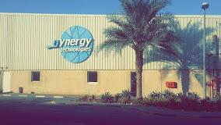

Ruszel is an Electrical Engineering graduate who has gained experience in varying sectors in electro-mechanical field & Ectrical Switchgear Companies. He has worked on numerous building projects from commercial and retail to residential

In the electrical field, He has previously worked at Hamad Al Alawi Contracting Company (HAPCO) from 2012 to 2014 in Riyadh KSA & Dynergy Technologies from 2015 to Present in Dubai UAE. The experience gained thus far has given him a very soundknowledge of electrical drafting and management processes and procedure.

Ruszel’s particular strenghts are team driven with excellent social skills, natural leadership, directing, engaging & supportive to staff. Honest with a high standard of personal integrity

Key / Relevant experience
The Circle Mall | MTBA Residence Rawda Palace
At Al Barsha South Fourth 681, Dubai | Prince Meteeb Bin Abdalla, Riyadh, KSA
Electrical Draftsman – 2017 to 2019 | Electrical Draftsman – 2012 to 2014
DIFC-ICD Brookfield Place | Prince Naif Medical Research Centre
 | King Saud University, Riyadh, KSA
Dubai, UAE
 | Electrical Draftsman – 2012 to 2014
Electrical Draftsman – 2017 to 2019
Deira Waterfront Development | Dental College Extension
Plot-1,Dubai,UAE | King Saud University, Riyadh, KSA
 | Electrical Draftsman – 2012 to 2014
Electrical Draftsman – 2018 to 2020
DSOA - P052 - Silicon Park | National Power Corporation
 | Government of the Philippines, Cebu City, Philippines
 | Junior Electrical Engineer – 2008 to 2009
Electrical Draftsman – 2017 to 2020

Duties & Responsibilities

- Generally responsible for implementations and monitoring of all electrical related works at site.

- Preparation of the working drawing and design of the assigned project using computer aided drafting equipment or conventional drafting stations in accordance to specification and requirements.

- Drafting of wiring diagrams and connections complete with specifications, cable cross-section and special instructions for the reference of the installation crew.

- Preparation of scaled master sketches of proposed installations to existing facilities with clear specs and dimensions.

- Determine the factors that may affect the installation of equipment’s and the laying of wires and cables. Recommend the necessary revision for approval.

- Conduct inspection and checking of the actual work whether it conforms to design and specification.

- Assembly of duly approved documentation including the final drawing of every assigned project.
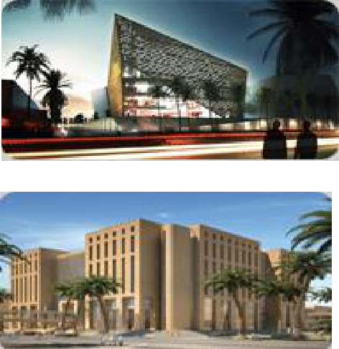

-
Photos: Dynergy Technologies Office /Bollywood Park/ Medical Research Centre/ Dental College Ext.

