Mushthaq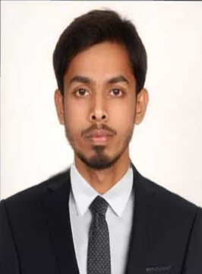

ADMINISTRATION OFFICER mushtaq-397442@gulfjobseeker.com

Qualified Masters in Business Administration, I am looking to work in an exciting and professional environment of the organization with personal development and growth possibilities and to achieve company’s goal through professional ethics, sincere commitment, team work and hard work.

Key Skills

- Interpersonal Communication/Written and Verbal  - Product Knowledge  - Time Management  - Flexibility | - Efficiency  - Attention To Detail  - Point Of Salesystem(POS)  - Positive Attitude

Professional Experience

Oasis International School – Warangal India. (2016-2018)
administration officer(December 2016to June 2018)

RESPONSIBILITIES:
- Create and update records and databases with personnel, financial and other proposal department data
- Submit timely reports and prepare presentations/proposals as assigned
- Coordinate office activities and operations to secure efficiency and compliance to company policies
- Maintains accurate records for employee vacation requests
- Drafts, formats, scan and prints relevant documents
- Preparing and processing employment documents and other related personnel’s tasks. (i.e., Employee ID, New Bank Account, Insurance, Medical, Labor, and Immigration Submission
- Document handling, copying, scanning, printing, book keeping, records maintaining and data entry for the work flow in manual and electronic formats

Professional Experience

In India. (2018-2019)
Administration Assistant

RESPONIBILITIES:
- Maintaining calendars and schedules and coordinates appointments
- Sorting, categorizing, filing, and retrieving documents or other materials
- Document handling, copying, scanning, printing, book keeping, records maintaining and data entry for the work
flow in manual and electronic formats
- Preparing correspondence, maintain all employees’ personal files and maintain the closed files

Education

- MASTER OF BUSINESS ADMINISTRATION (MBA)2016
- BACHELOR OF BUSINESS MANAGEMENT(BBM) 2014

Technology Summary

MS Office (Word, Excel, PowerPoint) Tally ERP 9

Personal Details:

Father’s Name : Mushthaq
Marital Status : UnMarried
Languages Known : English, Hindi and Telugu
Date of Birth : 22nd October 1992
Nationality : Indian
Visa Status : VISIT VISA

Interests & Hobbies
- I love to spend my leisure time in playing Guitar which improves my Concentration and focus.
- Depending upon my technique, I was known as a strong bowler in my Cricket team.
- Dancing plays a very important role in keeping me active, enthusiastic, fit and social.

Date:
Place:
(MUSHTHAQ)

