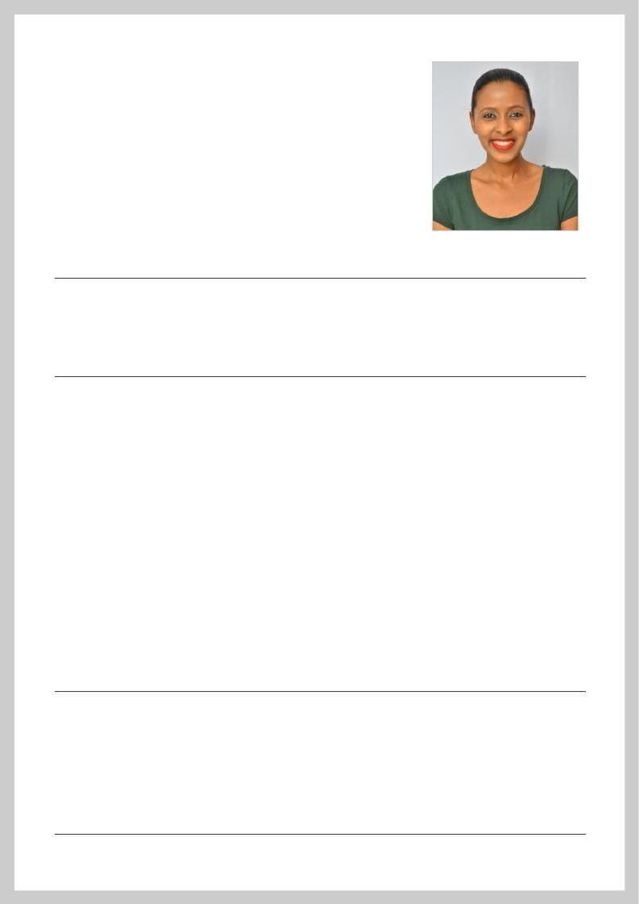
FEVEN

Address Dubai, United Arab Emirates

Email feven-397458@gulfjobseeker.com

Nationality Ethiopian

Gender Female

Date of Birth 11/09/1989

Marital Status Single

Professional Summary

A well-rounded Construction Project Manager with proven experience in the construction industry. I am enthusiastic, responsible, self-motivated and a hard-working person. I am a mature team worker and adaptable to all challenging situations. I am able to work well both in a team environment as well as using own initiative.

Work Experience

09/2015 - 01/2020

Construction Project Manager

Ethiopia

- Reviewing the project in depth to determine if everything went according to plan.

- Informing the staff of the project details and how I wanted to move forward with the project.

- Ensuring all the work was done as per the approved samples, methods and materials.

- Executing project work plans and revising as appropriate to meet changing needs and requirements.

- Allocating resources and made sure there were no shortages.

- Instructing and directed fellow workers so they can work together to create a great final result.

- Assuring the completion of the project on time and within the projected budget.

04/2013 - 07/2015

Sales Representative

Tega & Tula Coffee Industry, Addis Ababa, Ethiopia

- Demonstrating and presenting the product.

- Coordinating sales efforts with marketing programs.

- Attending trade exhibitions, conferences and meetings.

- Maintaining client records.

- Aiming to achieve monthly or annual targets.

- Reviewing sales performance.

Education

10/2010 - 07/2014
Hawassa University, Hawassa, Ethiopia

Bachelor of Science in Civil Engineering

09/2006 - 06/2009

School of Tomorrow, Addis Ababa, Ethiopia

High School Diploma, Natural Sciences

Languages

English

— Fluent

Arabic

— Fluent

Amharic

— Fluent

Tigrigna

— Fluent

Additional Skills

- Project Management
- Leadership

- Supervision

- Goal-oriented

- Microsoft Office

- Dedication

