JOSEMON

C a r g o

H a n d l i n

g

A s s i s t a n t

Email: josemon-397463@gulfjobseeker.com

To serve the organization with my full effort and to work in a challenging environment, to gain new knowledge and to grow with the organization, to become a part of it’s every successful milestone. To lead a helping hand to my society and to the world.

EXPERIENCES

Presently working as Cargo Handling Assistant since May 2016. I do have 1 year work experience.

May 2016 – till date
Role: Cargo Handling Assistant
Responsibilities
- For Export: Forwarding all the export ULD’s to the aircraft in appropriate time as per the flight schedule given.

- For Import: Forwarding import ULD’S to the warehouse and coordinating with technical team.
- ITT. [Inter Terminal Transfer]: Transferring cargo within Airport Terminals.

- Build up: Serving Airline as primary customer in Building ULD’s for their Passenger & Cargo Carriers as per their instruction mentioned in the load plan, and taking safety measures for handling special cargo (DGR, AXA and VUN).

- Have obtained Airport Commercial Operation Training from prestigious college of Dubai,U.A.E - Emirates Aviation

- Introduction to Civil Aviation
- Introduction to Cargo Operation
- Special Load Handling
- Cargo Product Knowledge & Documentation
- Dangerous Goods Regulation

- Aviation Security Awareness Training

BUILD UP

- While loading the cargo on ULDs/keeping for bulk loading, observe IATA/ICAO Regulations and any specific carrier instructions, such as handling/loading/ DGR loading/segregation/structural/operational weight limitations.

BREAK DOWN

- Receive flight manifest, FFN of breakdown cargo from SA Breakdown at the work station.

- Retrieve ULD for breakdown from the locations at the work station, and bulk dolly from Ramp position at the breakdown area as instructed by SA breakdown.

- Ensure to verify air waybill number and the number of pieces received against manifest/FFN. Enter the Air waybill number; location details with the number of pieces in Sky Chain through HHT, when required use manual LCS to recor

ACADEMIC QUALIFICATION:

- BDA(Bachelors Diploma in Aviation Management) from Asian Airline Academy. (2015)

- BBA in Airport and Airline Management from Bharathiyar university.(2014 to present)

- Higher Secondary School Education from Leo XIIIth HSS, Alappuzha (2012)

- Secondary School Leaving Certificate from St. Joseph’s HSS, Paravoor (2010)

TECHNICAL QUALIFICATION:

- MS Office Pack

- Basic Computer Knowledge

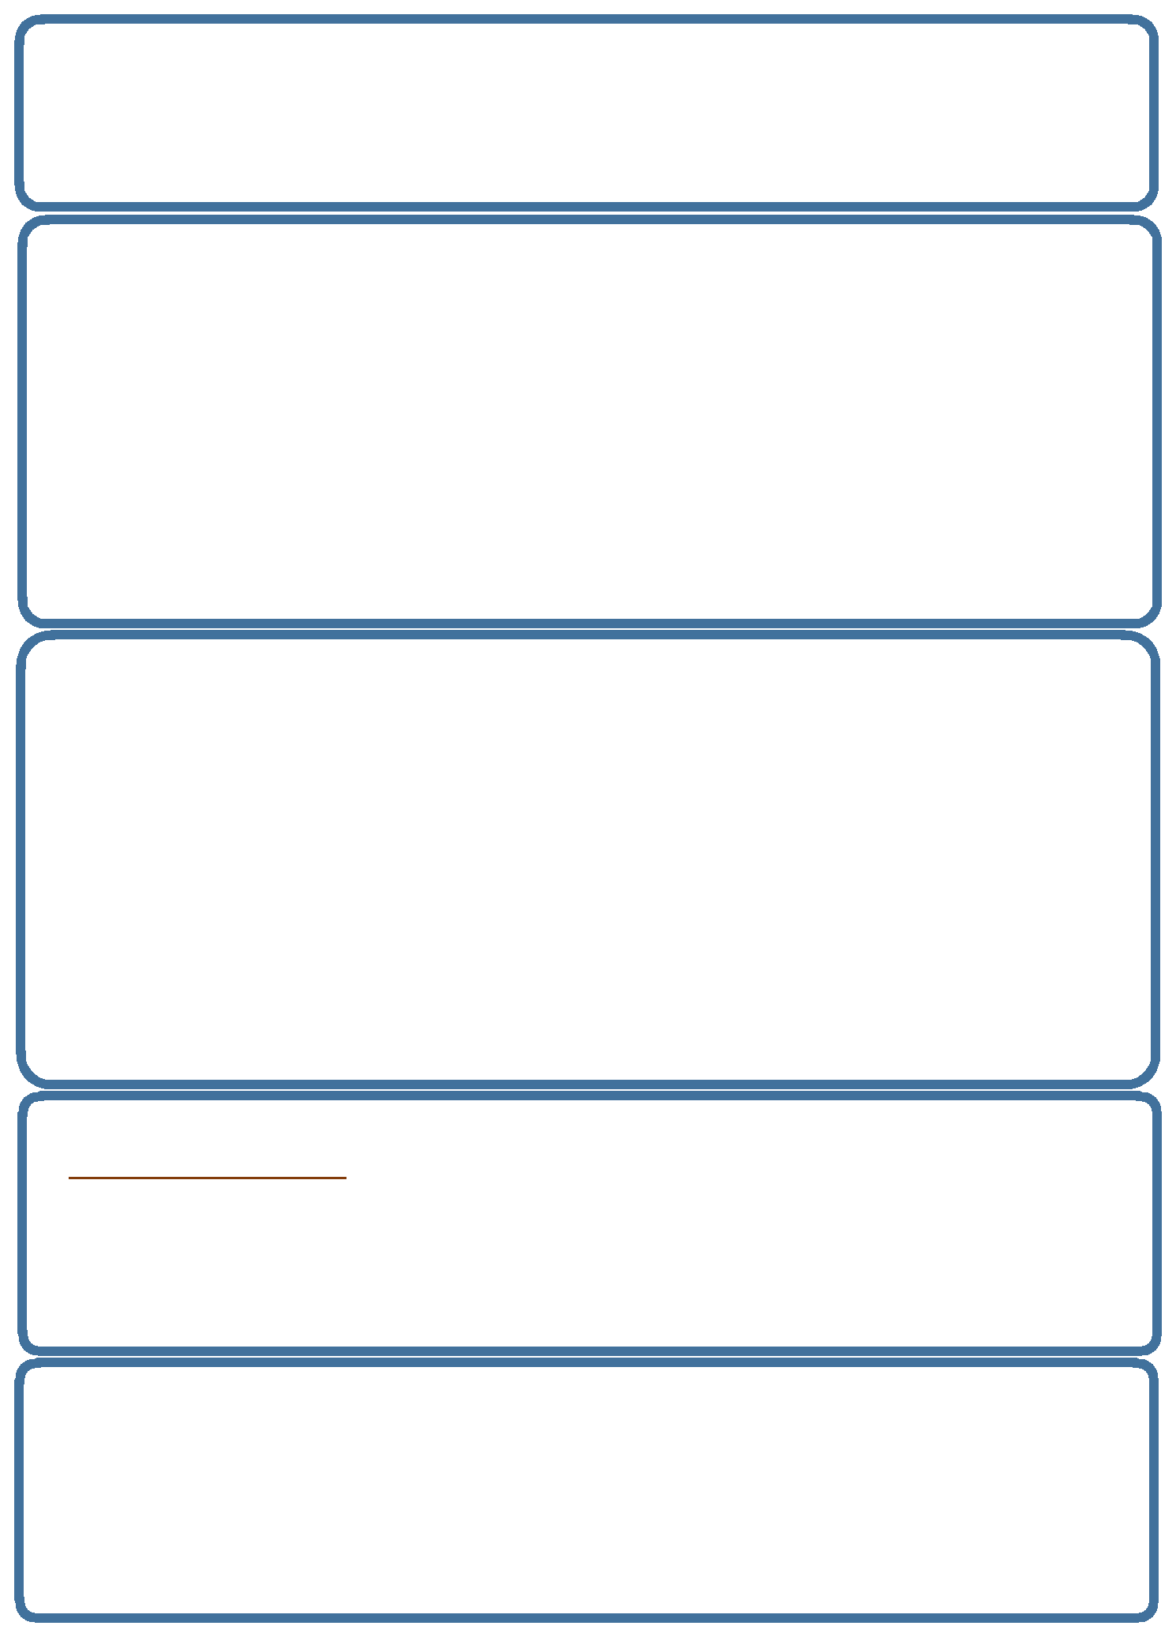
PROFESSIONAL QUALIFICATION:

- IATA in Customer Service

- BEC (British English Communication) certificate.

- Certificate course in International Aviation Security Force from Asian Airline Academy.

AREAS TRAINED IN:

- Department Of Airline, Tourism and Hospitality Management.

- Department Of International Language and Soft Skill Training.

- Department Of Aviation Security and Intelligence.

- Department Of Flight Handling and Ground Operations.

- Department Of Airline Cabin Crew and Commercial Services.

- Customer Service

- Sales and Marketing

- Body language Identification program

ACHIVEMENTS:

- Awarded Star Of The Month for Academic Performance

- Acted in a Short film as leading character named One Moment

PROJECT ACCOMPLISHED:

- Industrial exposure of travel and tourism visit to Major South Indian Airports (TRV, MAA, HYD, BLR).

- Industrial familiarization of airport visit to Trivandrum International Airport.

- Participation in food festival program.

- Industrial Exposure of travel and tourism. Visit to major Star Hotels in India.

LANGUAGES KNOWN:

- English (Read Write and Speak Fluently)

- Hindi (Read Write and Speak)

- Malayalam (Mother Tongue)

- Tamil (Speak)

INTERESTS:

- Becoming an expert in your field.

- Assuming a leadership position.

- Earning a degree or certificate to allow me to go further in my career

I hereby declare that the information furnished above is true to the best of my knowledge. I do hereby declare that above particulars of information and facts stated are true, correct and complete to the best of my knowledge and belief

