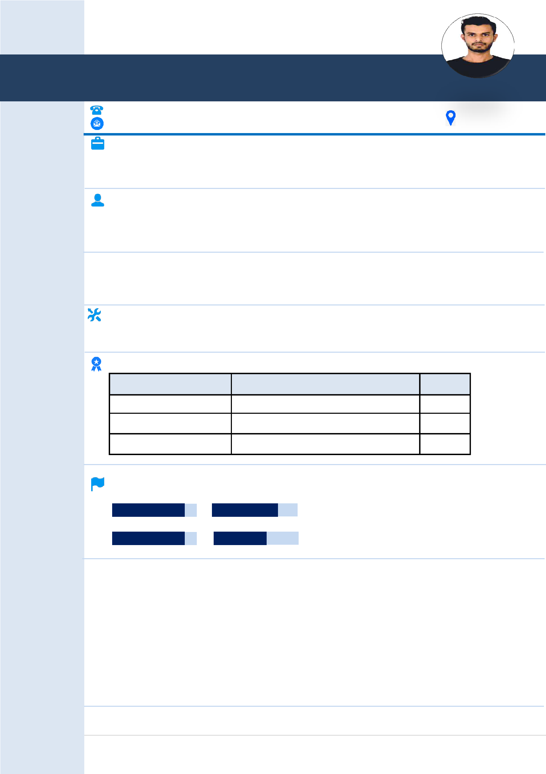
ABDUL

Mechanical Draughtsman

Email: abdul-397468@gulfjobseeker.com

Live in
UAE Since 2013

CAREER OBJECTIVE

Looking for an environment to interlard my academic and professional qualifications with my present career milestones which offers a challenging career continuation where I can exercise my expertise and ability to emerge as one of the best Engineers.

HIGHLIGHTS

Over 10. + Years of experience in Mechanical Draughtsman stream strong technological and software background hard working, flexible, self-motivated, and detail oriented professional. Dedicated, proactive and target oriented Team player good communication skills.

EDUCATIONAL

- S.S.L.C from Board of Secondary Education India.

- Diploma in Electrical Engineering, Karnataka India.

TECHNICAL SKILLS

- Auto CAD 2007 – 2020

- Microsoft Office 2007

- .
TRAINING | CERTIFICATE | COURSES:
Training/Courses | Institutes | Year
AutoCAD | APEX Computer Center | 2007
MS-Office | Microsoft Word, Excel & Power Point | 2007
MEP Course (HVAC) | TEC (Taiba Engineering Consultants) | 2008

LANGUAGES

ENGLISH URDU

HINDI KANNADA

- PRINCIPLE DUTIES

I was responsible for preparing the Mechanical layout for high rise buildings, Hotels, Hospitals, Schools, and Commercial & Residential Building etc. I was involved in developing the single line design drawing to double line shop drawing as per SMACNA, ASHRAE, etc. standards, assigning duct/pipe levels, Slopes preparing duct/pipe cross sections, preparing Equipment Schedule. I was responsible for identifying the interferences between different services, re-routing as per the other services/architectural/Structural plans & generating the sections as required. I was also responsible for creating the drawings as per the standards given by the clients and for updating the drawings as per the corrections marked by checker/design engineer.

CV –Abdul
Mechanical Draughtsman (CAD)

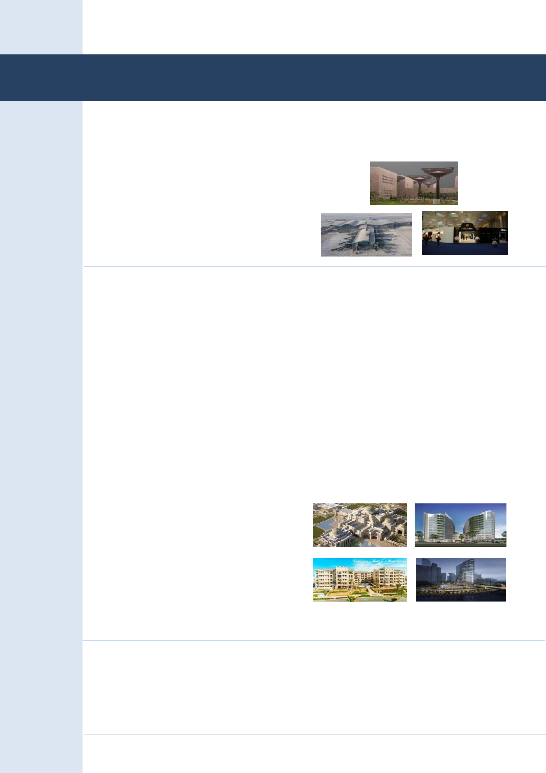
Mechanical Draughtsman

- PROFESSIONAL EXPERIENCE

- Drake & Scull International L.L.C Doha, Qatar Duration: From-Jan2009 to April2010

PROJECTS

- students Center, Education City Qatar Foundation, Doha – Qatar (Horizontal building with 9 segments)
- New Doha International Airport Doha – Qatar (Various Facilities)

- Al Fardan Jeweler, Porto Arabia the Pearl, Doha – Qatar

- Ramtech Software Solutions Private Limited Dubai, UAE Dubai Duration: From-May2011 to Nov2012

UNDER THE DEPUTATION WITH

- Drake & Scull International L.L.C

Abu Dhabi, UAE

AutoCAD Draughtsman–HVAC

- Trans Gulf.–Dubai, UAE

Auto CAD Draughtsman–HVAC

- AlEMCO LLC.-Dubai, UAE

Auto CAD Draughtsman–HVAC

- Al Futtaim Engineering.-Dubai,UAE Auto CAD Draughtsman-HVAC

PROJECTS

- Presidential Palace, Abu Dhabi-UAE

- Danat Al Emarat Women & Children’s Hospital

Abu Dhabi-UAE

- Saadiyat Beach Apartments Saadiyat Island, Abdu Dhabi-UAE

- Hotel Beach Resort Dubai-UAE

- Gourmet Tower

Dubai Marina Mall, Dubai-UAE

- 36 Villa Alin Alin-UAE

- Rose Wood Hotel

Abu Dhabi – UAE

CV –Abdul
Mechanical Draughtsman (CAD)

Mechanical Draughtsman

- Omnix International L.L.C Dubai, UAE Duration: From-Oct2013 to July2017

UNDER THE DEPUTATION WITH

- BK Gulf. - Doha Qatar

Auto Cad Draughtsman–HVAC

- Crown House Technology LLC.-Dubai, UAE Auto CAD Draughtsman-HVAC

- Al Futtaim Engineering.-Dubai, UAE Auto CAD Draughtsman–HVAC

- Drake & Scull LLC.-Dubai, UAE Auto CAD Draughtsman–HVAC
- ETTS. – Abu Dhabi, UAE

- Auto CAD Draughtsman–HVAC

- NORR. – Dubai, UAE (Architects Engineers Planners) Auto CAD Draughtsman

PROJECTS

- National Museum Of Qatar Doha Qatar.

- AL SUFOUH Transit System Project (Dubai Tram) Dubai, UAE.

- Mall Of Emirates,(Expenses) Dubai, UAE.

- Hidd Al Saadiyat 480 Villas Abu Dhabi, UAE.

- Hameni Tower residential Building Dubai, UAE.

- Solis Hotel, Doha Qatar.

- Al Zorah Resorts Hotel–2 Al Ajman

- Motion gate (Bollywood Theme Park) Dubai, UAE.

- Abu Dhabi, UAE Duration: From-Jul2017 to Till Date

PROJECTS

- Completion of Villa At UMM-SUQEIM (Crown Prince Court), Dubai UAE

- CICPA Facilities Phase-1, Abu Dhabi UAE

- Commercial Building, Abu Dhabi, UAE

(2B+G+8 Story Resident + Roof: consist of 2 basements parking level + Ground floor consist of gym and retail shops, + 8 typical stories consist of residential flats + Roof floor consist of guard room, services room for the building. Sector: RBW7 Plot:19, Shatie Al Raha Abu Dhabi)

- CPC Development Crown Prince Court, Khalifa City Abu Dhabi. UAE

CV –Abdul
Mechanical Draughtsman (CAD)

Mechanical Draughtsman

- Residential Building Abu Dhabi, UAE

(3B+LG+G+14TY Story Resident + Roof: consist of 3 basements parking level +Lower Ground floor + Ground floor consist of retail area and residential flat + 14 typical stories consist of residential flats + Roof floor consist of guard room, services room for the building and bathrooms. Sector: RBW7 Plot :C21, C27, C28 & 31, Shatie Al Raha Abu Dhabi)

RESPONSIBILITIES

- Experienced in preparation of shop drawings for HVAC, Drainage, Water supply And Fire fighting services based on design drawings

- Prepared detail drawings and sections in 2D and isometric based on plan layout.

- Designing and drafting of containments and routs coordinating with other MEP services

- Coordinated and solved drawing issues with relevant engineers, architects and system specialist

- Experienced in preparation of As-built drawings for HVACs and Plumbing services.

- Preparation of shop drawings for Mechanical. (Hotel public areas, Plant Rooms, Residential Layouts.)

- Raising RFIs if any problem exists in coordination drawing to get approval from the consultant.

- Changing duct sizes, rerouting the services according to the coordination drawings.

- Design of duct sizing, pipe sizing, selection of grills & diffusers.

- Creating the duct / Pipe supports according to the client requirement and specifications.

- Well Command in Roof Drawing in Numerable AHU’s Including Plinth Drawings.

- Performs other duties as directed by management, collaborate with design staff by establishing methods of closer communication and coordination.

- Preparing Detailed Drawings Using Xref Files, RCP & Reviewing Of Architectural Drawings.

- Responsible for the complete execution, material control, and manpower control.

- Follow-up and evaluate the daily, weekly and monthly progress reports.

- Reporting to the Project Engineer on daily basis.

PERSONAL DETAILS

Name

Father’s Name

Sex

Date of Birth

Marital Status

Nationality

Religion

Mohammed Abdul

Mohammed Ibarhim

Male

01-06-1988

Married

Indian

Islam

DECLARATION

I do hereby declare that the above mentioned subjects are true in the best of my knowledge and belief.

CV –Abdul
Mechanical Draughtsman (CAD)

