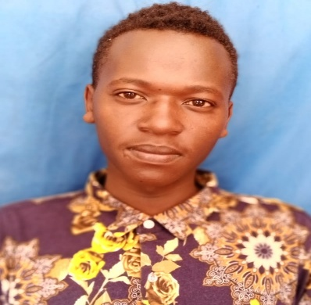
CURRICULUM VITAE

Dennis
Email: dennis-397474@gulfjobseeker.com
Nationality: Kenyan
Marital status: Single
Visa status: Visit visar
Age: 20

PROFILE
Mature positive minded hardworking man who always strives to achieve high standards possible at any given task. Highly computer literate, fluent in English verbal and written communication skills and team player. Tolerant and able to work in a culturally or racially diverse job, provide maximum security to company

CAREER OBJECTIVES
Looking up to a challenging position that will provide me with an opportunity to build a strong career opportunity in an environment that would enable further leadership in an organization and fully utilize my professional skills.

SKILLS
- Excellent interpersonal, verbal and written communication skill
- Natural ability to work on own initiative
- Strong organization skills.
- Excellent team player
- Good in micros

WORK EXPERIENCE

April 2019 toJune 2019:
Position:parking manager
- Completing security checks
- Handled late arrivals and assisted with early check-in and check-out
- Arranged brief tours of company facilities
- Take reservation
- Keep records as instructed
- Prepare check-out receipts
- Answering phone calls

April2018 to Feb 2019: African Economic Zone (AEZ)
Potion: security guard
Duties and Responsibilities:
- Maintain a record of all guests and members coming to the company
- Handle all incoming calls and answer the inquiries made
- Forward any customer complaints
- Administrate the payments made by the members
- Re-organize and maintain cleanliness of the company
- Promote new classes and additional service offered by the business to the clients
- Composed and distribute brochures, flyers and signs

Jan 2018Feb 2018Kenya Economic Zone
Position: front office receptionist
Duties and Responsibilities:
- Accommodate guests request
- Maintain a clean and neat front desk
- Route calls to specific people
- Answer phones and operate a switchboard
- Arrange appointments
- Direct visitors to where they are assigned
- Sending emails and fax
- Update appointment calendars

EDUCATIONAL BACKGROUND
F2018-Dec-2018 The KM security college
Jan 2018-Discipleship College
Course: computer application(part time)
Dec 2017 :African institute of research and development studies
Course: faculty of hospitality
Jan 2014- Decembet2017: Turbo school
Secondary level

INTERESTS AND HOBBIES

- Travelling
- Making new friends and exchanging ideas
- Reading novels
- Reading novels and motivational books.

REFFERIES AVAILABLE UPON REQUEST

