MUNIASAMY
E-Mail: muniasamy-397509@gulfjobseeker.com
SENIOR MEP PROJECT MANAGER
A versatile, high-energy professional with the distinction of executing prestigious projects of large magnitude within strict time schedule, cost & quality
Industry Preference: MEP – Electro Mechanical Services Design & Execution / Location Preference: Qatar/ Oman / Kuwait/UAE

AN OVERVIEW

- Possess 27 years of experience in the domain of MEP Project Management, Site Engineering and Relationship Management including 21 Years in Gulf Countries.
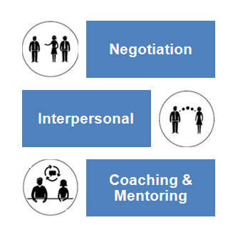
- Currently working withM/s.Al Sabbah Electro Mech contracting, UAE as Senior Project Manager (MEP)
- Proficient in planning, executing and spearheading MEP projects involving designing/design coordination, value engineering, construction development, quality assurance/control, HSE compliance, installation & commissioning, resource planning with a flair for adopting modern methodologies / techniques in compliance with quality standards
- Adept in creating comprehensive designs / plans, layouts, working drawings and construction details to ensure execution of projects within time and budgeted parameters
- Merit of coordinating the design and implementation of some of the most prestigious and internationally recognised construction, infrastructure and environmental projects
- Detail oriented & organised professional with goodplanning, analytical & interpersonal skills
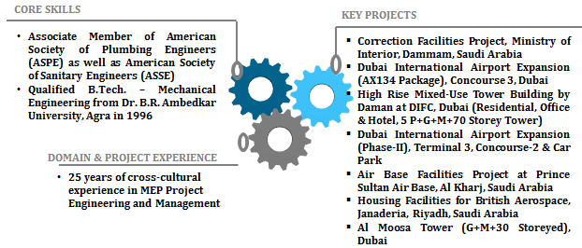

CAREER CONTOUR

Since Mar’18 : in UAE as Senior Project Manager(MEP).
Mar’17 – Feb’18 : M/s. Lodha Group, Mumbai, India as Deputy General Manager ( MEP).
Nov’13- Oct’16:M/s. Unistar Contracting Company, Saudi Arabia as Senior MEP Project Manager (Execution)
Jul’07-Aug’13: M/s. Emirates Trading Agency, M&E Division, Dubai as MEP Manager (Design & Execution)
Aug’05-Jul’07: M/s. Thermo LLC, Dubai as Senior Design Engineer (Plumbing & F.F. - Design)
Dec’97-May’05: M/s. Joannou & Paraskevaides (O) Ltd., Saudi Arabia as Project Engineer (Mechanical - Execution)
Jun’96-Nov’97: M/s. RPP Construction Ltd., Chennai, India as Project Engineer (MEP - Execution)
Mar’89-Apr’92: M/s. Emirates Trading Agency,M&E Division, Dubai / Kuwait as Project Engineer (Plumbing & F.F.)
Sep'85-Feb'89:M/s. Nadamuni Reddy & Son's Construction, Chennai, India, as Project Engineer

Key Result Areas:
- Monitoring projects with respect to cost, resource deployment, time over-runs, quality compliance and manpower planning to ensure timely execution of projects
- Handling the planning, scheduling and management of setting up MEP projects; ensuring completion of assignments
- Reviewing engineering drawings, layouts, diagrams, technical specifications, cost estimates for erection & commissioning of the projects.
- Anchoring on-site construction activities to ensure completion of project within the time & cost parameters and effective resource utilization to maximise the output
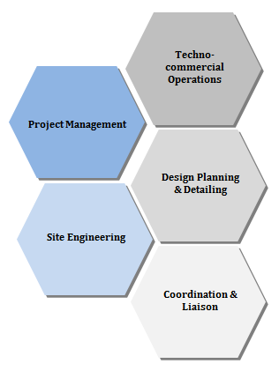
- Inspecting field sites to observe and evaluate condition and operability of facilities and structures, and to collect field survey data and measurements
- Designing and implementing stringent systems and quality plans / manuals to ensure high quality standards during all the stages of project
- Liaising with consultants, contractors, sub contractors & external agencies for determining technical specifications, approvals and obtaining clearances
- Working in close relation with main contractors for raising RFI’s thro’ QA / QC Team and get approvals from the consultants
- Attending senior level construction & business development meetings; also participating in developing effective measures to solve site coordination issues affecting project execution
- Looking after technical coordination with all other Discipline Heads for site clarification issues
- Planning as well as imparting continuous on job training to the workforce for accomplishing greater operational effectiveness / efficiency
- Working on talent pool and succession planning of the management cadre and workforce, appraising their KRAbased performance and providing feedback on the same

Project Overview:

Title: Residential Towers, B+G+45 Floor, New Cuffe Parade Project, Wadala, Mumbai, India.
Role: Deputy General Manager (MEP)
Client: Lodha Group.
Main Contractor: Lodha
MEP Sub Contractor: Drake & Scull, Abhisheik Millenium.
Consultant: AECOM
Project Value: INR 838 Million

Title: Correction Facilities Project, Ministry of Interior, Dammam, Saudi Arabia
Role: Senior Project Manager (MEP)
Client: Ministry of Interior, K.S.A.
Main Contractor: Saudi Binladen Group
MEP Sub Contractor: Unistar Contracting Company.
Consultant: Dar AL-Handasah
Project Value: SAR 306 Million

Title: Dubai International Airport Expansion (AX134 Package), Concourse 3, Dubai
Role: MEP Manager (Design)
Client: Dubai Aviation City Corporation-Engineering Project
Main Contractor: ALEC
MEP Sub Contractor: Emirates Trading Agency.
Consultant: Dar AL-Handasah
Project Value: AED 1.8 Billion

Title: High RiseMixed-Use Tower Building by Daman at DIFC, Dubai(Residential, Office & Hotel, 5 P+G+M+70 Storey Tower)
Role: MEP Construction Manager
Client: Daman Real Estate
Main Contractor: OgerDubai
MEP Sub Contractor: Emirates Trading Agency.
Consultant: Arif&Bintoak / BuroHappold
Project Value: AED 365 Million

Title: Dubai International Airport Expansion (Ph-II), Terminal 3, Concourse-2 & Car Park
Role: Senior Design Engineer(Plumbing & F.F.)
Client: Department of Civil Aviation
Main Contractor: HMRT-JV
MEP Sub Contractor: THERMO LLC.
Consultant: Dar AL-Handasah
Project Value: AED 1.3 billion

Title: Air Base Facilities Project at Prince Sultan Air Base, Al Kharj, Saudi Arabia
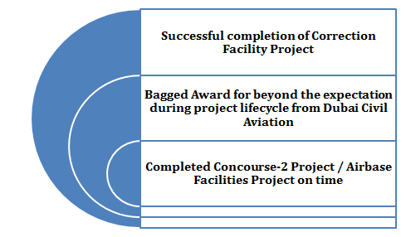
Role: Project Engineer(Plumbing & F.F.)
Client: Royal Saudi Air Force
Main Contractor: Joannou&Paraskevaides (O) Ltd.
MEP Sub Contractor: Joannou&Paraskevaides (O) Ltd.
Consultant: British Aerospace, London, U.K.
Project Value: SAR 2.1 Billion
Facilities :Family Villas – 1008 Nos& Bachelor
Accommodations For all Grade Officers;
Schools from Kinder Gartento High
Schools for Boys & Girls; Small
Mosques to Big Mosques; Clinics; Fire
Station; Vehicle Service Station, Dining &
Clubs including Kitchens for all Officers;
Hospital; Super Market; Swimming Pools –
Indoor and Outdoors;WTP ( 8400 cu.m / Day) including
6 DeepWells; Internal and External potable watersupply, Drainage, Rain water, Waste water&
Treated water supply for Irrigation systemand STP.

Title: Housing Facilities for British Aerospace, Janaderia, Riyadh, Saudi Arabia
Role: Project Engineer(Plumbing & F.F.)
Client: British Aerospace, London, U.K.
Main Contractor: Joannou&Paraskevaides (O) Ltd.
MEP Sub Contractor: Joannou&Paraskevaides (O) Ltd.
Consultant: British Aerospace ( BAe), London, U.K.
Project Value: SAR700 Million

Title: Al Moosa Tower (G+M+30 Storeyed), Dubai
Role: Project Engineer ( Plumbing & FF).
Client: Mr.AlMoosa
Main Contractor: AlHabtoor Engineering
MEP Sub Contractor: Emirates Trading Agency.
Consultant: ARENCO
Project Value: AED 160 Million

SCHOLASTICS
BachelorsofTechnology – MechanicalEngineering in 1996
Dr.B.R.AmbedkarUniversity, Agra, India

Diploma in MechanicalEngineeringin 1985
Board of Technical Education, Tamil Nadu, India

Professional Memberships:
- Associate Member of American Society of Plumbing Engineers (ASPE)
- Associate Member of American Society of Sanitary Engineers (ASSE)

PERSONAL SNIPPETS

Date of Birth: 6thMarch, 1967
Nationality: Indian
Salary Drawn : AED.30,000/-

