GENERAL DENTIST
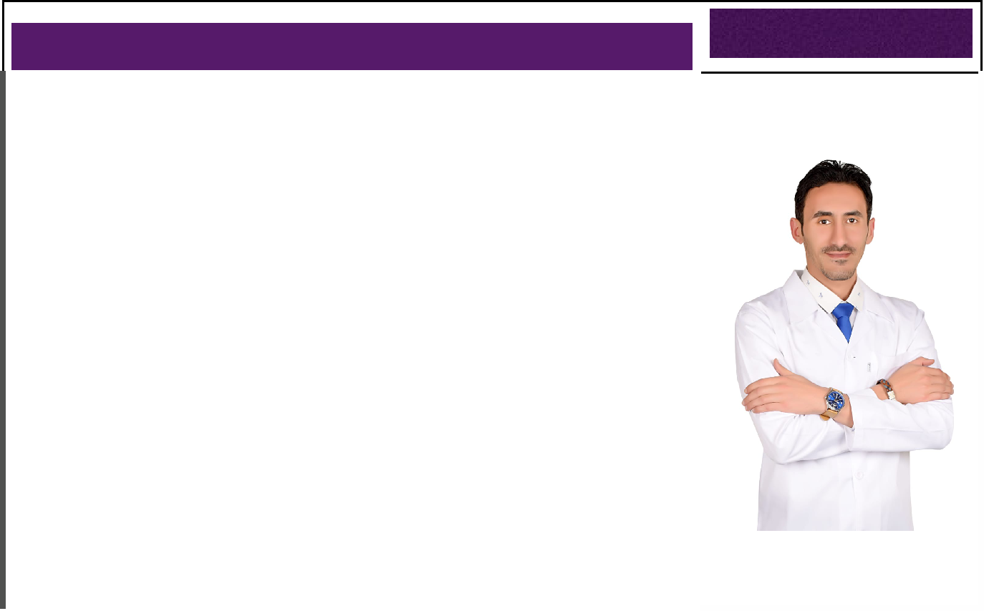

Personal Information

Name: Ahmed

Email : Ahmed-397514@gulfjobseeker.com

Nationality: Egyptian

Date Of Birth: 22 April 1984

Place Of Birth: Egypt

Religion: Muslim

Visa status:UAE Transfable Residence

.

PROFILE OBJECTIVE

Seeking a job opportunity full time as a general dentist.

I am a Dentist with 10 years of experience in delivering quality healthcare services with a passion & dedication with extensive knowledge of dental procedures hygiene

products devices and solutions with a specific interest in compromised care and

geriatrics hygiene care, also the knowledge of clinical procedures and medical and dental terminology. Periodontics Endodontics and Cosmetic Dentistry expert.

ACADEMIC QUALIFICATIONS

2008 Bachelor of Dental Surgery (BDS) 6thOctober University.

Graduation Grade: Good.

ACHIEVEMENT :

- National Competition for ENACTUS 6th October University. (2007/2008)

GENERAL DENTIST

JOB PROFILE

- Desensitizing agents.

- Bleaching and whitening technique.

- Hollywood smile.

- Pedo and prophylaxis expertise.

- Restoration.

- Skilled in root canals.

- Diagnostic aids.

- Mastery in veneers

- Dental records.

- Soft tissue management.

EXPERIANCES

2019-present

Dentist

MEDICAL CENTER in United Arab Emirates.

2018-2019

Dentist

Dr.Ahmed Refaat Megahed Dental Clinic, Mansoura , Batra ,Talkha , Egypt.

2017- 2018

Dentist

Dr. Mohamed Mahmoud Dental Center, Mansoura city, Egypt.

2009-2017

Dentist

Dentist in Hospital of El Kharga, new valley at ministry of health in Egypt.

Manager of medical convoys at Ministry of health, new valley in Egypt.

2008-2009

Dentist

6thOctober Hospital, 6thOctober University, 6th October city, Egypt.

GENERAL DENTIST

KEY SKILLS

- Ensure that verbal and written instructions are clear concise and understood.

- Work in coordination with other clinic staff to effectively educate the patient on their course of treatment in order to increase the likelihood of compliance.

- Provide on-going feedback to dental staff to improve communication and is receptive to feedback from dental staff.

- Provide patient education that consists of advising patients and family members in methods that facilitate a capacity for self-care and movement towards a healthcare partnership between the healthcare providers, the patients, and their families.

- Counsel and instruct patients and family members either directly or refer to the appropriate healthcare provider.
- Utilize opportunities and stress preventative care and maintenance to patients and their families regarding dental hygiene, health habits, and home care.

- Listen for clues that the patient needs additional assistance in understanding the treatment plan or in carrying out the treatment.

- Ensure maintenance of accurate patient records to reflect each patient's health status and risk factors. Monitor the quality if care delivered.

- Completed rotations in oral surgery, oral diagnosis and radiology, oral pathology operative and pedodontics, orthodontics, perio-dontics, endodontics and prosthodontics.

- Cosmetic dentistry: anterior composite filling, veener and Hollywood smile.

CORSES & CERTIFECATES

- Cosmetic Dentistry workshop : anterior composite filling, Veneers and Hollywood Smile.

- Assigned quota of clinical requirements to be completed over one year period, which included all aspects of restorative dentistry.

- Contacted patients on hospital waiting list for treatment by appointment card or by phone.

- Performed clinical assessment on patients – discussed treatment options and de-cided best suited treatment plan taking into account factors including time, cost, age and medical history of patient .

- Attended weekly dental pediatric sessions and performed procedures on children.

GENERAL DENTIST

AFFILIATION

Member at Egyptian dental syndicate.

Valid current license fromMinistry of health in Emirates MOH.

LANGUAGES

- Arabic : Native

- English : Excellent

DECLARATION

I hereby declare that the above furnished particulars are true to the best of my knowledge and belief.

Thanks for your time..

Ahmed

