FAVAZ (Estimation/QS/Planning Engineer)

E mail id: | Favaz-397535@gulfjobseeker.com | Nationality: | Indian
Date of Birth: | 12 March 1994 (26 yrs) | Sex: | Male

Graduated in Civil Engineering Specialized in Estimation and Quantity Surveying

CCS Candy Estimation Certified

Objective:

Seeking a better job position in a reputed Engineering firm in order to build a long term career by investing the best of my technical knowledge, educational qualification and professional experience to serve the organization with outstanding output.

Professional Experience:

Estimation/QS Engineer (in Dubai):

From February 2018- February 2020:

Duties:

Estimation and preparing budget for tendering works and preparation of final proposals. Taking of quantities for monthly progress invoice from all running / Active projects.
Preparation of commercial and Tax invoice for all running / Active projects.

Coordinating with Site team to attain required daily progress as per internal schedule. Preparation and revising of work schedule by coordinating with project execution team. Reconciliation of materials and sub contract payment.

Budget comparison and evaluating weekly cost report. Preparing monthly sale reports.

Preparing technical submittals for tendering and awarded projects.

Raising Variation Order/ Contract Amendment request and Additional climes.

Preparing Pre-qualification document and updating company PQ-approval in supplier’s online portals.

Estimation/Planning Engineer (CV Construction, India):

From December 2016 – December 2017:

Duties:

Estimation and preparing budget for tendering works and preparation of final proposals.

Planning of awarded project according to the available time frame and resource availability. Coordinating with Site team to attain required daily progress as per internal schedule.

Preparation and revising of work schedule by coordinating with project execution team. Budget comparison and evaluating weekly cost report.

Preparing monthly sale reports.

Proficiency:

Software Skills: CCS Candy, Primavera, Auto CADD, STADD pro & MS Office

Project management systems: Aconex, Dome connect

Estimation Skill: Good Knowledge in CCS Candy Estimation, Microsoft Excel and professional planning software like Primavera

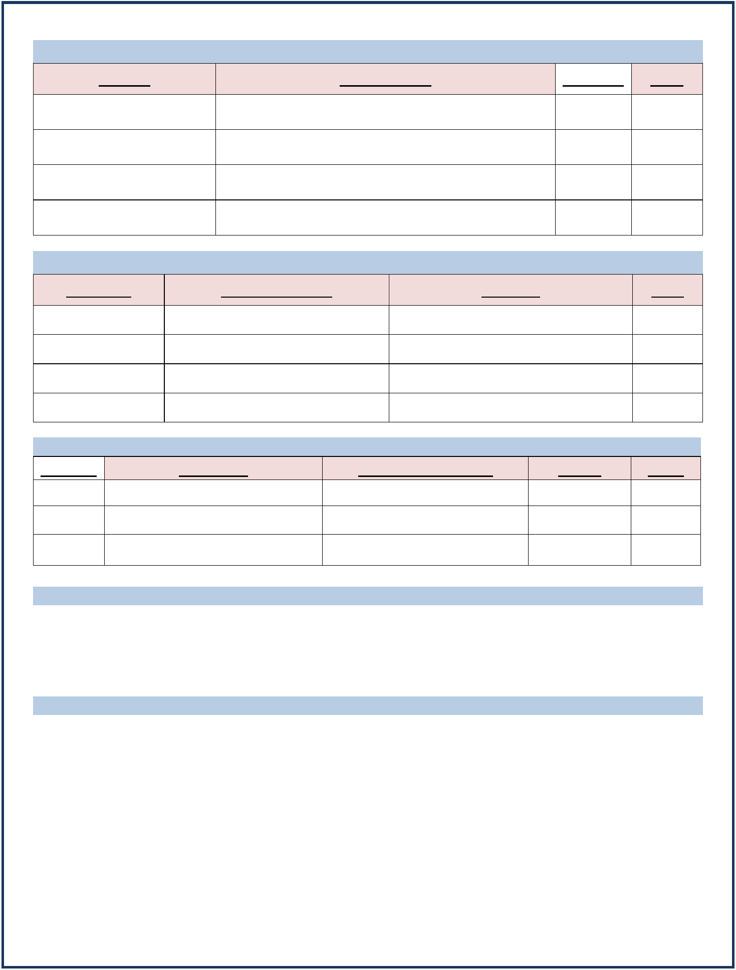
Major Projects:

Project | Involvement | Location | Year
Thematic District Expo | Final proposal (Commercial/Technical) preparation, | Dubai | 2018
2020 | Project Planning and Commercial duties
One Za’abeel | Final proposal (Commercial/Technical) preparation, | Dubai | 2018
 | Project Planning and Commercial duties
One Meydan Mall | Final proposal (Commercial/Technical) preparation, | Dubai | 2019
 | Project Planning and Commercial duties
Midfield Terminal, Abu | Final proposal (Commercial/Technical) preparation, | Abu | 2018
Dhabi Airport | Project Planning and Commercial duties | Dhabi

Professional Software Credentials:

Software | Training Centre | Purpose | Year
CCS Candy | CCS, Cochin | Estimation and Project control | 2017
Primavera | CADD centre, Thrissur | Project planning | 2017
Auto CADD | CADD centre, Thrissur | Drafting and designing | 2017
STADD pro | REC | Structural analysis | 2015

Academic Credentials:
Degree | Institute | University/Board | CGPA | Year
B.E | REC | Anna university, Chennai | 7.1 | 2016
H.S.E | Karuna higher secondary school | BHSE Kerala state | 7.3 | 2012
S.S.L.C | Karuna higher secondary school | Kerala state board | 8.1 | 2010
Language Skills:
To speak | : Malayalam, English, Tamil and Hindi
To write | : Malayalam, English and Arabic
To read | : Malayalam, English and Arabic

Declaration:

I do hereby declare that the particular of information and facts stated above are true, correct and complete to the best of my knowledge and believe.

FAVAZ

