CURRICULUM VITAE

BALVINDER

Address: Sharjah, U.A.E

E-Mail

Balvinder-397549@gulfjobseeker.com

Personal Profile:

Date of Birth: 16, march, 1993

Gender: Male

Nationality: Indian

Marital Status: Unmarried

Language known: English, Hindi And Punjabi.

Visa status: Visit visa

About My Self:

I aspire to do justice to my work.

Career Objectives
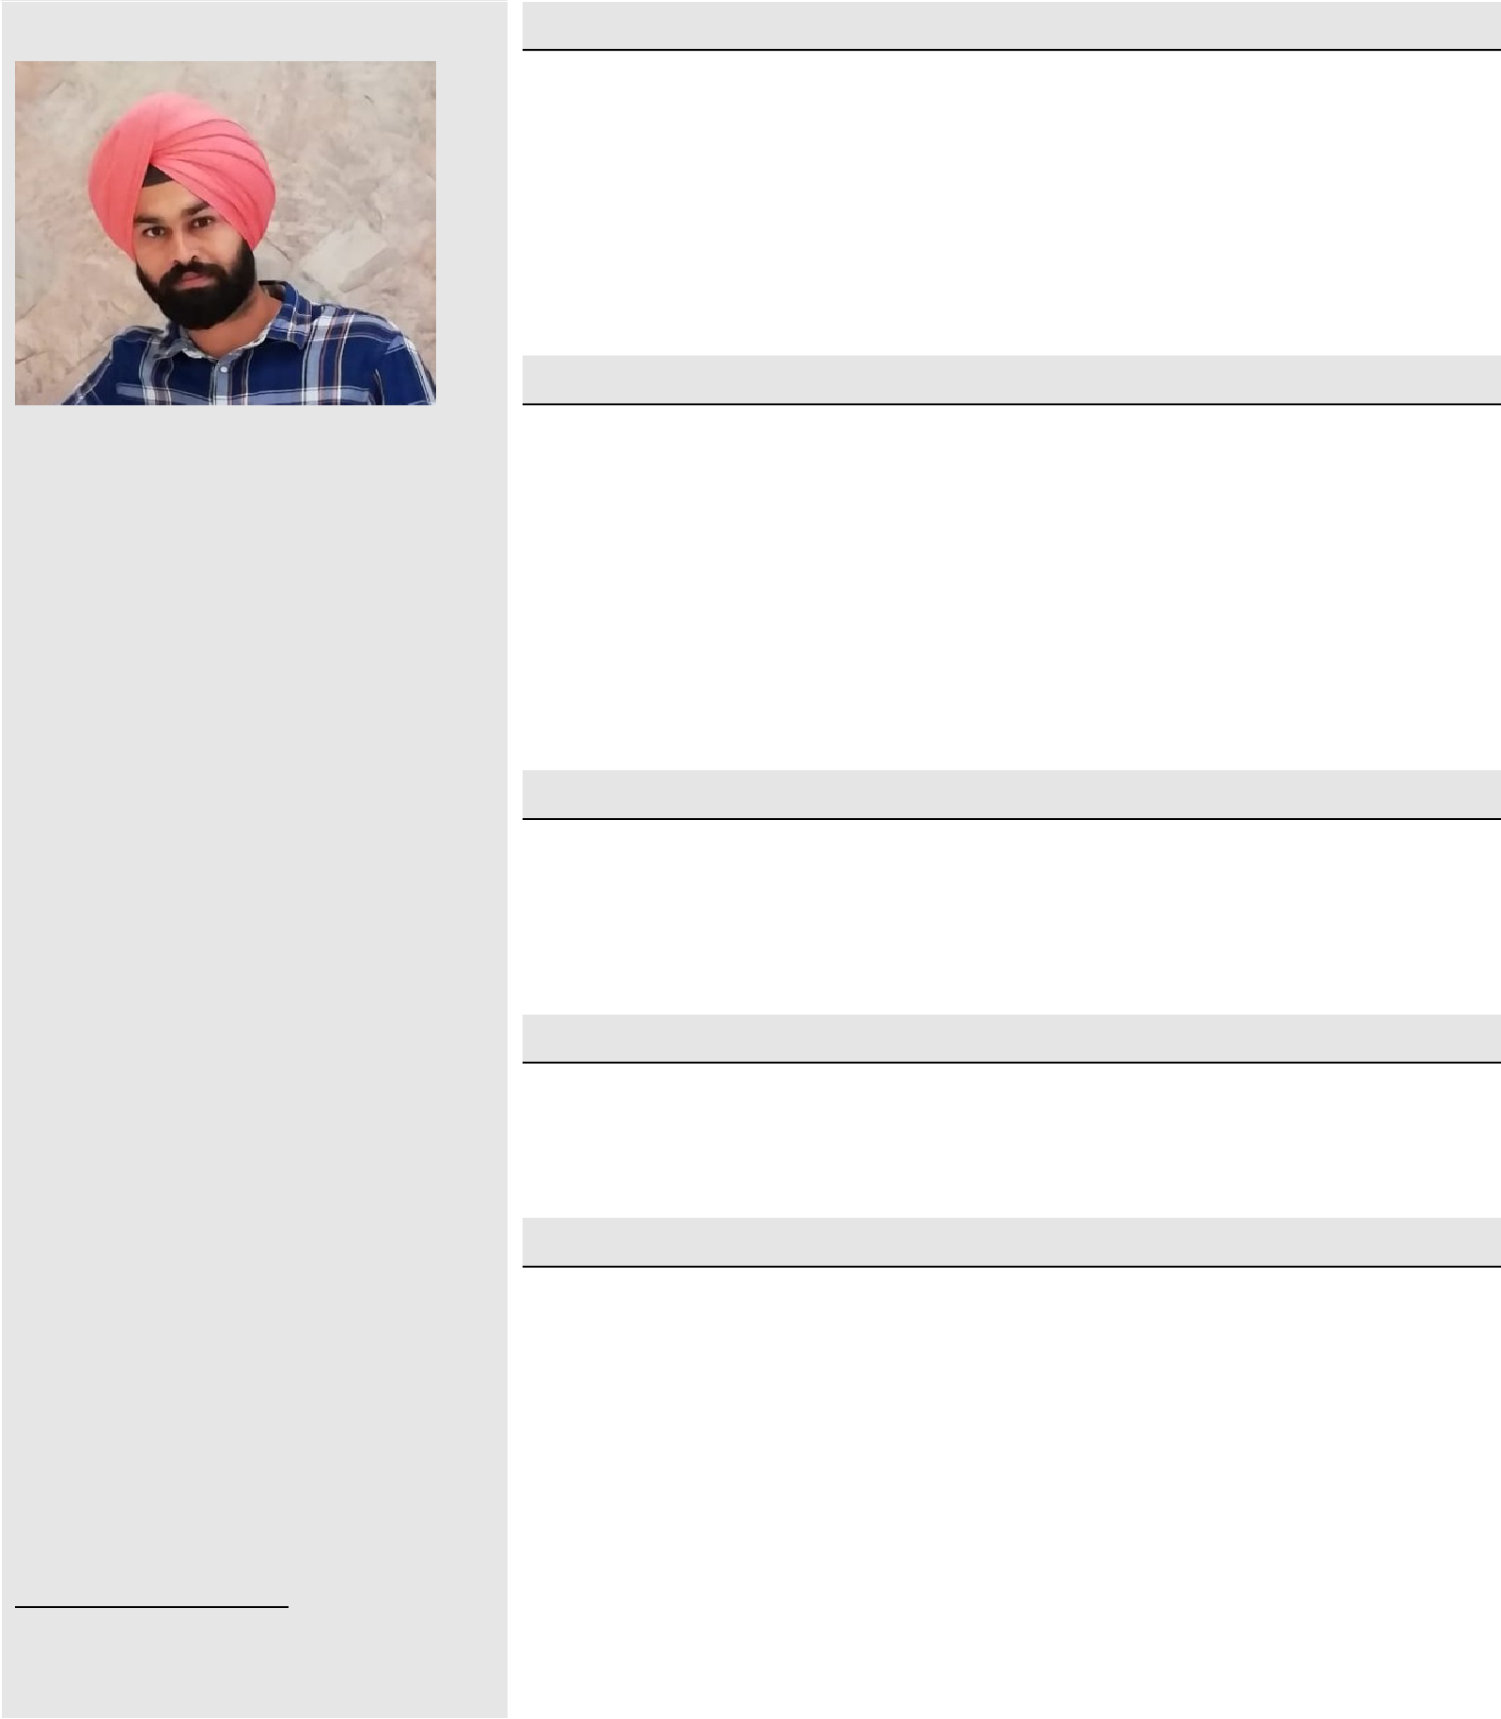

To associated with organization that provides me opportunity to show my skill & improve my knowledge with latest trends.
As soon as possible want to achieve high rank in my career.

Academic Qualification

12th : State Board of Andhra Pradesh in 2011.

10th : K.V.CRPF HYDERABAD in 2009.

Technical Qualification

B.Tech in civil Engineering from "LUDHIANA GROUP OF COLLAGES” in 2011 to 2015

Computer Proficiency

Platform : Windows 7.
Packages : AutoCAD,

Professional experience

P.D.AGARWAL AND CONTRACTORS( June 2015 to April 2016) Site Supervisor

Manage a team of 27 construction workers on a 25-million-dollar housing development project by scheduling shifts, delegating responsibilities, and supervising tasks.
Follow engineering and architectural recommendations on the blueprints when completing construction tasks for the project.
Order construction materials, tools, and machines in relation to needs according to the schedule of construction.

I believe that honest efforts for doing a work never get wasted. My Strength lies in my perseverance and inter-personal skills that contribute in all possible ways to achieve the goal.

General Skills:

Ability to organize events

and manage deadlines.

Ability to deal with people and manage client relations.

Ability to work successfully in a team and motivating people to work effectively.
Creative thinking and confidence to utilize the available resources to their full extent.

Dara Estates Pvt. Ltd.( May 2016 to July 2019)

site engineer

Resolving technical issues with employer’s representatives, suppliers, subcontractors and statutory authorities
Ensuring that all materials used and work performed are as per specifications.
Checking plans, drawings and quantities for accuracy of calculations
Day-to-day management of the site, including supervising and monitoring the site labour force and the work of any subcontractors.
Planning the work and efficiently organising the plant and site facilities in order to meet agreed deadlines.

(Oct 2019 to Pursuing) as a Carpenter

Fixing the furniture at the customers house. Delivering the items to the customers house.
Packing the furniture for delivery and taking care of customer satisfaction.
Fixing furniture for display in store. Handling stock room.

Hobbies

Working hard is only my hobby now and doing new creative things and to overcomes new challenges

Strengths

Quick adaptability of new environment. Hard working person
Self motivated and full of self confidence.

To overcome new challenges coming at work.

BALVINDER

