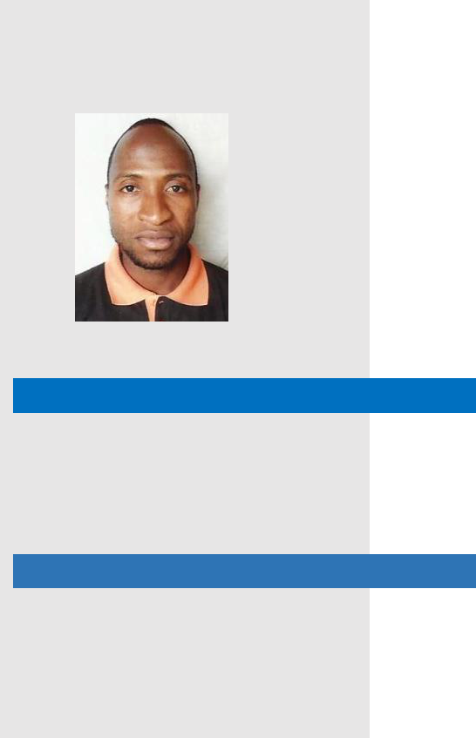

OJUBANIRE
34 years

Email: ojubanire-397559@gulfjobseeker.com

ABOUT ME

Highly enthusiastic individual looking to add value towards the attainment of the organization and wishing to be connected with prestigious companies where my skills, talents and abilities could be utilized at the same time greatly contribute to the development of my career. Excellent communicator, multilingual English &

Yoruba. Nigerian, Muslim, Married.

SKILLS
WORK

TREND AWARENESS

INITIATIVE

PEOPLE

DRIVE

CONFIDENT

PERSONAL

COMMUNICATION

ORGANIZATION

TEAM PLAYER

TIME MANAGEMENT

SOCIAL

RESUME

EXPERIENCE
Position: HSE Assistant/ First Aider

(July 2016 – Feb 2018)

PROJECT:
Internal Road Work in Various Location Stage #20, Al ain.

RESPONSIBILITIES OF THE JOB
- Routine safety inspections of sites and daily reporting’s.

- Incident reporting and participate in investigations.

- Co-ordinate with Consultants on HSE related works.

- Safety induction to visitors and new workers.

- Co-ordinate with concern authorities to take work permits.

- Ensuring that equipments are installed correctly and safely

Position: HSE Assistant

(Feb 2018 up to date)

PROJECT:

Construction of Road Between Wadi Al-Qawr And Link Road Between Al Hibab R/A and Nazwa Road.

RESPONSIBILITIES OF THE JOB
- Maintaining proper records.

- Making regular safe inspection.

- Ensuring that equipments are installed correctly and safely.

- Exercise emergency authority to prevent or stop unsafe acts.

- Monitoring all healthy and safety activities and ensure proper implementation.

- Help to manage risks and hazards in the site.

EDUCATION

➢ | BSC in Mathematics (Attested) | 2009
➢ | WAEC in science subjects (Attested). | 2003

PROFESSIONAL QUALLIFICATIONS

- NEBOSH IGC (International General Certificate, UK)

- Working at height Certificate

- Accident Reporting Awareness Certificate

- Workplace fire safety Certificate

- Electrical Safety Awareness Certificate

- Forklift truck Safety Awareness Certificate

- Manual handling operation Awareness Certificate

- The control of substances hazardous to health(COSHH) assessor certificate

- COSHH and working in confined spaces certificate

- Slip , Trips and Falls Awareness Certificate

- Personal Protective Equipment awareness certificate

- Display Screen Equipment (DSE) Hazard Awareness certificate

- Spillage Response Awareness Certificate

- Asbestos Awareness Certificate

- Positive Intervention and Situational Awareness Certificate

- Occupational Dermatitis Prevention Certificate

- COSHH and Respiratory Sensitizer Awareness Certificate

AWARDS

- Certificate of safety commitment by MUSANADA, Abu Dhabi General

- Certificate of Appreciation by Western Bainoona Group (WBG).

REFERENCE – Available Upon Request

