ABOUT ME
JHUN
Emal: jhun-397586@gulfjobseeker.com
Mechanical Engineer
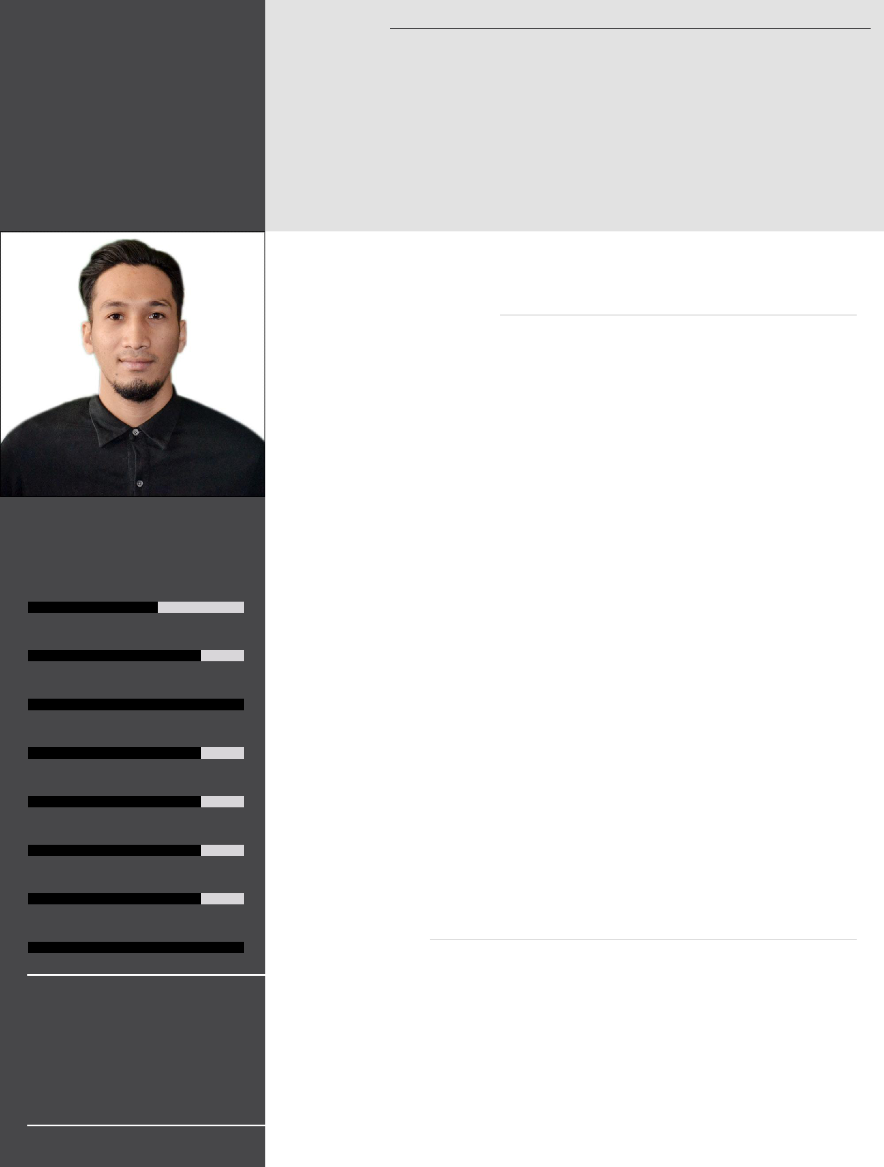

Highly analytical, performance-driven engineering professional with 2+ years' experience organizational supervising of process and maintenance. Coming with the ability to work with the team, to developed solutions and creating innovative, cost-effective designs.

WORK EXPERIENCE

August, 2019 - December, 2019

PLANT MAINTENANCE SUPERVISOR

Planning preventive maintenance schedules of the Feed mill plant and executed with highest quality. Coordinate other supervisors prior executing corrective maintenance.

Minglanilla City Cebu, Philippines

SKILLS

AUTOCAD

MAINTENANCE PLANNING

LOAD CALCULATION

March, 2018 - February,

2019

MILL AND BOILER SUPERVISOR

Universal Robina Corporation Sugar and Renewable

Keep tracking of mill equipment’s, milling operation parameters and performance. Detecting any unsafe/unhealthy conditions and take immediate actions. Coordinate other supervisor to avoid milling stoppages.
Negros Oriental, Philippines

ROOT CAUSE ANALYSIS

COMMUNICATION AND LEADERSHIP

METAL FABRICATION

SMAW/GMAW

January, 2017 - March,

2018

PLANNED MAINTENANCE ENGINEER

Universal Robina Corporation Sugar and Renewable

Ensuring the preventive maintenance schedules are executed with highest quality. Investigate equipment’s failures and make recommendations to maintenance crew. Coordinate other supervisors prior executing corrective maintenance.
Negros Oriental, Philippines

AUTOMOTIVE ENGINEERING

LANGUAGES

ENGLISH - Fluent

TAGALOG - Fluent

CEBUANO - Expert

EDUCATION

June, 2011 - March, 2016 BACHELOR OF SCIENCE IN ENGINEERING

Cebu Technological University

- top-ranked public university that has a tradition of excellence in research, learning and teaching, sports and the arts, and more.

Cebu City, Philippines

3.6/4.0

TRAINING & CERTIFICATIONS

2015 | MECHANICAL ENGINEERING INTERN
 | Mitsubishi Motors

PROJECTS

June, 2017 - July, 2017 |  | WASTE WATER FILTRATION SYSTEM
 |  | Responsible of designing the filtration system.
August, 2018 - |  | HOT WATER CONDENSATE TANK
September, 2018 |  | Responsible of designing the pressurize tank, pipings and pumps.
AWARDS
2015 |  | 3RD PLACER OF MECHANICAL QUIZ BOWL COMPETITION
 |  | Organized by Philippines Society of Mechanical Engineer

EXTRA CURRICULAR

SUPREME STUDENT COUNCIL MECHANICAL REPRESENTATIVE

Voice of mechanical department in the University of any activities.

VOLLEYBALL PLAYER

Volleyball player representative of Engineering department.

UNIVERSITY QUIZ BOWL TEAM CAPTAIN

Lead the quiz bowl team and compete to regional and national quiz bowl competition in the philippines.

PERSONAL INFORMATION

Birthday : 01/10/1994

Nationality : Filipino

Gender : Male

Marital Status : Single

CAREER HIGHLIGHT

Solid command of technologies, tools and best practices in designing mechanical equipment using AutoCAD, SolidWorks and engineering drawings. Excellent shop and safety skills honed from work as a mechanic and welder. Able to design and fabricate tooling and mechanical test fixtures. Work closely with team members to achieve engineering goals.

