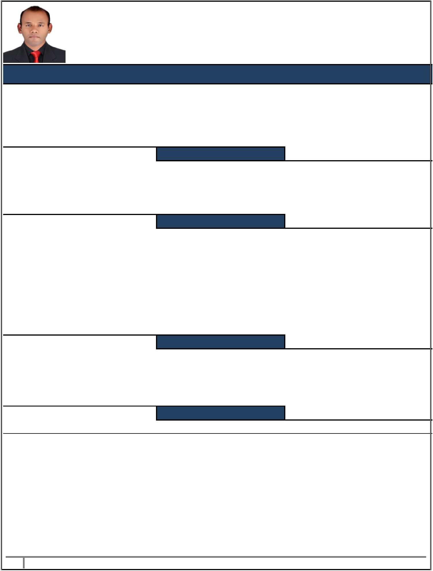**STEPHEN**

**E-mail:** [**Stephen-397587@gulfjobseeker.com**](mailto:Stephen-397587@gulfjobseeker.com)

**SUPPLY CHAIN AND LOGISTICS SPECIALIST**

**A hardworking & multifaceted professional with abilities to contribute in Supply Chain, Logistics, Operations, Administration, Inventory, Warehousing, Vendor Management. A quick learner, self-motivated, result oriented professional with demonstrated abilities in management, with effective cross-cultural communications. Seeking a challenging position with a dynamic organization that welcomes initiative, dedication and demands excellence in consistently meeting business objectives & exceeding standards.**

|  |  |  |  |
| --- | --- | --- | --- |
|  | **AREAS OF EXPERTISE** | | |
|  | **Supply Chain & Logistics Operations** |  | **Import & Export** |
|  | **Vendor Management/3PL/Account Handling** |  | **Warehousing & Distribution** |
|  | **Team Management & Problem-Solving Abilities** |  | **Inventory Management** |
|  | **Excellent Interpersonal Skills** |  | **IT Skills** |

**CORE COMPETENCIES**

**Dedicated and hard working, with a good Knowledge in Supply Chain Management and Logistics, Resource Planning and a willingness to excel my knowledge and experience in the field of Supply Chain Management and Logistics.**

**Quick- Learner: Good leadership Skills, organizational, oral/ written communication interpersonal analytical and problem resolution skills, thrives in both independent and collaborated with a work environment.**

**Corporate Relations / Client Servicing: Managing all matters with a high standard of professionalism, high attention to detail and confidentiality.**

**Administration: Self-correspondence, Good Knowledge in Computer software’s, good communication, Good Technical and Analytical Skills.**

**Excellent Communicator: Excellent oral and written communication skills; ability to negotiate and comfortably interface with all levels of management and staff.**

**CAREER SNAP SHOT**

**Jun 2010 to Oct 2019**

**Logistics Executive, Dubai, UAE.**

**Nov 2003 to May 2010**

**Administration Supervisor, Jawad Business Group, JAFZA - Dubai, UAE.**

**Apr 2002 to Oct 2003**

**Digital Studio Manager cum Graphic Designer, Akruthi Digital Studio, Mangalore, India.**

**Jun 1999 to Dec 2001**

**Computer Lab Instructor, IMS Technologies, Mangalore, India.**

**PROFESSIONAL EXPERIENCES**

**Logistics Executive**

**(Supply Chain Dept.)**

**(Jun 2010 to Oct 2019)**

**(Largest Retail Group in UAE)**

**Dubai, UAE.**

**Responsible for Vendor Management and ensure “Standard Operating Procedures” are followed.**

**Efficiently handling day to day logistics operations for a business, handling 2500 FEU per year through various supply chain networks across 10 countries for 150 stories**

**Planning freight consolidation and containerization of shipments to reduce shipping cost.**

**Monitoring Vendor / Freight Forwarder SLA metrics to analyze performance & compliance and grievance resolution. Developing logistics network and negotiate rates with service providers for cost effective and seamless movement. Efficiently managing Imports, Exports & all relevant Documentations.**

**Liaising with CDC team for Goods Receipt, Distribution & Re-export of received materials as per SLAs Monitor all orders/allocations/replenishments are processed accurately & within given time limit.**

**Monitor and ensure merchandise is shipped from CFS & CDC and delivered to RDCs as per the delivery timelines.**

* **STEPHEN**

**Coordinate with territories to ensure on-time clearance and delivery of goods & inventory updates**

**Maintain Shipment Tracker & monitor Liner/Forwarder’s delivery lead times for the concept and review exceptions Resolve any queries or issues with regards to Import/Export of shipments.**

**Interact with Buyers/Planners to communicate status of orders/shipments & provide them end to end visibility Minimizing port storages and demurrages.**

**Liaising with banks for shipping document/Bank guarantees. Track customs deposit as well as refunds & managing LOIs**

**Review service provider Billing invoices associated with freight and clearance charges.**

**Conducting recurrent stakeholder meetings to discuss service levels and align expectations. Prepare and review weekly/monthly reports on concept logistics efficiency and productivity. Designated as Logistic Executive, leading 10 members’ team & reporting to Logistics Manager.**

|  |  |
| --- | --- |
| **Admin. Supervisor (Logistics, Distribution and Inventory)** | **(Nov 2003 – May 2010)** |
| **JAWAD Business Group –JAFZ (Bahrain based Retail Group)** | **Dubai, UAE.** |

**Worked as Administration Supervisor and reported to the Distribution Center Manager & managing a team of 8 Distribution Center administratives.**

**Managing incoming shipments from overseas & local suppliers, Storage & overseeing Distribution & Re-export process.**

**Handling DC warehousing & logistics activities and Maintaining proper records of daily inwards and outwards and circulate reports on daily basis**

**Inspecting items, as to quality and quantity, against Customs Invoice & Packing List**

**Stock allocation from Distribution Centre to Stores (outbound) & ensure efficient delivery from warehouse to store Schedule all export deliveries as per the requirement of Sales. Ensure store replenishments dispatch as per schedule. Getting quotes from Freight forwarder, 3PL providers, negotiating & ensure effective Freight management.**

**Liaise with Shipping lines, freight forwarders/CHA/transporters for smooth functioning of timely deliveries. Preparing Import/Exports documents as per customs/country requirements.**

**Organizing transportation for local deliveries as well as cross border movements.**

**Coordinate with suppliers on SED (short / excess/ damages) & Prepare GRN & Consignment Variance Note (CNV) reports for discrepancies**

**Inspect damages and investigate & raising claims with insurance service providers with relevant documents.**

**Communicate with the Brand Managers/Merchandisers/Stock control/Finance team for the re-order level, minimum stock level, stocks in hand, daily dispatch schedule, damaged goods & write offs.**

**Handling store returns & Inter Branch stock transfers of various stores.**

**Monitoring distribution of visual merchandising/display materials/store fixtures to stores. Efficiently handling periodic Stock Audit & Reconciliation (Inward & Outward) of warehouse. Maximizing the customer satisfaction level by on time delivery & handling customer complaints.**

**Coordinating with certification agencies including customs, SASO agents and Government/Municipal authorities etc. in order to ensure a smooth flow of shipment movement in to various Middle East countries including UAE, KSA, Bahrain, Qatar & Kuwait with all government, regulatory, quality and enterprise requirements, guidelines, policies and procedures.**

**Training team members, allocate work as per requirements, motivate personnel towards achieving organizational objectives & review work for accuracy and completeness.**

**Digital Studio Manager cum Graphic Designer**

**(Apr 2002 - Oct 2003)**

**Akruthi Digital Studio.**

**Mangalore, INDIA.**

**Worked as Digital Studio Manager cum Graphic Designer, and I was reporting to the Owner.**

**Managing Digital studio & staffs. General Administrative duties. Overseeing Graphic Designing work. Handling customer enquiries. Account/cash Handling, Order processing,**

**Maintaining and developing relations with customers, Liaise with suppliers, Purchases and payments.**

**Computer Lab Instructor**

**(Jul 1999 - Dec 2001)**

**IMS Technologies**

**Mangalore, India.**

**Worked as a computer lab instructor, coaching students.**

**General administrative duties like admission, customer enquiries etc.**

**Preparing schedules for classes. Maintaining Library,student’s records, Maintaining Course Materials Organizing Personality Development programs/Sports/cultural activities.**

* **STEPHEN**

**Conducting exams & evaluating student performance. Lab maintenance. Handling staff Issues.**

|  |  |
| --- | --- |
|  | **QUALIFICATION & SKILLS** |
| **Educational Qualifications** | |
| **1998** | **Diploma in Computer Technology, Mangalore University, Karnataka, India.** |
| **1996** | **Pre University College, Jain Pre University College, Karnataka, India.** |

**Training and Personal Enhancement**

**2011**

**1999**

**1999**

**CISCP (Certification in International Supply Chain Management, IPSCMI USA) from Blue Ocean Academy, Dubai, UAE**

**Diploma in Client/Server Programming from IMS Technologies Mangalore, India.**

**Diploma in Computer Applications, Manipal Institute of Computer Education, Mangalore, India**

**I.T. Skills**

**ERP - Retail Pro System Version 7.0 (RPro), Oracle Business Interface in Supply Chain Management WMS: Exceed**

**Applications Software: SCP, OBI, RMS, Share point, Lotus Notes**

**Programming: C, C++, Visual Basic**

**Data Base: Oracle 7.x, SQL Server, MS Access 97**

**MS Office: MS Word, MS Excel & MS PowerPoint**

**Operating Systems: MS DOS, Windows & Windows NT.**

**Designing software: Adobe Page Maker 6.5, Adobe Photo Shop, Auto CAD 14**

**Web designing: HTML, DHTML, Java Script**

**Languages Known**

**English (Read, Write & Speak) Hindi (Read, Write & Speak) Kannada (Read, Write & Speak), Tulu (speak), Konkani(Speak)**

**Interests & Hobbies**

**Travelling, Trekking/Camping, Sports, Gym, Music, Photography.**

**Indian**  **Married** **Male**

**Resident Visa** **UAE Driving License** **D.O.B. 02/10/1978**

**\*Supporting Documents and References will be provided on request \***

* **STEPHEN**