RESUME

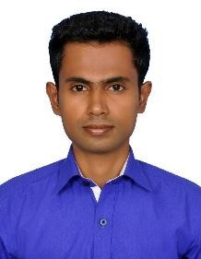
SULTHAN
Email : sulthan-397592@gulfjobseeker.com

Objectives:

To have a growth oriented and challenging career, where I can contribute my knowledge and skills to the organization and enhance my experience through continuous learning and teamwork.

Experience Details:

- Position: ELECTRICAL ENGINER
Period : JAN2019- JAN2020-UP TILL NOW (1 YEAR)

- Blue sky Middle East Company LLC, Dubai.
Position: Site Engineer
Period : Mar 2016- MAR 2018

Educational Details:

Course | University/Board | Institute | Year of Passing | Percentage/  CGPA
BE- Electrical and  Electronics  Engineering | Anna University | Mohamed Sathak Engineering College, Kilakarai. | 2015 | 6.5
DEEE- Electrical Engineering | DOTE | Mohamed Sathak Polytechnic College, Kilakarai. | 2012 | 75
SSLC | Matric Board | Hameediah Matric Hr.  Sec. School, Kilakarai. | 2008 | 60

UG Project:

- Project Area: Embedded System.
- Project Title: Implementation of Multilevel inverter for Seismic Green Energy
Harvesting.

Diploma Project:

- Project Area: Embedded System
- Project Title: Single axis Solar panel tracking.

Personal Trait:

- MS EXCELL,POWER POINT ,MICROSOFT WORD
- INTERNET KNOWLEDGE
- NEWS READER
- QUICK LEANER
- TAMIL ENGLISH READ AND WRITE
- HINDIN & ARABIC SPEEKING

Hobbies:

- Playing CAROOM
- Internet Surfing
- Reading stories

Personal Profile:

Date of Birth : 29-10-1992
Gender : Male
Marital status : Single
Languages Known: Tamil, English

Declaration:
I hereby declare that all the details furnished here are true to the best of my knowledge.
(SULTHAN)

