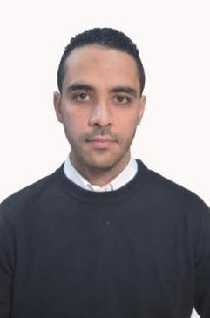
Curriculum vitæ

KIES

Date place of birth: 10/11/1991 Saïda Algéria

Email : kies-397593@gulfjobseeker.com

DIPLOMAS

July 2015 Master degree in French language

July 2013 B A degree in French language

2008/2009 Baccalauréat Languages Stream

13/05/2017 DALF c2 degree (Advanced French language Diploma) from the French institute of Algeria, Oran

EXPERIENCE

From 19th /10/2017 to 30th /6/2019 non- qualified teacher. Secondary school

From 07th /09/2016 to 14th /12/2016 non- qualified teacher.Secondary school of Berrahou Techicum .Saïda Algéria.

From 25th to 27 july 2016 participation at the Youth Employment Summit .World Learning Algiers .

From 06th /09/2015 till 03rd /12/2015 non- qualified teacher. in the secondary school of Seddik Brothers in the town of Saïda.

From 03rd /12/2013 till 02nd /12/2015 recruited by the direction of The Youth and Sports as a teacher of French at Saïda.

23rd and 24th may 2012 participated in the international colloquium organization about the French language University Saïda.

Personal Skills

Native language : Arabic
Other languages : French Dalf C2 . Good knowledge in English

Numerical competence: Independent user of office software (Word, Internet..)

MY INTERESTS

Readings related to the field of French , internet , foreign languages , writing , cinema, sport and traveling

MY PLANS

Plan to work in high education (university), communication manger

