PROFILE

To grow up as a good professional in a challenging environment and to be associated with a progressive Organization that gives me scope to exhibit my knowledge and skills.

CONTACT

EMAIL:
Aswathi-397603@gulfjobseeker.com

PERSONAL PROFILE

Date of Birth:
20.10.1994
Father’s Name:
- Prakashan

Marital Status: Single

ASWATHI
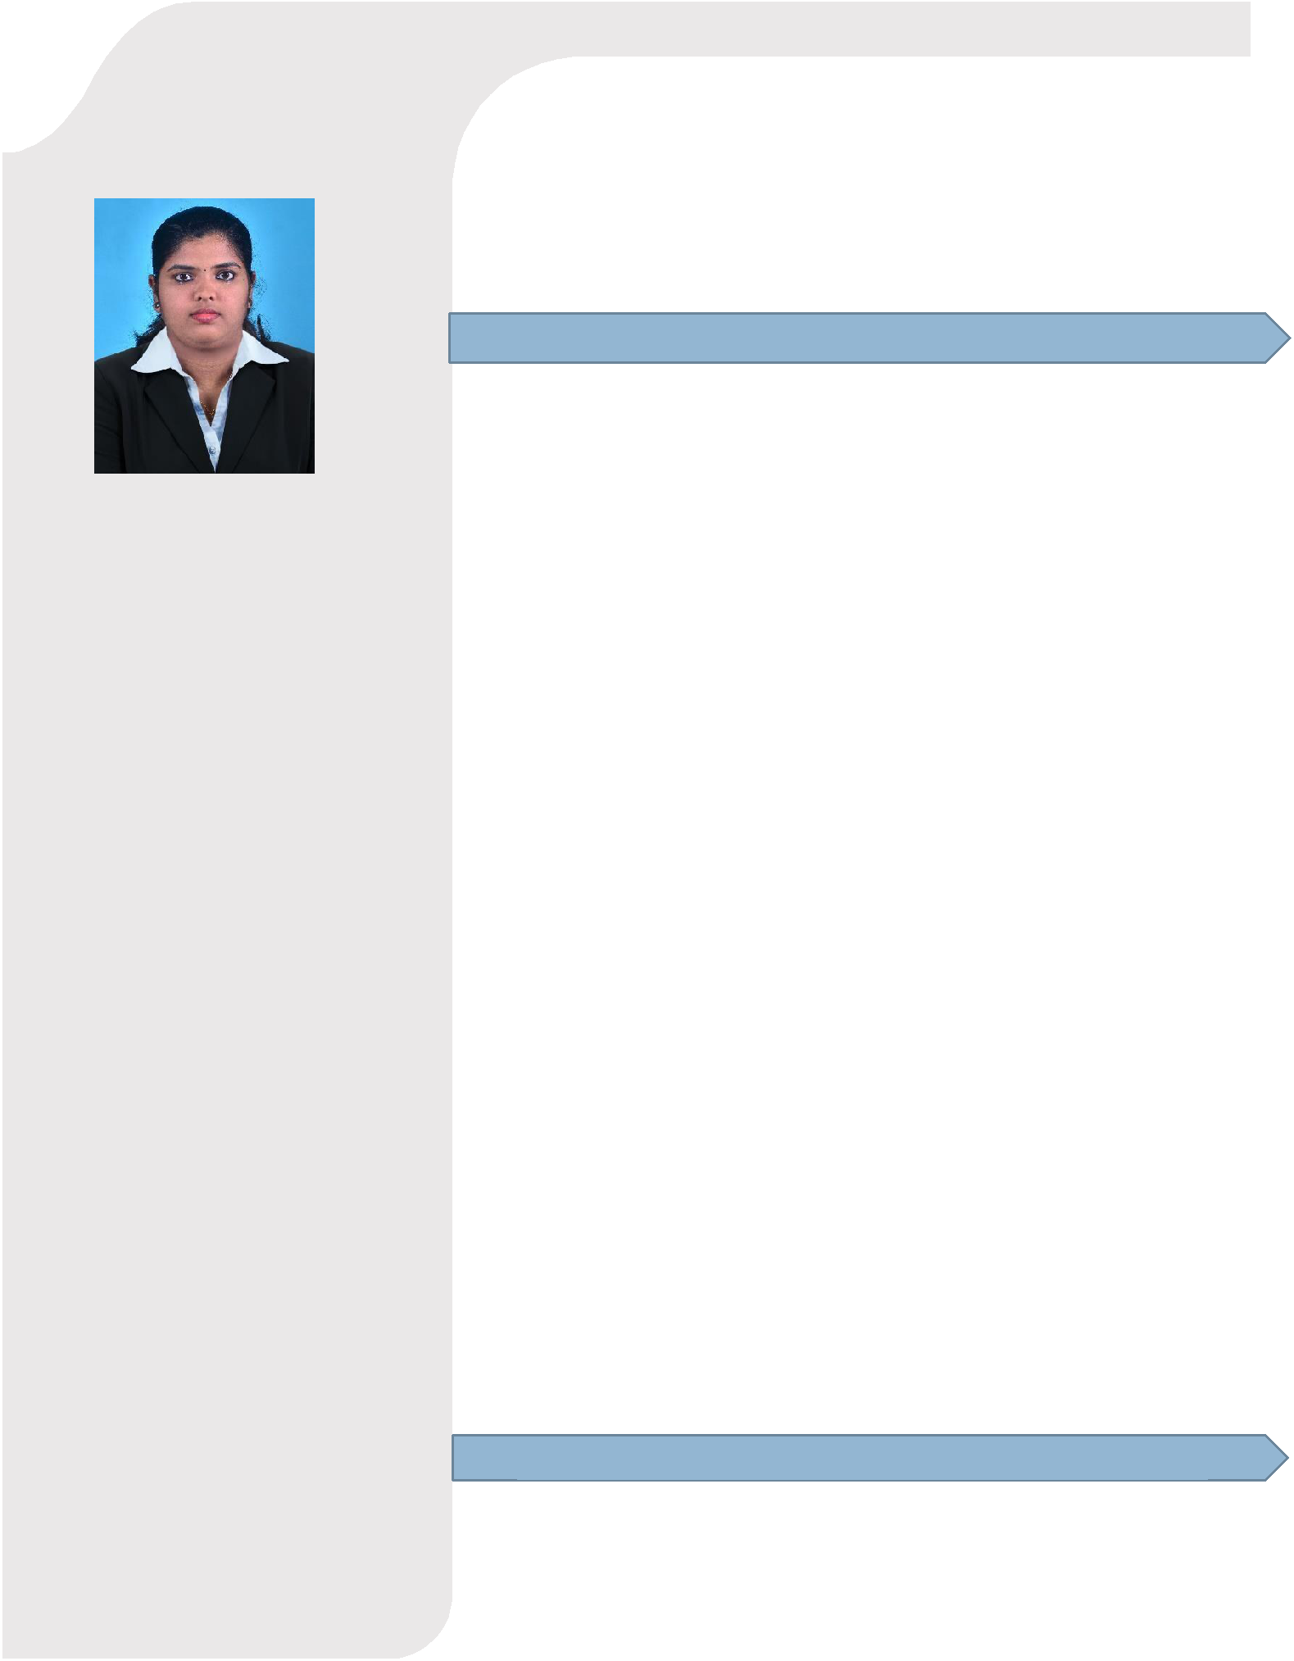

WORK EXPERIENCE

July 2017- Nov 2019-Study world, Kannur.
Course Counsellor, 2 years 5 months

Job role:
- Converting walk-ins to admissions
- Creating walk-ins from the telephonic leads

- Preparing and sending weekly and monthly admission details to head office

Apr 2017 – July 2017-Win Wincorp, Kannur.
Event Organizer, 3 months

Job role:

- Working with clients to identify their needs and ensure customer satisfaction
- Organizing team
- Establishing budget
- Brand event

- Organizing facilities and details such as décor, catering, entertainment, transportation, location, invitee list, special guests, etc.

Aug 2016 – Mar 2017-CMS IT Training Institute, Kannur. Administrative assistant cum Career Counsellor, 8 months

Job Description:
- Administration works

- Converting walk-ins to admissions
- Creating walk-ins from the telephonic leads

- Preparing and sending weekly and monthly admission details to head office
- Scheduling exams and interviews

EDUCATION

2016 | Pondicherry Engineering College,
 | Pondicherry University, B-Tech
 | Electronics and Instrumentation

LANGUAGES KNOWN

English Hindi Tamil Malayalam

COMPUTER SKILLS

- MS Office

- Windows

PERSONAL TRAITS

- Good team worker

- Quick learner.

- Knowledge seeking

- Never say die attitude

HOBBIES

- Reading books

- listening music

2012 | C.E. Bharathan Govt Higher
 | Secondary School, Mahe, Kerala
 | Board for Higher Secondary
 | Examination Higher Secondary
2010 | C.E. Bharathan Govt Higher
 | Secondary School, Mahe, Kerala
 | Board for Higher Secondary
 | Examination Higher
 | Secondary

ACADEMIC PROJECT

Mini project on “Light detecting alarm”

Project onS
“Computer aided detection and grading of Paediatric brain tumor”

Role:
- Segmentation of images and detection of severity of tumor.

Duration:
- One year

Information about Project:

- This project aimed at doing image processing using MATLAB of CT scan images of patients and telling severity of brain tumor. We went for CT scan instead of MRI as its cheap and easily available.

Responsibilities:
- Pre-processing
- Thresholding,
- Segmentation of images and detection of severity of tumor

WORKSHOPS

- Participated in the “Solar mobile battery charger” workshop in association with Pragyan 2014, NIT-Trichy

- Participated in the “Acclerorobotics” workshop in association with Pragyan 2015, NIT-Trichy

IN-PLANT TRAININGS

- Undergone in-plant training at ‘Keltron Component Complex Ltd’, Kannur, Kerala from MAY 13th 2014 to
MAY 26th 2014

