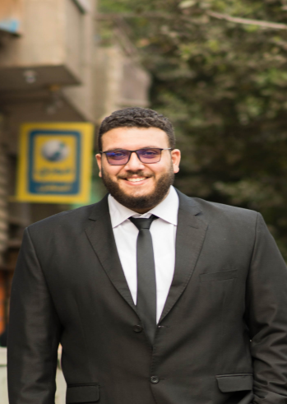
Abdelrahman
E-mail : abdelrahman-397617@gulfjobseeker.com
Education:
Bachelor Degree of Commerce English section, Cairo University (September) 2017-2018
Accounting major
Cumulative grade:
Accepted
Courses:
Human resources sessions with HR specialist: Ramy Boshra
English course in AUC
Skills:
Microsoft office, word & excel
Advanced web search
Working on Oracle, AR module
English: reading, writing and talking very good
Arabic: Mother tongue
Work experience:
Partner in a private business (accountant of the business) sep.2015-feb. 2018
Commercial department manager assistant in Gulf Catering Company, Riyadh March 2019 –September 2019
Accountant at Financial department in Gulf Catering Company, Riyadh. September 2019 – till now
Extracurricular Activities:
Fundraising member at Xproject Student activity 2014-2015
Fundraising Vice head at Xproject Student activity 2015-2016
Fundraising Head at Xproject Student activity 2016-2017

Personal Data:
Date of birth: 28/6/1994
Marital Status: Single
Nationality: Egyptian
Military Status: Exempted

