KHURRAM
Email: khurram-397651@gulfjobseeker.com

Having almost 5 years of extensive experience in Retail Banking, Credit and Collections, Investment and Business Development in

U.A.E. Currently resident in U.A.E.

Nationality - Pakistan

Date of Birth – 02-12-1978

Skills

Commercial/Retail Banking | Client Handling | Business Development Programs

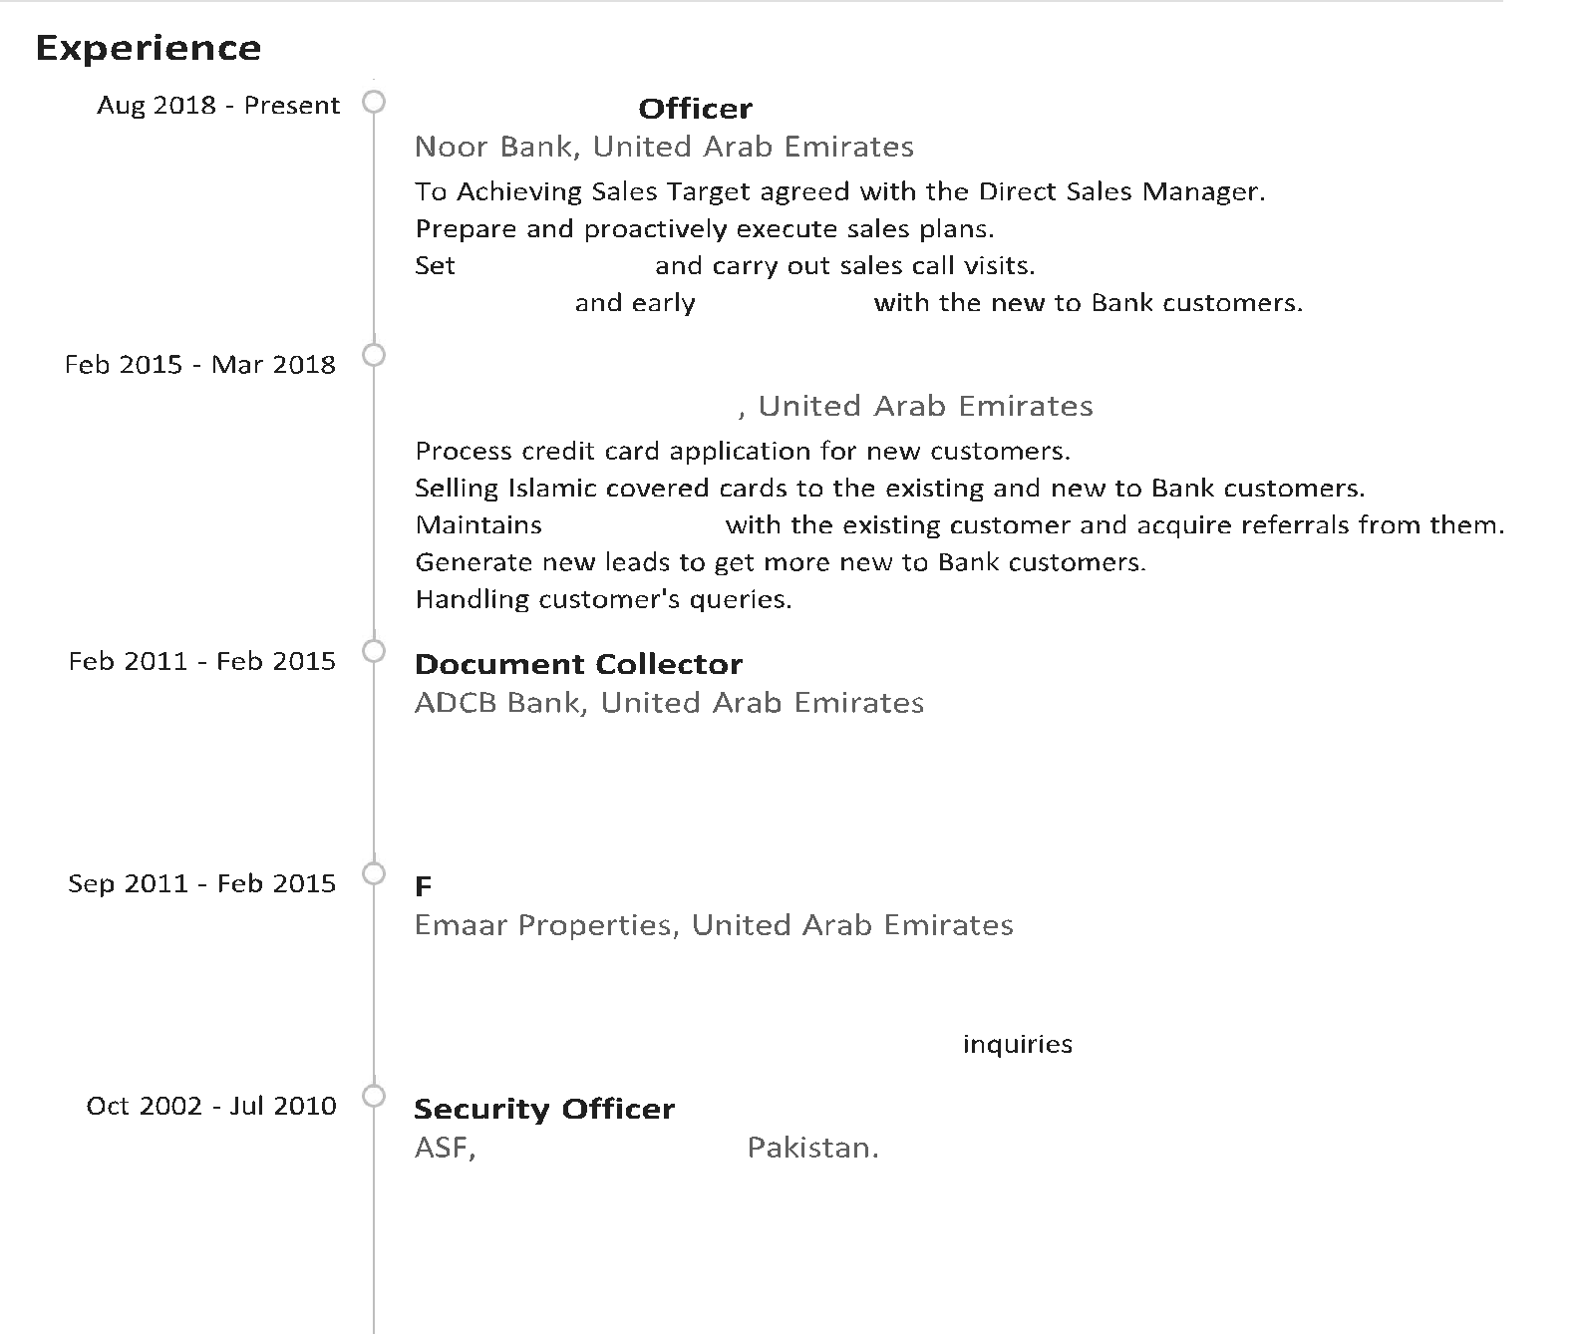

Coordinate with CIU Department.

Security Surveillance.

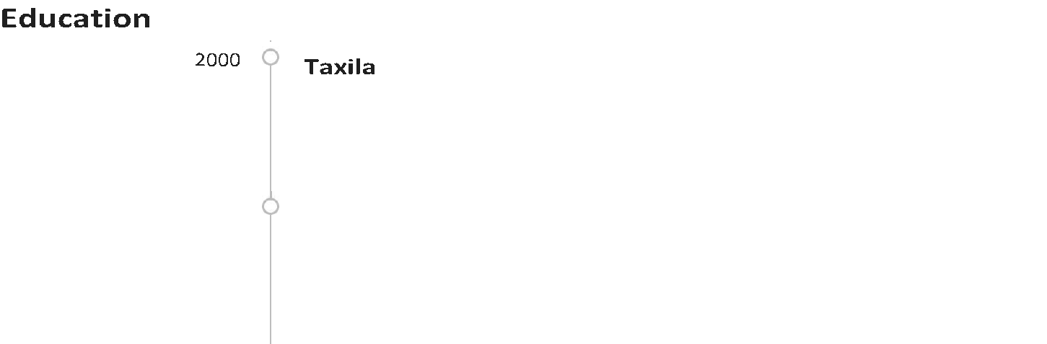
Rawalpindi, Board.

Page 2 of 2

