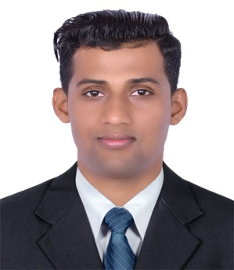
Curriculum Vitae
EIKARAJ
: eikaraj-397652@gulfjobseeker.com

Career Conspectus
- To achieve professional excellence in any above mentioned field that provides me with opportunities to fully utilize and develop my knowledge, skills, information and education. I am easily motivated, confident, honest and dedicated to my job.
Experience Summary

Housekeeping superior
August-2016 to November2019.

sales man
Vatvatani supermarket Kathmandu Nepal
jan-2014 to March2015.

Office Boy
Manakamana Travel and Tours Kathmandu Nepal.
June-2012 to Aug 2013

Skills and strength
  - Co-imperatively Pleasant personality, self, motivated and hard working.
  - Capable of working with sound mind under pressure.
  - Communicate effectively at all levels.
  - Strong and enthusiastic to success, able to work at flexible timing and shifts,
  - Quick in groping new areas. can work as a good team player.
  - Flexible in working with the different areas in the place.

Training & Development
  - Front desk opera training 90 Days Dusit Residence Dubai Marina.
  - Food preparation-oriental training center, Nepal.
  - Chef Commis-CTEVT Board, Nepal.
  - Food hygienic training.
  - Chemical handing training, First Aid training.
  - Fire, fighting training Telephone manner.
  - Complaining hanging training.
  - Guest Request, Complains follow up-Dusit Residence Dubai Marina.
  - Lost & Found procedure-Dusit Residence Dubai Marina.
  - Guest Room Key handling Procedure-Dusit Residence Dubai Marin.

System Knowledge

• Opera, (Back Office system)
• Opera, (Housekeeping System)
• Microsoft Excel,Word

Qualification

• Intermediate in Education
Higher Secondary Education Board Kathmandu Nepal
Personal Details

- Date of Birth 19thJanuary 1993
- Marital Status UN-Married
- Nationality Nepalese
- Current Location Bur Dubai, UAE
- Religion Hindu
- Gender Male
- Health Excellent
- Languages Known English, Hindi and Nepali
- Visa status Employment visa with- NOC

Declaration

I hereby declare that the details furnished above are true and correct to the best of my knowledge
& belief.
Eikaraj

