CURRICULUM VITAE

PERSONAL INFORMATION
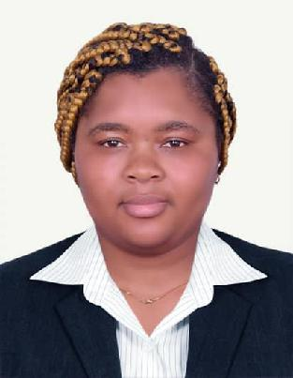

Name | : |  | EPIPHANIE
Visa Status | : |  | Husband Visa
Gender | : |  | Female
Nationality | : |  | Cameroonian
Marital Status | : |  | Married
Email | : |  | Epiphanie-397658@gulfjobseeker.com
Address | : |  | Abu Dhabi
Language | : |  | English & French
Position :
 |  | CLEANER/HOUSEKEEPING

Professional Summary

Hardworking and dependable Cleaner has excellent leadership skills and the ability to effectively communicate with crews corporate management and clients. Has a client-focused approach and observes principles of good customer service delivery and more than 1year of active Cleaning Supervisor experience.

Core Qualifications
- Excellent supervisory skills

- Extensive knowledge of successful cleaning crew management

- Good interpersonal and oral communication skills with people at all levels

- Understanding of safety and sanitation standards and guidelines

- Excellent crew monitoring

- Strong dedication to enforcement of company policies

- Client-focused and ensures cleaning crews deliver good service

Working Experiences
Cleaner

Duration: 1year

RESPONSIBILITIES:

- Emptying waste bins or similar receptacles, transporting waste material to signaled collection points.
- Sweeping floors with brushes or dust control mops.
- Mopping floors with wet or damp mops.
- Suction cleaning carpeted areas and “spot” cleaning carpets.

- Using electrically powered scrubbing and polishing machines to scrub, p olish and spray clean floors (after receiving proper instruction and trainin g).

- Using electrically powered pick up machines, to dust, damp wipe, wash or polis h furniture, ledges, window sills, external surfaces of cupboards, radiators, shelv es and fitments.

Hotel Room Attendant
HOTSPOT BOTANIC GARDEN Hotel LIMBE
Duration: 3years

Responsibility:
- Maintained hotel locker rooms lounges and back of house areas
- Supplied guests with extra towels and toiletries when requested
- Informed supervisor when supplies were low
- Replenished guest supplies and amenities

- Cleaned and returned vacant rooms to occupant-ready status
- Operated incinerators and trash compactors to dispose of garbage
- Stocked toilet tissue and paper towels as well as other restroom supplies

- Cleaned the exterior surfaces of lighting fixtures including glass and plastic enclosures
- Spot cleaned carpets using industrial carpet cleaner
- Emptied and cleaned all waste receptacles
- Hand dusted and wiped clean hotel furniture fixtures and window sills

- Removed finger marks and smudges from vertical surfaces including doors f rames and glass partitions

Education
High school certificate

DECLARATION: I certify that all the information above is correct and reference are available if they are needed hoping that my experience will be useful to you.

