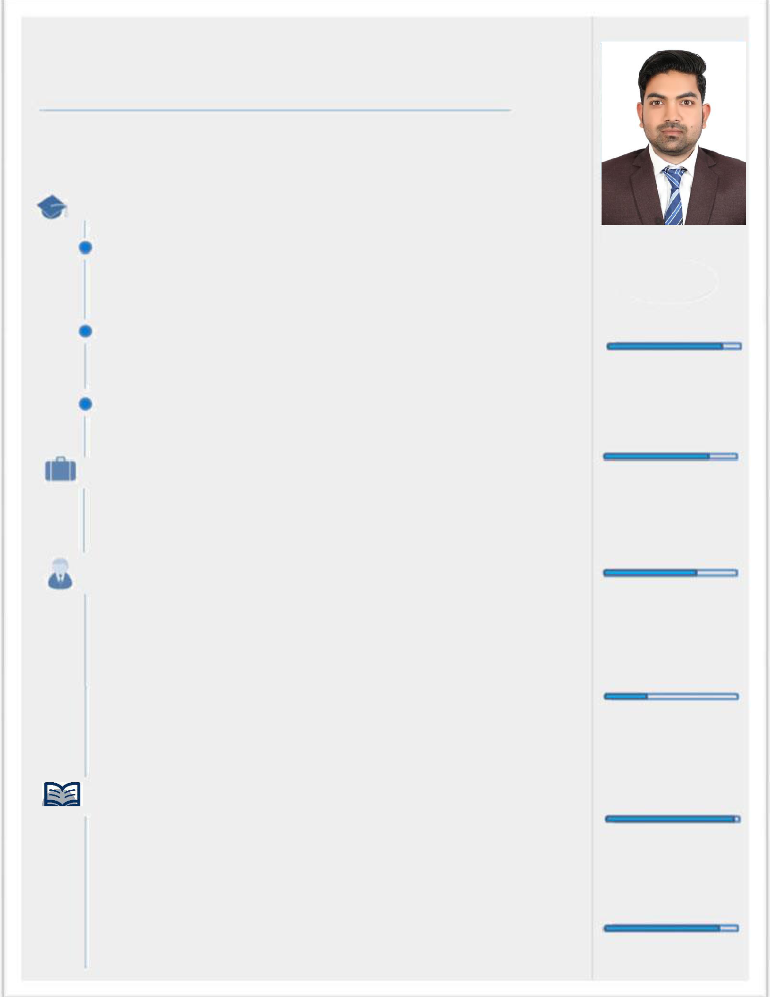
FAHAD

Architect

Email: fahad-397676@gulfjobseeker.com | VISIT VISA VALID TILL 20 DEC 2020
 | Availability: Ready to join immediately

EDUCATION

B. Architecture 2011 – 2016

Balochistan University of Information Technology Engineering & Management Sciences Takatu Campus Balieli Airport Road Quetta, Pakistan.

Intermediate Pre-Engineering 2008 – 2010

Govt. Science College Quetta.

Matriculation Science 2007 – 2008

Islamia High School (Balochistan Board of Intermediate & Secondary Education Quetta.

WORK EXPERIENCE
.
Position: Architect
(The development and implementation of strategic plans) |  |  | 2017-2019
Company: National Engineering Services Pakistan NESPAK Karachi
Position: Done internship in different department of company. |  |  | Feb – Mar 2014
PERSONAL DATA
Religion: | Islam
Marital Status: | Single
Date of Birth: | 25/10/1991
Nationality: | Pakistani

CERTIFICATION

- AutoCAD, Photoshop & 3D MAX

- Participate at Street Art Competition

- English language from Ideal Center Quetta

- Participate in exhibition at Balochistan university Quetta

COMPUTER SKILLS

PHOTO SHOP

MS OFFICE

GRAPHICS

HARDWARE

WINDOWS

(Xp, Vista, Win7, Win8, Win 10)

AUTO CAD

 | EXPERIENCE PROJECTS:
 | • | RESIDENTIAL
 | • | COMMERCIAL
 | • | INTERIOR DESIGNER
 | FINAL THESIS PROJECT:
 |  | Addressing diversity of youth through Architecture (youth center)
 | INTEREST:
 | • Reading about latest Architectural Materials & Styles
 | • | 3D Modeling
 | • | Architectural Design
 | • | Sketching
 | • | Model making
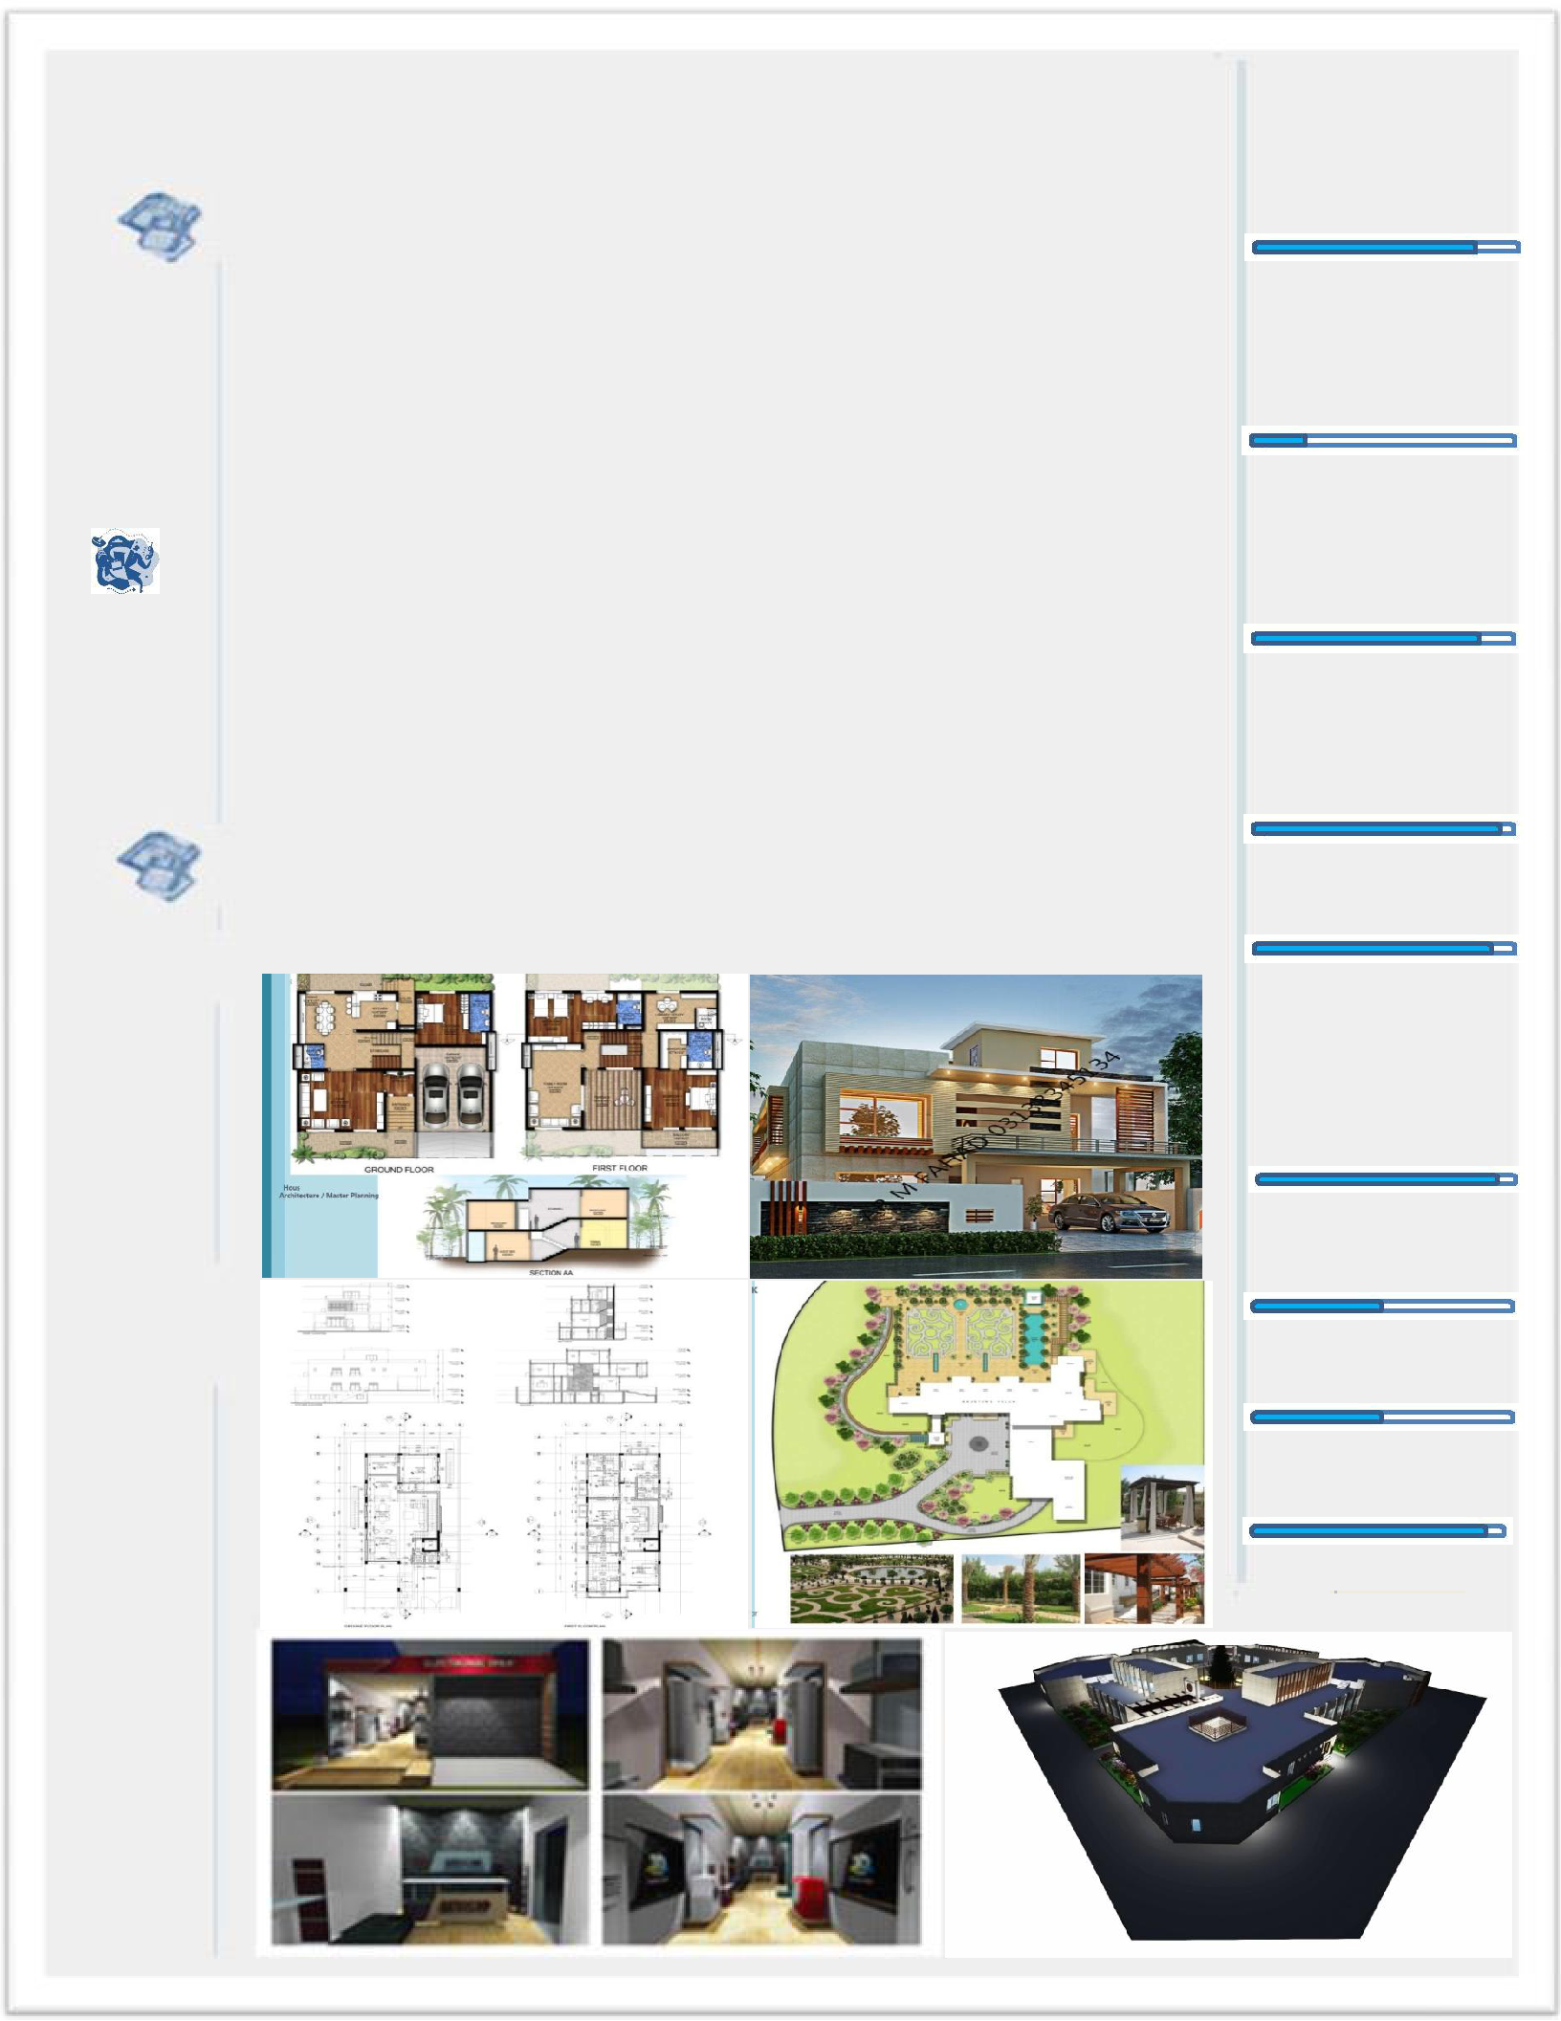
• Research for Structure, Materials
ARCHITECTURAL WORKS:

SKETCHUP

LUMION

VIDEO EDITING

3D ANIMATION

MULTIMEDIA

LANGUAGES

ENGLISH

URDU

ARABIC

PASHTO

