CURRICULUM VITAE
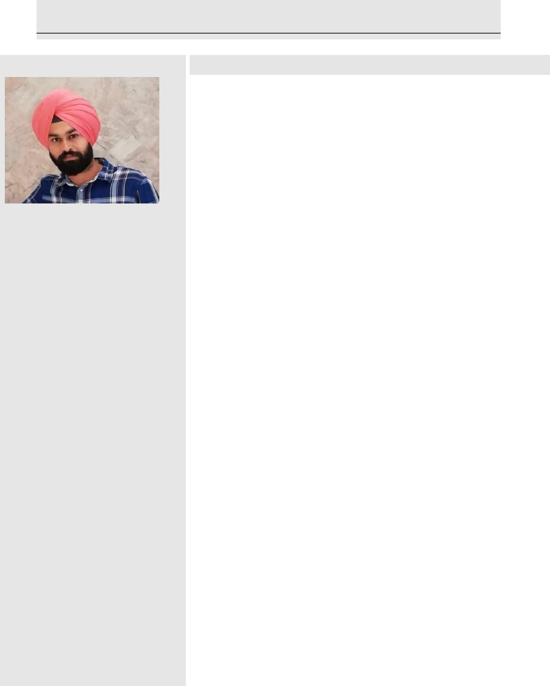

BALVINDER

Address: Sharjah, U.A.E

Career Objectives

- To associated with organization that provides me opportunity to show my skill & improve my knowledge with latest trends.

- As soon as possible want to achieve high rank in my career.

Academic Qualification

- 12th :State Board of Andhra Pradesh in 2011.

- 10th :K.V.CRPF HYDERABAD in 2009.

E-Mail

Balvinder-397687@gulfjobseeker.com

Personal Profile:

Technical Qualification

- B.Tech in civil Engineering from "LUDHIANA GROUP OF COLLAGES” in 2011 to 2015

Computer Proficiency
Date of Birth: 16, march, 1993

Gender: Male

Nationality: Indian

Marital Status: Unmarried

Language known: English, Hindi And Punjabi.

Visa status: Employment visa

About My Self:

➢ Platform : Windows 7.
- Packages : AutoCAD,

Professional experience

- P.D.AGARWAL AND CONTRACTORS( June 2015 to April 2016) Site Supervisor

- Manage a team of 27 construction workers on a 25-million-dollar housing development project by scheduling shifts, delegating responsibilities, and supervising tasks.

- Follow engineering and architectural recommendations on the blueprints when completing construction tasks for the project.

- Order construction materials, tools, and machines in relation to needs according to the schedule of construction.

I aspire to do justice to my work. I believe that honest efforts for

doing a work never get wasted. My Strength lies in my perseverance and inter-personal

skills that contribute in all possible ways to achieve the goal.

- Dara Estates Pvt. Ltd.( May 2016 to July 2019)

site engineer

- Resolving technical issues with employer’s representatives, suppliers, subcontractors and statutory authorities

- Ensuring that all materials used and work performed are as per specifications.

- Checking plans, drawings and quantities for accuracy of calculations

- Day-to-day management of the site, including supervising and monitoring the site labour force and the work of any subcontractors.

- Planning the work and efficiently organising the plant and site facilities in order to meet agreed deadlines.

General Skills:

- Ability to organize events and manage deadlines.

- Ability to deal with people and manage client relations.

- Ability to work successfully in a team and motivating people to work effectively.

- Creative thinking and confidence to utilize the available resources to their full extent.

- French Departmental Store(Oct 2019 to Pursuing) as a Carpenter

  - Fixing the furniture at the customers house.
  - Delivering the items to the customers house.

  - Packing the furniture for delivery and taking care of customer satisfaction.
  - Fixing furniture for display in store.

  - Handling stock room.

Hobbies

Working hard is only my hobby now and doing new creative things and to overcomes new challenges

Strengths

- Quick adaptability of new environment.

- Hard working person

- Self motivated and full of self confidence.

- To overcome new challenges coming at work.

BALVINDER

