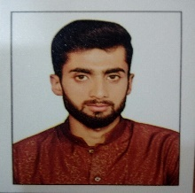
SAIF
Email: saif-397689@gulfjobseeker.com

Objective

Devotion to job is not sacrifice; it is the justification of your existence in this world
“Anticipating for a challenging and motivating position in a reputable organization, which should quenchthe thirst of growth, besides enhancing my capabilities”. Always willing to undertake challenging tasks!

Professional Experience
- 1 year experience warehouse restaurant Islamabad as a cook one.
- 6 year experience AFC Iqbal Town Lahore as a pizza man.
- 1 year experience Rahim store Iqbal town Lahore as a salesman.
- 6 month experience national foods company as a salesman.
- 1 year experience Jalal Sons main market Gulberg Lahore as a salesman.
- 1 year experience Emporium Mall Lahore as a security guard.

Education

Institutions: | Seagal institute of tourism & Hotel Management Lahore. |  | Himayat-e-Islam higher secondary school Multan road Lahore.
BOARD/  UNIVERSITY | City and Guilds | B.I.S.E  LAHORE
DEGREES OR DIPLOMA: | Culinary Arts  Course | MATRIC  (SCIENCE)  2013-2015

Computer Skill

- MS OFFICE (2007) WORD , EXCEL , POWERPOINT
Interests

- Reading Books  - Cooking | - Sports
Personal Information

- Date of Birth | 27-09-1998
- Religion | Islam

Reference

- Will be furnished on demand.

