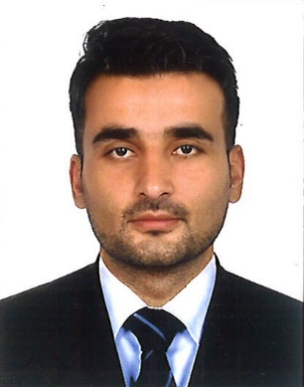
IKRAM

Email: ikram-397710@gulfjobseeker.com
Visa status visit visa

PROFESSIONAL GOAL:
To accept challenging and responsible position, where my intention, education and my capabilities can be utilized for mutual benefits and interest in efficient manner.

PROFESSIONAL CAPABILITIES:

- Ability to initiate, organize and maintain performance to achieve desired goals.
- Patiently analyze the situation and ability to adopt a suitable decision.
- Supportive team player in challenging and fast paced environment.

PERSONAL INFORMATION:
Religion : Islam
Nationality : Pakistani

EDUCATIONAL PROFILE:

ACADEMIC:
BSC (Double Math’s& Physics) University Of AJK
2012-2015

FSC (Per Engineering) Islamabad School & College
2008-2010

Matriculation (Per-Medical) Islamabad School & College
2006-2008
EXPERIENCES:

01-Jan-2017 to Feb. 15-2020

Accountant
Now in these days I was work as a account with dawn events.

Accountant
- Manage accounts
- Machinery Record/ Salary Record
- Patty cash handling

Ijaz& Company01-Jan-2017 to 01-Dec-2017

Accountant
- Manage accounts
- Machinery Record/ Salary Record
- Received and Dis-pitch Documents

Public World Development (PWD) 01-Jun-2014 to30-Dec-2016

Data entry Operator
- Official work/ Administration work
- Telephone operator/ PS to SE.

Per Continental HOTEL01-JUL-2013 to 30-may-2013

Receptionist/Guest Service Agent/Front Desk Clerk

Main job Tasks & Responsibilities
- Guest dealing/Reservation
- Cashier / Communication Officer
SOFTWARE Opera 7

COMPUTER SKILLS:

- In page
- Opera 5
- MS Office
- Scan Documents
- Mail
- Faxing Documents
- OPMS
- Internet browser
- Photo-static Documents.

