CONTACT

Rikka-397730@gulfjobseeker.com

PERSONAL

DETAILS

DOB : 26/12/1993

Civil Status : Single

Visa Status: Visit Visa

SKILLS

- Over 5 years' experience in different food service capacities

- Accounting and budgeting

- Points of sales, micros and symphony skills

- Strong leadership skills

- Ability to understand and improve human relationships

- Interpersonal communication (Oral and written)

- Well versed in providing and maintaining high standards of guest service

RIKKA
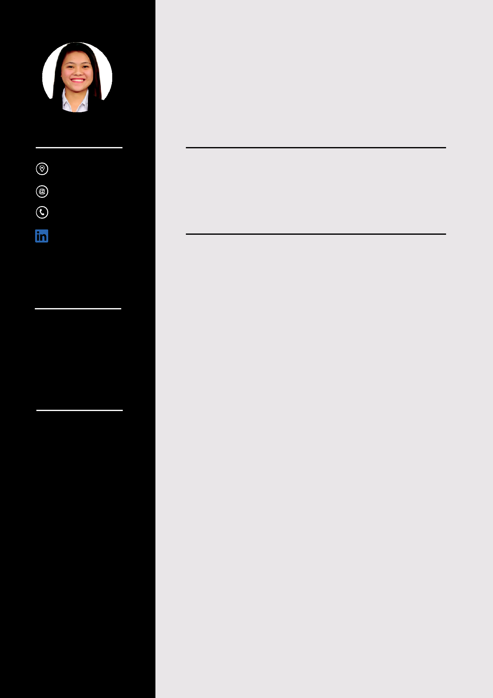
Restaurant Manager

OBJECTIVE

Dynamic, hardworking and committed individual seeking a role in managerial position; where I can apply my knowledge and skills in hospitality industries.

WORK EXPERIENCE

Restaurant Manager
December 2019 to March 2020

Assistant Restaurant Manager
September to November 2019

- Handling customer inquiries and complaints.

- Recruiting, training and supervising sta .

- Managing the profit and loss.

- Promoting and marketing the business.

- Setting targets.

- Creating detailed reports on weekly, monthly and annual revenues and expenses.

Conference and Events
Jumeirah at Etihad Tower Hotel
March 2018 to August 2019

- Review and understand banquet event orders (BEO’s) or Event Plan at the beginning of each shift to ensure banquet rooms are set as per the customer request.
- Prepare coffee breaks stations with appropriate food and beverages as stated in Banquet Event Order.
- Handling meetings in fulfilling customer needs to ensure events flow smoothly.
- Respond to guest requests in a friendly, timely, and efficient manner.
- Preparing Buffet tag for the upcoming events.

- Be in communication with the team member regarding any special needs

Restaurant Supervisor
Hilton Hotel Abu Dhabi
September 2015 to February 2018

Food and Beverage Attendant
February 2015 to August 2015

- Ensure customer satisfaction by closely monitoring all food and beverages served are of optimum quality meeting best in class restaurant standards.
- Ensure VIP and Corporate guests (ADNOC/ ADGAS, ADIA, Embassy of Japan, Embassy of Korea) are well treated and their requirements fulfilled.

- Handling guest complaints, inquiries, reservations and bookkeeping.
- Maintain appropriate interpersonal relationships with employees, peers, and customers.
- Responsible for inventory tracking and management.

Food and Beverage Attendant
Hotel H2O Philippines
October 2014 to January 2015

- Warmly greeted guests, escorted them to tables,

and provided menus and information on daily specials.

- Taking customer orders and delivering food and beverages
- Providing excellent wait service to ensure satisfaction.

EDUCATION

Bachelor of Science in Hotel and

Restaurant Management S.Y. (2010- 2014)

Don Honorio Ventura Technological State University

- Facilities and Area Design and Management

- Entrepreneurship and Project Identification

- Event Planning and Management

- Hotel and Restaurant Planning and Design

CERTIFICATION

- Hospitality Manager: Leadership National Restaurant Association

- Supervisory Skill Builders National Restaurant Association

- Bartending National Certificate II
Technical Education and Skills Development Authority

- Front Office National Certificate II
Technical Education and Skills Development Authority

- Essential Food and Safety Training Abu Dhabi Food Control Authority

Personal Reference and other documents will be furnished upon request.
I hereby certify that above information are true and correct to best of my knowledge.

Dear Sir/ Madam,

Greetings of the Day!

I would like to express my interest in the restaurant manager position being advertised by your company. I have more than 5 years of experience in managerial roles in hotel and restaurant industry.

My professional expertise aligns perfectly with the goals of this position in your already very popular establishment. In my role as a Restaurant Manager, I proved to be an e cient, enthusiastic, and strong leader.

My value was demonstrated by training the entire FOH & BOH sta s in the Organization.

Company would benefit from my skills in the following areas:

- A keen eye for excellence and high level of standards

- Strong work ethic and leadership skills

- A positive attitude even under pressure

My extensive expertise would be a valuable asset for

the company. It would be a good opportunity for me to get a perfect feel for the quality and expectations of this establishment. It would be a privilege to discuss the contributions and qualifications that I can bring to your company. I would be happy to come by whenever it is most convenient for you. Thank you for your time, and I am looking forward to hearing from you.

Sincerely,

Rikka

