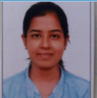 |  | LAKSHMI
 | | lakshmi-397734@gulfjobseeker.com
CAREER | Looking to obtain a position in a dynamic organization, bringing exceptional ability to
OBJECTIVE | handle multiple projectsand office with high professionalism.
EXPERIENCE |  | Oct 2019 - March 2020
 | Admin 1 policy service officer
 | Insurance policy operations dealt with insurance approval and cancelations.
 | Sutherland Global Services | Aug 2018 - Sep 2019
 | Customer Service Associate voice
 | Customer Service Associate for Mcafee Antivirus Software handling US, UK and
 | Australian calls.
EDUCATION | Sree Buddha College of Engineering ,Kerala University
 | Electrical Engineering
 | 70%
 | Dec - 2018
TECHNICAL | Operating System : Windows Applications : MS Office 97, 98, 2003, 2007, 2010 &
SKILLS | 2013. Word, Excel, Power Point. Technical : CAD
PROJECTS | Automatic Accident Alert System | 6 months
 | The proposed system deals with the accident alerting and detection. Arduino is the
 | heart of the system which helps in transferring the message to different devices in
 | the system. Vibration sensor will be activated when the accident occurs
 | and the information is transferred to the registered number through GSM module.
 | Using GPS the location can be sent through tracking system to cover the
 | geographical coordinates over the area. The accident can be detected by a vibration
 | sensor which is used as major module in the system.
ACHIEVEMENTS | Best Social Worker Award for the year 2017 from National Service Scheme behalf of
& AWARDS | Sree Buddha College of Engineering.
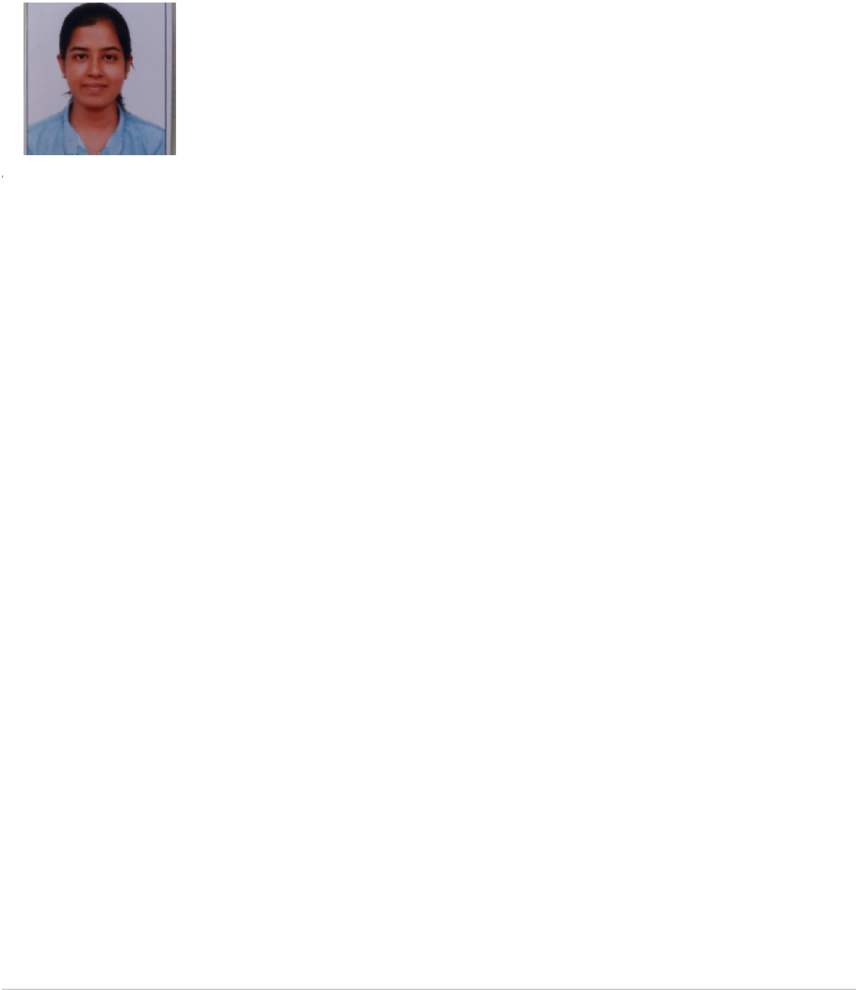

INDUSTRIAL EXPOSURE

KERALA STATE ELECTRICITY BOARD • Done internship of 3 months with Kerala State Electricity Board at 220KV substation Punnapra • Went through the detailed study of operations of transformers , generators ,Circuit Breakers etc

SABARIGIRI HYDRO POWER PROJECT • One of the major generating station in Kerala situated at Pathanamthita District. • Provides a major contribution of energy in Kerala for public distribution of energy. • Detaily gone through the study of hydro electric power plant operations.

Administration
^{INTERESTS} Office works and reception

Project Management

PERSONAL | Quick learner, Good Communication Skill,Ability to handle any situation,Team Builder
STRENGTHS | and Worker and Easily adaptive with new working conditions.
PERSONAL | Date of Birth | : 25 /02/1995
PROFILE | Marital Status | : Single
 | Nationality | : Indian
 | Known Languages | : English, Hindi, Tamil, Malayalam

DECLARATION | I hereby declare that all above mentioned details are true to the best of my
 | knowledge.

Date : 10.05.2020

Place : Dubai

LAKSHMI

