Afzal

Spearheading the entire Finance & Accounts Operations with focus on Investments, Logistics, Payroll, administration, Negotiation & Procurement, Internal Control and continuous system improvements; targeting assignments as a CFO / Financial Controller & Finance-Head, with an organization of High Repute

Afzal-397737@gulfjobseeker.com

Core Competencies

Finalization of Accounts

Accounts Payable & Receivable

Financial Analysis and Planning

Taxation (Direct / Indirect)

Audits (Internal / Statutory)

Budgeting, Job, Contract, Finished Goods and Semi-finished Goods Costing

Stakeholder Engagements (Business / Client)

A.T. Jain & Co.,

Mumbai as

Article

Managed Finance, Accounts, Commercial Operations and Project Management for companies in Renewable Energy Sector; expertise in executing the projects in the Renewable Energy Sector, right from tendering process, bank guarantee, technical and financial feasibility study, liaising, till

Spearheaded the structuring, consolidation & analysis of financial data using Advance MS Excel; developed budgets, forecasts & other financial reports for specific organizational sub-divisions, i.e., departments, regions & units Established cordial relationship with banking & finance institutions for fund & non-fund finance, project finance, finance restructuring, working capital, Letter of Credit, Bank Guarantee and import / export related matters Expertise in financial planning & analysis and costing that led to improvements in cost savings, profitability & productivity; prepared Feasibility Reports & financial projections of payback with debt & equity Managed the development of a range of financial and management reports for variance analysis & improvement strategies including Opex, Inventory MIS & Capex
Took control of all receivables, payable, stocks and assets (tangible and intangible); maintained vendor relations as well as timely and accurate processing of invoices, purchase orders, expense reports, credit memos and payment transactions in Tally & Inhouse software

2004 - 2007
Work Experience
Since Mar’20 Financial Manager, Dubai, UAE.

Apr’14 – Feb’20 Green Power Consortium Management Company Pvt. Ltd., Mumbai as CEO

Aug’04 – Apr’14 Tax Consultant then Practicing Chartered Accountant

Significant Achievements:

and around Mumbai, Maharashtra

Key Result Areas:

Spearheading overall accounting operations pertaining to accounting transactions, formulation/finalization of various accounts and statements like trial balance, profit & loss account, balance sheet and various reconciliation statements while ensuring compliance with accounting standards & IFRS
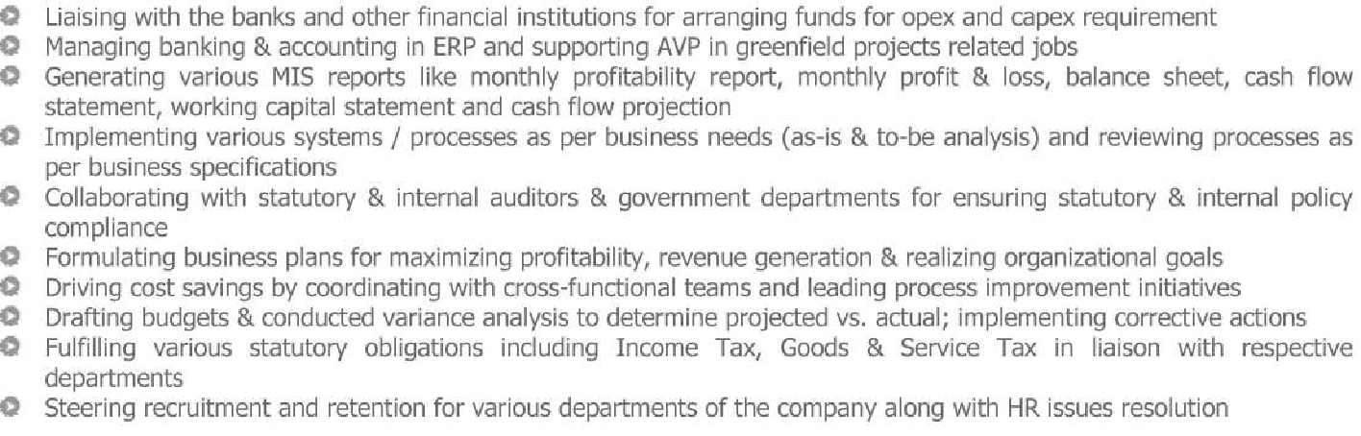

Articleship Experience

2004 - 2008 A.T. Jain & Co., Mumbai

Key Result Areas:
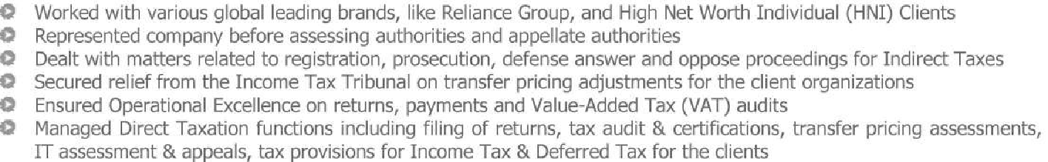

Co-ordinated with the top management of the client organization in formulating corporate strategies on re-structuring, amalgamation, demergers, and so on

Date of Birth: 28th August 1981 | Languages Known: English & Hindi

