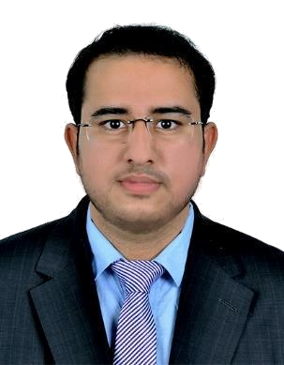

HITESH
Associate Chartered Accountant
Email: Hitesh-397738@gulfjobseeker.com

Objective: -
To be a part of an organization where I can grow in terms of knowledge, skills and attitude and put to an effective use my analytical abilities and professional competence in the areas of accounting & financing, auditing & strategic budgeting, so as to align self- development with organizational development.

Professional Experiences: -
Senior Accountant • (June 2017 – Present)
- Presides over account reconciliations; makes sure all supporting documents are in order, reviews all account entries then prepares a summary of recommendations.
- Leads and oversees the closing responsibilities of the accounting team; performance of all key tasks must be done within the prescribed time-frame.
- Periodically reviews all accounting guidelines, policies, and procedures; introduces amendments as necessary for the purpose of improving accuracy, risk control, and for timely reporting.
- Performs both internal and external audits; provides complete, comprehensive reporting to all company managers, officers, and directors.
- Prepares Financial Statements of the company; conducts comprehensive analysis including recommendations for streamlining costs and funding revenue generating programs.
- Collaborated with the IT department during the implementation of change management policies.

- Preparing client deliverables, building relationships with the client staff and acting as ambassador for the Firm.

VAT Compliance:-
• Verifying documentation and computation of tax obligation.
• Investigating potential miscalculation or deliberate fraud.
• Reviewing balance sheets accounting records and profit & loss statements.
• Ensuring constantly evolving tax laws are adhered to at all times.
• Filling of periodic returns under UAE VAT regime as well as preparation of Vat compliance reports.

Associate • BSR & Associates (KPMG), Chartered Accountants (Oct-2012 – Oct-2015)
- Carrying out external audit and other assurance services to clients in multiple industries.
- Obtaining all necessary audit working papers and documentation including researching and documenting facts and findings.
- Identifying and communicating accounting and auditing matters.
- Interacting with clients to help ensure that the information flow from the client to the audit team is efficient.
- Analyzing and evaluating the accuracy of accounting systems and procedures.
- Applying IFRS and ISA framework consistently in complex and challenging situation.

Education:
- Chartered Accountancy (ICAI) in May 2017 with distinction marks in 5 papers.
- Company Secretary in May, 2016.(62.36%)
- Master in commerce (MLSU, Udaipur) in May, 2017.(57.65%)
- Bachelor in commerce (MLSU, Udaipur) in May, 2014.(77.67%)
- Senior secondary (RBSC) in May, 2011.(82.48%)
- Secondary (RBSC) in May, 2009.(87.67%)

Achievements & Certifications:

- Best presentation award on “Artificial Intelligence” conducted at ITT training, Pali branch.

- Pursued “DIP IFRS” Course accredited by ACCA.

- Best essay reporting on water conservation conducted at SIRT, Udaipur.

- Silver medal at Commerce Olympiad, 2010 conducted at Udaipur.

- Successfully conducted ICAI’s AMCS, GMCS etc. & ICSI’s trainings.

Core Competencies:

- Audits & financial reporting

- Tax accounting & compliance

- Compliance with accounting standards

- Technologically adaptable (software like tally, Peachtree, KFRS, Genius, case ware etc.)

- Team work, responsible, adaptable, good written communication, quick learner, self-motivational, responsible.

Personal Profile  Nationality | : Indian
Date of Birth | : 13/09/1993
Marital status | : Single
Languages known | : English & Hindi
Reference | : Will be readily furnished upon request.

Appreciation Food: -Always believe in learning, irrespective of concerned peer’s position.

