CURRICULAM VIATE
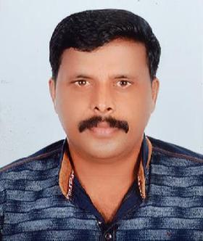

SAJITH
E-mail: sajith-397755@gulfjobseeker.com

POST APPLIED FOR: FORK LIFT OPERATOR

OBJECTIVES:

To work in a growth oriented organization, where I can enhance my knowledge base.

EDUCATIONAL QUALIFICATION

S.S.L.C. (Passed 1999)

EXPERIENCE:-

16 Years Experience in mechanic & operator.

PREVIOUS EMPLOYMENT:-

- Worked with M/S BEL Engineering Limited, Ernakulum in INDIA for year 2000 to 2005 as a ‘MECHANIC’ we have working in all India states.
  - Worked with M/S Falcon Technologies International L.L.C in U.A.E in ‘FORKLIFT OPERATOR’ From 26-03-2005 to 28-10-2009

PREVIOUS EMPLOYMENT:-

Worked With M/S S K M AIR CONDITIONING L.L.C In U.A.E. In ‘FORKLIFT OPERATOR’ From 23-01-2010 to 07-05-2017

COMPANY PRFILE:-

A Largest Manufacturer Of Optical Storage Media In The World.

JOB PROFILE:-

Working as a ‘FORKLIFT OPERATOR’ in warehouse department.

PROFILE:-

- Good Team Co-coordinator. Ability to work under pressure.

- Flexible, Open minded , Sincere and Trustworthy

PERSONAL DETAILS:-
➢ Date of Birth | : | 20-05-1983
➢ Marital Status | : | Married
➢ Languages Known | : | Malayalam, Hindi, English,
➢ Nationality | : | Indian

PASSPORT DETAILS:-
➢ Date of Issue | : | 22-01-2013
➢ Date of Expiry | : | 21-01-2023
➢ Place of Issue | : | Dubai

DECLARATION:

- I hereby certify that the above mentioned Statement is correct & true to the best of my knowledge & belief.

SAJITH

