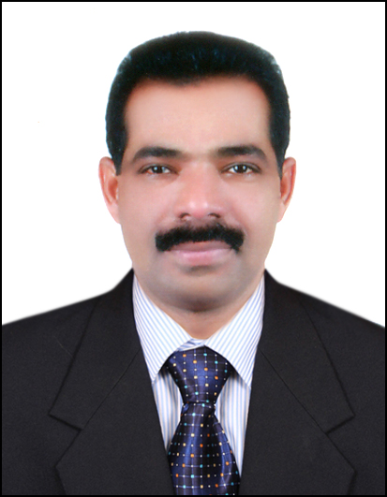

JEEJO

Jeejo-397758@gulfjobseeker.com

Seeking Position As:

EXECUTIVE CHEF/EXECUTIVE SOUS CHEF

Career Objective

To be a part of an Organization which offers a challenging, yet friendly atmosphere, appreciation of initiative and drive, encouragement to work independently, an opportunity to utilize skills attained through past experiences and scope for growth.

Experience
Over 24 years of experience in Gulf countries and India as chef in hospitality industry.
Very good knowledge in Continental, Arabic, Asian and International dishes

Professional Qualification

Diploma in cookery from Food Craft Institute, Kalamassery, Kerala, India. 1990

Bachelor Program In Business Administration (BPBA) Hotel management and Hospitality management from ISME, Cochin, Kerala, India- 2012

Strength
Self-starter, creative, honest, sincere and hard working.
Excellent pre-opening experience

Present job

Working as Executive Sous Chef (4*deluxe,pre-opening) Al Ain, UAE
From April-2014 (Head of the kitchen department, Hotel)
Responsibilities

- Maintain the highest possible hygiene and maintainstandards in the kitchen.

- Achieve the highest degree in applied hygiene and food saftey as per the ADFCA guidelines to ensure that the food served to the guest is of highest quality and standard.

- Report directly to the Hotel manager and Cluster Executive Chef in the daily operation and take full responsibilities of the kitchen department of the hotel, in order to ensure a smooth operation.

- Ensure food perpared is according to high quality as per hotel standard, menu planning and maintaining food cost

- Organise the kitchen according to the plan deviced by the Cluster Executive Chef, in order to ensure smooth operation.

- Practice economy of inventory items to ensure sufficeint supplies and minimize cost by avoiding wastage and spoilages.

- Operate in a safe and environmentally friendly way to protect guests and and employees health and safety, as well as protect and conserve the environment.

- Comply with the hotel environmental, health and safety policies and procedures

- Staff recruitment according to the required positions by suitable candidates

- Train, supervise, counsel and discipline Culinary associates for the efficient operation of the kitchen

- Organize and conduct pre-shift and departmental meetings communicating pertinent information to the staff, such as house count and menu changes.

- Control food, payroll and equipment costs (minimizing loss and misuse). Ensure par stock levels are maintained. Evaluate cost effectiveness of all aspects of kitchen operation. Develop and implement cost saving and profit enhancing measures, review, prepare and update forecasts as needed

Employment Data

March 2010 to March 2014:Senior sous chef, (Head of the kitchen department)
CitymaxHotels, Al Barsha, Dubai, UAE , from pre-opening( 3* hotel with 376 rooms, 2 bars, All day dining restaurant, coffee shop and room service )

November 2009 to March 2010;SajEarth Resort. Nedumbassery,Cochin, Kerala

( 3* Resort,located near Cochin International Airport with 60 villas , multi cuisine restaurant, all day dining buffet restaurant and 500 seated banquet hall
Position; Sous Chef

May, 2008 to August 2009 : Kuwait towers (TEC ) , Kuwait

[It’s a land mark of Kuwait which has 2 multi cuisine restaurants and a revolving coffee lounge with a full view over Kuwait city.]
Position; Senior Chef De Partie

June 2004 – May 2008 Al Qasr, MadinatJumeirah 5* Dubai, UAE

(Highly prestigious 5*deluxe resort (Jumeirah group) in Dubai, having 4 units like Mina Salam, Dar Al Masyaf, Al Qasr and C&I (Conference and Incentives)

Position: Chef de partie (pre-opening)

June 2000-May 2004 Hilton International 5*, Al Ain, UAE
(202 rooms and chalets, 14 outlets serving variety of foods and drinks)

Position: Commis II (June 2000-May 2002)
Final Position:Commis I(june2002-May 2004)

Dec 1993to June 2000 Abu Dhabi National Hotels, Abu Dhabi, UAE
Position: Commis II

Oct 1992-Sept-1993 Al Mana General Hospital, Saudi Arabia

Position: General Cook

April 1992-Sept-1992 The Kamatz Plaza, Mumbai, India
Position: Continental Cook

Training
2014- Food handlers certificate from ADFCA

2012 - PIC Level 3 certificate in Supervising Food Safety in Catering (Dubai)

2011 - Essential Food Safety Training Certificate from Dubai Food Control
Authority

2010 - Basic Food Hygiene Training Certificate conducted by Dubai municipality

2002 - Cross Exposure in Dubai Hilton’s Kitchen for 10 days

1992– One and half year on the job training certificate from KTDC, Kerala, India as cook trainee

Additional Qualifications

Valid Driving License from U.A.E.

Education

1986 – S.S.L.C from Govt. High School, Puliyanam, Ernakulam, Kerala, India.

1988 - Pre Degree (+2)from S.S.C. College,Kalady, Kerala, India.

1990 – Diploma incookery fromFood Craft Institute, Kalamassery,
Kerala, India
2012- Bachelor Program in Business Administration (BPBA) Hotel management and
Hospitality managementfrom ISME Cochin, Kerala, India
2009- IELTS with the score of 5.5 in general

Personal Data

Date of birth : 13thDecember 1969
Nationality : Indian.
Sex : Male.
Marital status : Married.
Appearance : Height: 171 cm
Weight: 72 kg.
Hobbies : listening music, watching movies, spend time with family
Languages known : English, Hindi & Malayalam.

JEEJO

