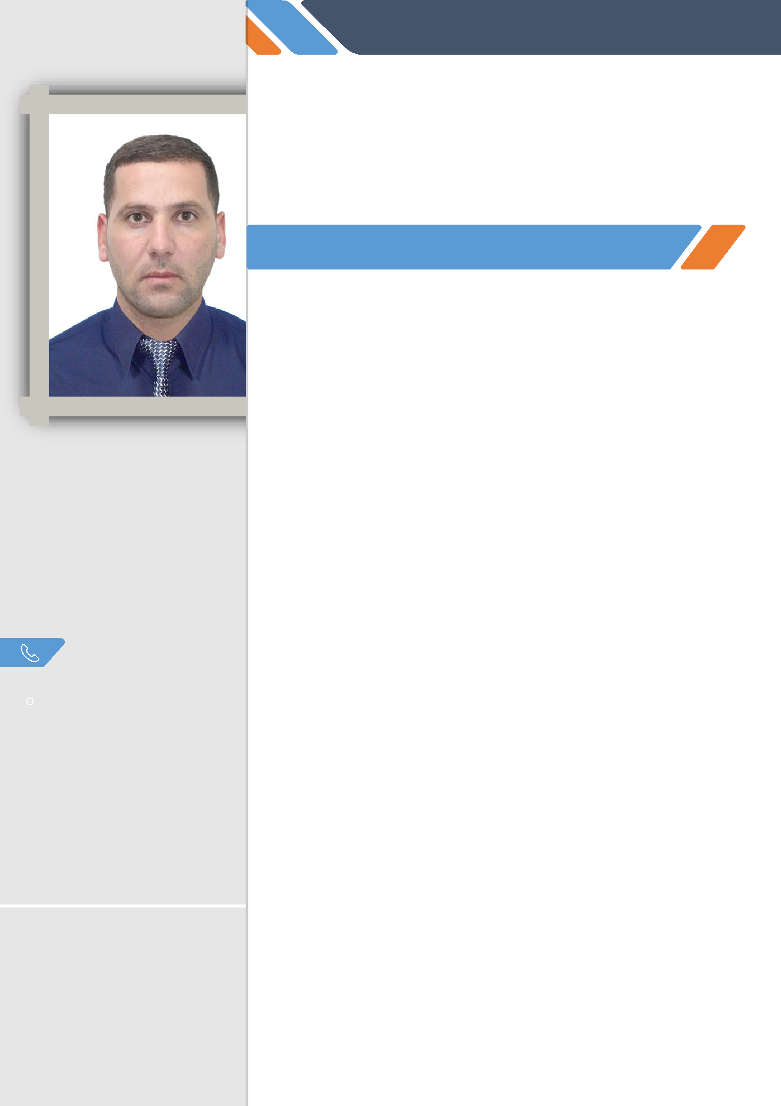
Mourad

*MONITOR, TRANSLATOR CUM NEWS EDITOR *FRENCH TEACHER

EXPERIENCES

CONTACT

mourad-397760@guljobseeker.com

Old airport/ Doha/Qatar

Nationality : Algerian

Date of birth : 10/07/1989

Marital status: Single

Visa status: resident

COMPUTER
_{WORD} ⬇⬇⬇⬇⬇

EXCEL ⬇⬇⬇⬇⬇
POWERPOINT ⬇⬇⬇⬇⬇
ACCES ⬇⬇⬇⬇⬇
PHOTOSHOP ⬇⬇⬇⬇⬇

- MONITOR/TRANSLATOR CUM NEWS EDITOR

2018/2020

- Editing stories headlines and subheads based on daily news aired on local and

international TV channels, radio and all kind of media.

- Creating and translating political, economic and social reports. (English, French to Arabic)

- Find the right translations for the specialty expressions and how to find equivalence in Arabic language

- Developing comprehensive media monitoring report to be completed sharply on time.

- Prioritizing articles by importance, and organizing reports.

- Selecting relevant keyword search topics and writing reports to reflect the media orientation

- contribute in the edition of our daily journal

- FRENCH TUTOR AT SHEAKSPER LANGUAGE INSTITUTE 2019.

DOHA/QATAR.

- ensure individual classes to VIP students (high sovereignty)

- lead different private classes for kids 07-14 years old

- find our student needs and choose the adequate contents to teach

- Put our learners in different situation oF communication to learn the right vocabulary according to the situation.

- FRENCH TUTOR AT BROTHERS BOUKHLIL SECONDARY SCHOOL

2016/2018 ALGIERS/ALGERIA

- Managing classes and grape student's attention

- identify student's needs and implement the right methods to satisfy its

- ensure the good choice of didactic support and learning method

Fieldworks ⬇⬇⬇⬇⬇
    

LANGUAGES

Arabic: Mother tongue

English: advanced level

French: advanced level
- Italian: beginner

  - respect the gender, the student's interests before choosing the topics

  - preparing different types of activities depending of the level of knowledge on the language

  - Developing individual skills, disseminating the group's language skills and knowledge and sharing experience with others

  - participate in the meeting with colleagues to study progress and how to respect the right steps to reach the goals-objectives

- FRENCH/ENGLISH/ ARABIC LIBERAL TRANSLATOR AT CHERAGA TRANSLATION OFFICE ALGIERS/ALGERIA 2015-2018

- Select documents and ensure its authenticity to make sure that the certificates

are not fraudulent.

- coordinate with different universities around Algiers and the rest of the country to verify that informations are correct

- translate from English to Arabic and vice versa

- Translate from French to Arabic and vice versa

- Translate from French to English and vice versa

- Coordinate with the ministry of foreign affairs for the authenticity of our translation

- helping our clients and make tasks relative to the authentication in the ministry of foreign affairs easier
- ARABIC TEACHER AT NEW GENERATION SCHOOL 2013-2015

ALGIERS/ALGERIA.

- ensure arabic classes for the preparatory and secondary phases
- coordinate with all tutors to discuss the advancement of programs

EDUCATION

- Certificate of equation for master2 in French language 2017 at the ministry of education/Algeria

- Master1 in French language specialization didactic 2017 at Algiers university.

- Master’s degree in media science and communication specialized in public studies at Algiers university 3

- Bachelor’s degree in French literature 2015 at Algiers university2

- Bachelor’s degree in media science and communication

specialized in public relations 2012 at ferhat abbes university setif-

algeria

SKILLS

- Good communication skills

- Taste of human contacts, sense of diplomacy.

- Patient and quick problem resolution

- Initiative, organized, rigorous

- Curious (Finding information and enriching my knowledge)

- Dynamic, enthusiastic, optimistic.

- Appreciate team work

