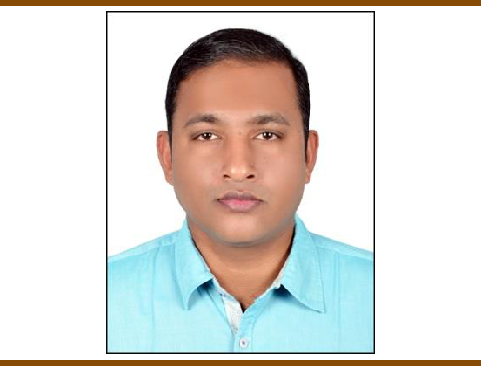

RAJEESH

MULTI-TALENTED WITH 16-YEARS EXPERIENCE

PROFILE

I have an experience of more than 15 years in various sectors including E-commerce, Technology start-ups, Art Industry & non - government organizations. My strength lies in core office operations, extensive logistic management, events planning, administration and banking. I have continuously strived to improve the functionality of my workplace by developing and implementing new systems for better productivity. I am looking to utilize my skill set to the maximum.

CONTACT

Rajeesh-397782@gulfjobseeker.com

EXPERIENCE

OPERATIONS MANAGER
FEBRUARY 2017-JANUARY 2020

The company is in to Furniture Manufacturing and Interior Designing. I was handling a multi- tasking role includes Operations, Administration, Warehouse management & Logistics. Manages schedules, organizes office functions, and oversees daily operations of office/factory with more than 50 employees.

OPERATIONS MANAGER, CRAYON CAPITAL, NEW DELHI, INDIA OCTOBER 2007-JANUARY 2017

This company was active in to Art Advisory Services and Asset Management Services. This was a very challenging and exciting position for me. I was handling a multi-tasking role including Administration-HR, Operations, Finance & Logistics and I was directly reporting to the directors.

Design Deal India Pvt. Ltd. (An ecommerce portal focused on design.) This company was part of Crayon Capital, and I had played an important role in this firm since the inception of this company.

ADMINISTRATION EXECUTIVE, JONSON RUBBER INDUSTRIES, NEW DELHI, INDIA

MARCH 2007-SEPTEMBER 2007

This company was in to manufacturing of conveyor belts. I was handling Administration as well Export Documentation in this firm.

ADMINISTRATION EXECUTIVE, TRIGGER FURNISHINGS PVT LTD, NEW DELHI, INDIA
FEBRUARY 2006-MARCH 2007

This company was an export house and manufacturer of Home Furnishing Items. I had worked here as an administration executive.

OFFICE EXECUTIVE, PIONEER BUYING HOUSE, NEW DELHI, INDIA MARCH 2004-JANUARY 2006

This company was a buying house working between the manufacturer and international buyer. I was working here as an Office Executive.

ACTIVITIES AND INTERESTS | EDUCATION
 | DIPLOMA IN ELECTRONICS & COMPUTER HARDWARE
Travelling •Art • Music •
 | ITCESI, KERALA
 | JUNE 2002

RAJEESH | HIGHER SECONDARY
 | KERALA EDUCATIONAL BOARD, KERALA

KEY SKILLS AND CHARECTERISTICS:

- Effective communication and leadership skills with strong analytical, problem solving abilities.

- Good knowledge in computers.

- Highly achievement oriented with an ability to develop effective strategies.

- An ability to take up challenges and consider each problem as an opportunity.

- Keen and quick learner, constantly making an effort to enhance skills. Provide timely report and meeting deadlines.

- Excellent knowledge in MS office and other applications

LANGUAGE PROFICIENCY

English

Hindi

Malayalam

KEY EVENTS CO-ORDINATED

- India Art Fair: 2013-2020, NSIC Okhla, New Delhi: Played important role in India Art Fair in setting up of the entire booth for the last many years.

- ADDS Mumbai 2019: Played an important role in setting up of the booth.

- India Design: 2019 – NSIC Okhla, New Delhi: Played an important role in setting up of the booth.

- Managed more than 20 art shows/exhibitions: Managed and helped in entire set up for quite few art shows & art exhibitions.

- Pop up shops: Managed two pop up shops for Design Deal in Delhi and Gurgaon.

- Handled important role in installation of an artwork by Subodh Gupta(Sculpture named Line of Control) in Kiran Nadar Museum of Art in Saket, New Delhi.

CORE AREAS OF SPECIALISATION

- Key roles in start-up firms: Managed important roles in setting up of Design Deal India Pvt. Ltd (an e commerce portal) and Cinema Capital Venture Fund (a venture fund focused on film industry). Managed to set up the infrastructure, negotiations with vendors, new recruitments, effective budget management, etc. Helped in funding of 170 crores in Cinema Capital Venture Fund.

- Important role in Art Funds: Managed Crayon Capital Art Fund (an art fund based in Indian Art) for more than 7 years. Managed about 500 investors, their payouts, client queries, etc. Also helped in the management of CC Art Limited (an offshore art fund).

- Operations: Daily office operations, Budget Management, Payroll management, management of art shows and functions, travel arrangements, etc.

- Co-ordination with Auction Houses: Complete co-ordination with auctions houses from selection of the artwork till the sale of the artwork. Majorly coordinated with auction houses like Saffron Art,

Christie’s and Sotheby’s.

- E Commerce Operations: Important role played in setting up of Design Deal India Pvt. Ltd. (Designdeal.com – an online portal based on design). Warehouse management, logistics handling, HR, administration etc, helped in complete set up.

- Finance & Banking: Management of Salaries of staff, vendor payments, purchase and sales payments, utility payments, budget management of the company, etc.

