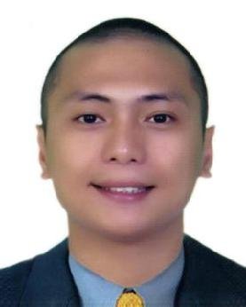
JEFFREY

Jeffrey-397786@gulfjobseeker.com

Dubai UAE

- CAREER OBJECTIVE

To procure a competent career which best fits my skills and profession intact with proper values and attitude towards a productive and efficient work.

- QUALIFICATIONS
  - Professional Driver

  - Computer proficient

  - Well-rounded person

  - Willing to learn and undergo training

  - Dedicated and hardworking

  - Excellent team work

- EDUCATIONAL ATTAINMENT
  - 2 Year Diploma in Computer Studies

Informatics Computer Institute (Fairview) Philippines

  - Bachelor of Science in Information Technology System Technology Institute (Fairview) Philippines

- WORK EXPERIENCE

Lead 3D Designer

(August 2019 – Present)

Dubai, United Arab Emirates

- 3D Interior/Exterior/Event Designing

- 3D Rendering

- 3D Walk Through

- AutoCAD

- Technical Drawing

3D Designer

(June 2018 – August 2019)

Courtyard Wedding & Events Services / The White Boutique 127 Umm Al Sheif St. Dubai, United Arab Emirates

- 3D Interior/Exterior/Event Designing

- 3D Rendering

- 3D Walk Through

- AutoCAD

- Technical Drawing

3D Designer

(November 2017 – May 2018)

Ray Interior Decorations LLC

409 Pinnacle Building, P.O. Box 487602

Al Barsha Dubai, United Arab Emirates

- 3D Interior/Exterior Designing

- 3D Rendering

- 3D Walk Through

- AutoCAD

- Technical Drawing

3D Designer / Photographer / Videographer / Video Editor

(February 2015 – November 2017)

Rio Hospitality

611 Gold Crest Executive Tower, P.O. Box 282963

Jumeirah Lake Tower Dubai, United Arab Emirates

- 3D Interior Designing

- 3D Rendering

- 3D Walk Through

- AutoCAD

- Technical Drawing

- Photo / Video Shooting

- Photo / Video Editing

3D Designer / Post Production Assistant / Offline Video Editor

(September 2013 – January 2015)

ABC Development Corporation

Novaliches, Philippines

  - Assisting master editor

  - Rough editing

  - Video editing

  - 3D Designing

  - 3D Rendering

  - 3D Walk Through

- PERSONAL DATA

Age | : | 31 years old
Civil Status | : | Married
Sex | : | Male
Height | : | 5’6
Weight | : | 130 lbs
Birth Date | : | June 5, 1988
Birth Place | : | Manila
Religion | : | Roman Catholic
Languages Spoken | : | English & Tagalog

