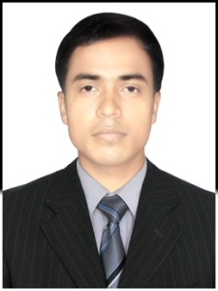
RESUME

MD IBRAHIM
E-mail ID: Ibrahim-397813@gulfjobseeker.com
Visa Status: Employment Visa/Immediate Join

CAREER OBJECTIVE

Intend to build a career with leading corporate of hi-tech environment with committed & dedicated people which help me to explore myself carefully & realize my potential willing to work as a key player in challenging & creative environment.

EDUCATION PROFILE

COURSES | INSTITUTE/SCHOOL | UNIVERSITY/  BOARD | YEAR OF PASSING | % of Marks/CGPA
Matriculation | Gujidarada High School,Gujidarada | B S E, Odisha | 2007 | 48.26
I.T.I | Royal I.T.C Charampa, Bhadrak. | S.C.T.E & V.T | 2009 | 84.85
+2 (Arts) | Salandi Mahabidyalaya,  Uttarbahini | C.H.S.E, Odisha | 2010 | 48.33
PGDCA | I.T.C Charampa computer, Bhadrak | SCOPE | 2011 | 69.21
+3 (Arts) | Brahmabarada Mahabidyalaya, Brahmabarada | Utkal University | 2013 | 52.64

EXPERIENCE

  - 2 Years’ Experience in maintaining in ANUS Chemical Industrial, Hyderabad.
  - 2 Years’ Experience in Fork-lift operation KD Group of Industries, India.
  - 3 Years’ Experience in Fork-lift operation in DNATA CARGO DXB/DWC.

EXPEIENCE
STRNGTH

- Leadership quality
- Cool in nature
- Never feel out of race at any stage
- Good motivator for myself & others.

PERSONAL DETAILS

- Date of Birth : 11thMay 1992
- Nationality : Indian
- Marital Status : Single
- Gender : Male
- License No : Fork-lift light vehicle no:7
- Languages Known : English, Odia& Urdu.

DECLARATION

I solemnly declare that all the information furnished above mentioned is true to the best of my knowledge and belief.

Date:

Place: (Signature of the Applicant)

