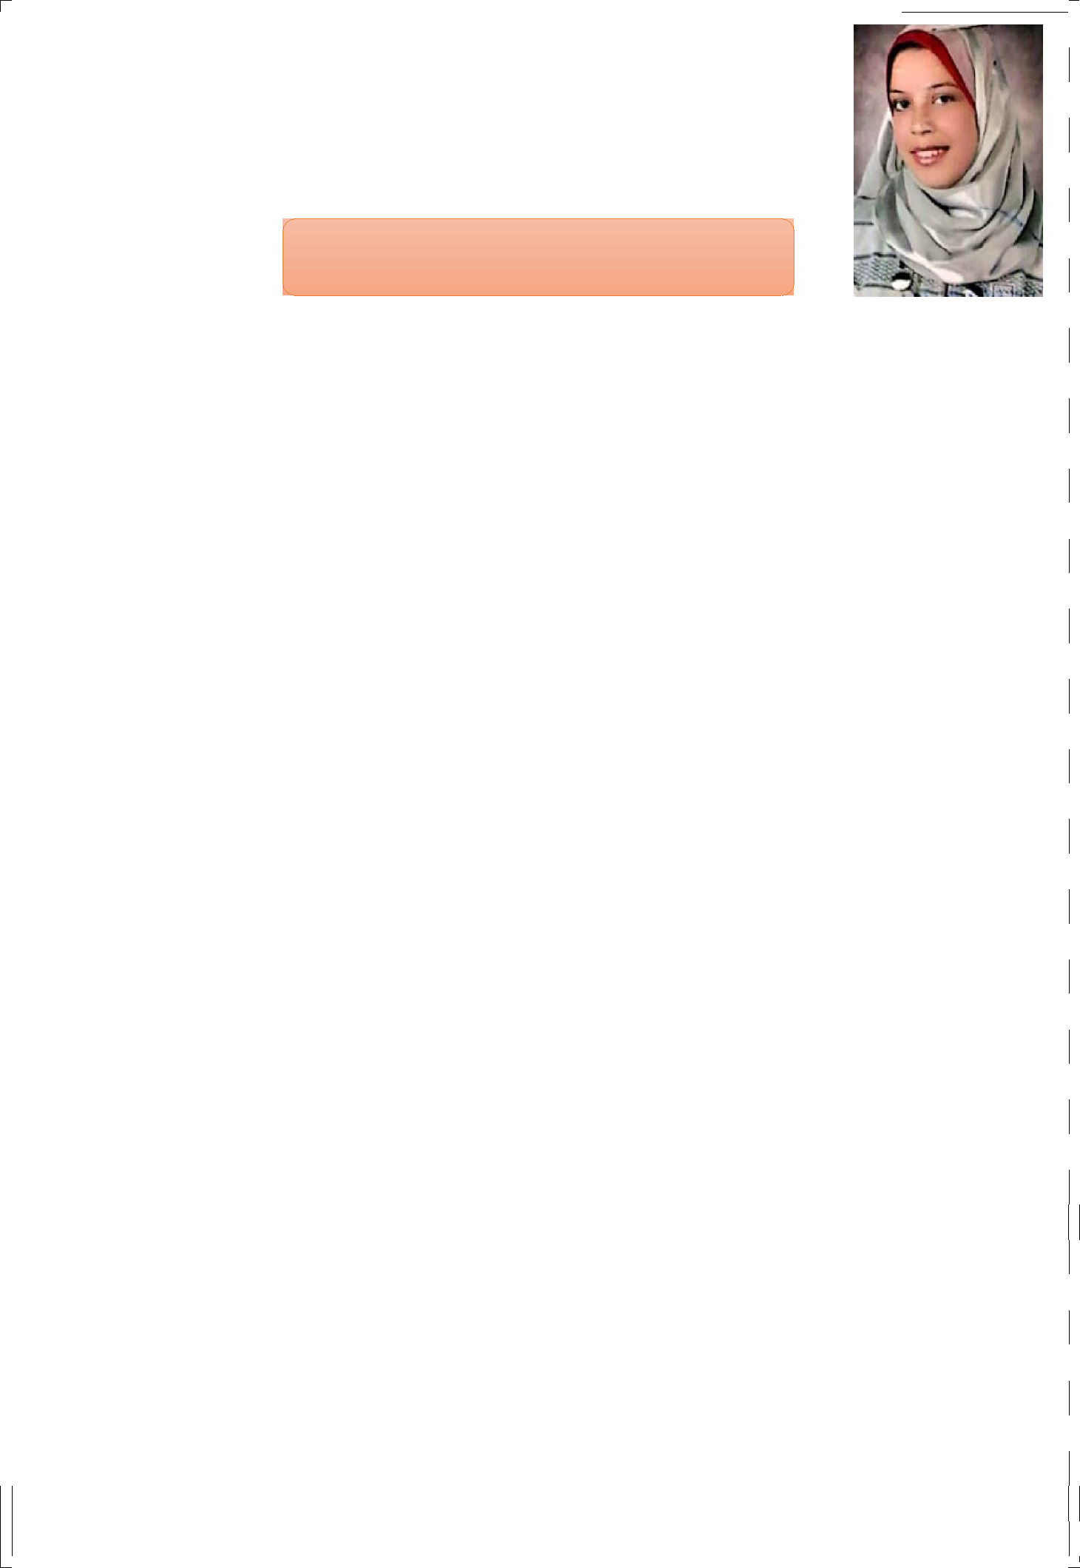
Curriculum Vitae

Rakia
Personal Information

- Email address: rakia-397820@gulfjobseeker.com

Date of birth: 25 / 10 / 1992.

Nationality: Egyptian.

Gender: Female.

Marital Status: single.

Employment and relevant work-related experience

 | Contract
 | Type |  |  |  | Date | Date
 | (Full, Part
Job(s) title |  | Organization | City | Country
 | time or |  |  |  | From | To
 | hourly
 | paid)

Teacher of | Full time |  | Egypt | 8/25/2019 Till now
American Social |  |  | Alexandria
Studies (Grades 4
& 5 )
English Language | Hourly | I Can Read | Egypt | 8/25/2018
instructor in an |  | Academy | Alexandria | 8/20/2019
academic center
(Young learners )
Main Teacher of | Full time | Al Rahman | Alexandria Egypt | 15/10/2015 _{6/25/2019}
English |  | Languages
Language ( Grades |  | School
1,2&3)
MacMillan
Curriculum
Trainee | Full time | Amina | Egypt | 10/3/ 2013 4/25/2015
Kindergarten Stage |  | Elsaeed | Alexandria
 |  | Experimental
 |  | School
MacMillan
Curriculum

Education/qualifications
Qualifications / Grade | Awarding body / Institution – Date
Bachelor degree in | Alexandria University - 2015
Education and Childhood.
( Very good ) ( B+)
ICDL certificate | Alexandria University - 2015
Diploma level TEFL qualification | Notting Hill College –Alexandria -
(adults and Young Learners). ( | 2017
Excellent ) ( A-)
Diploma level in Phonetics and | Notting Hill College –Alexandria -
Phonology. ( A) | 2020

Personal Skills

1-Professional at Microsoft Office programs.

2-profession at teaching English Language and Social Studies.

3-Time management and adaptability.

4-Organisation and flexibility.

5-Solving problems skills.

6-Ability to deal with young learner's problems and challenges.

7-Ability to work in a team and share ideas.

8-Using learning applications like: Kahoot and quizlet.

9-Preparing my lesson using Kagan Structures.

10-Gamafication is a must in my lessons.

11-Ability to work under pressure.

12-Abilit to finish tasks perfectly.

13-Experienced in American Schools Curricula.

14-Experienced in teaching depending on E-learning.

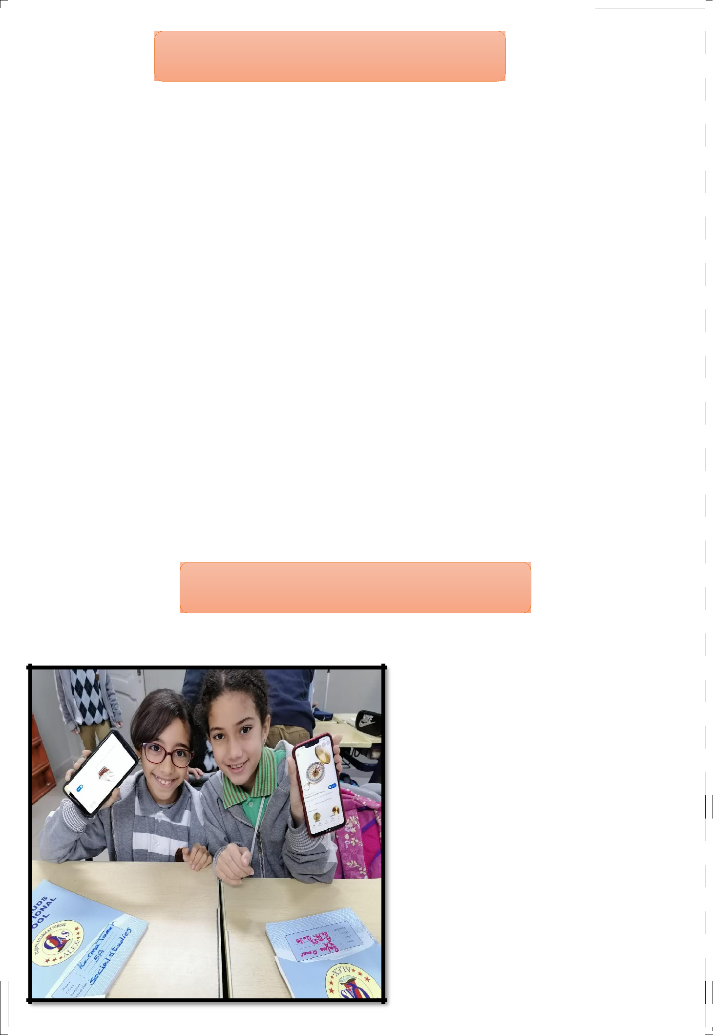
My teaching aims and goals

I do believe that children learn in different ways and to support this, I provide a rich and varied learning environment to allow all learners to develop their skills and abilities to their full potential.

Through my teaching, I aim to help each learner become:

1-A cooperative person who can form positive relationship.

2-A whole person who responding to challenges, motivated and independent.

I also give them opportunities to develop in different ways .These include:

1-Investigation

2-Paired work and Group work.

3-Using ICT across the curriculum.

4-Debates, role play and oral presentation of work.

5-Learning outside the classroom.

6-Physical and kinesthetic learning.

Real pictures at work

The students are using their cell phones as a pair work to finish a given task during the lesson.

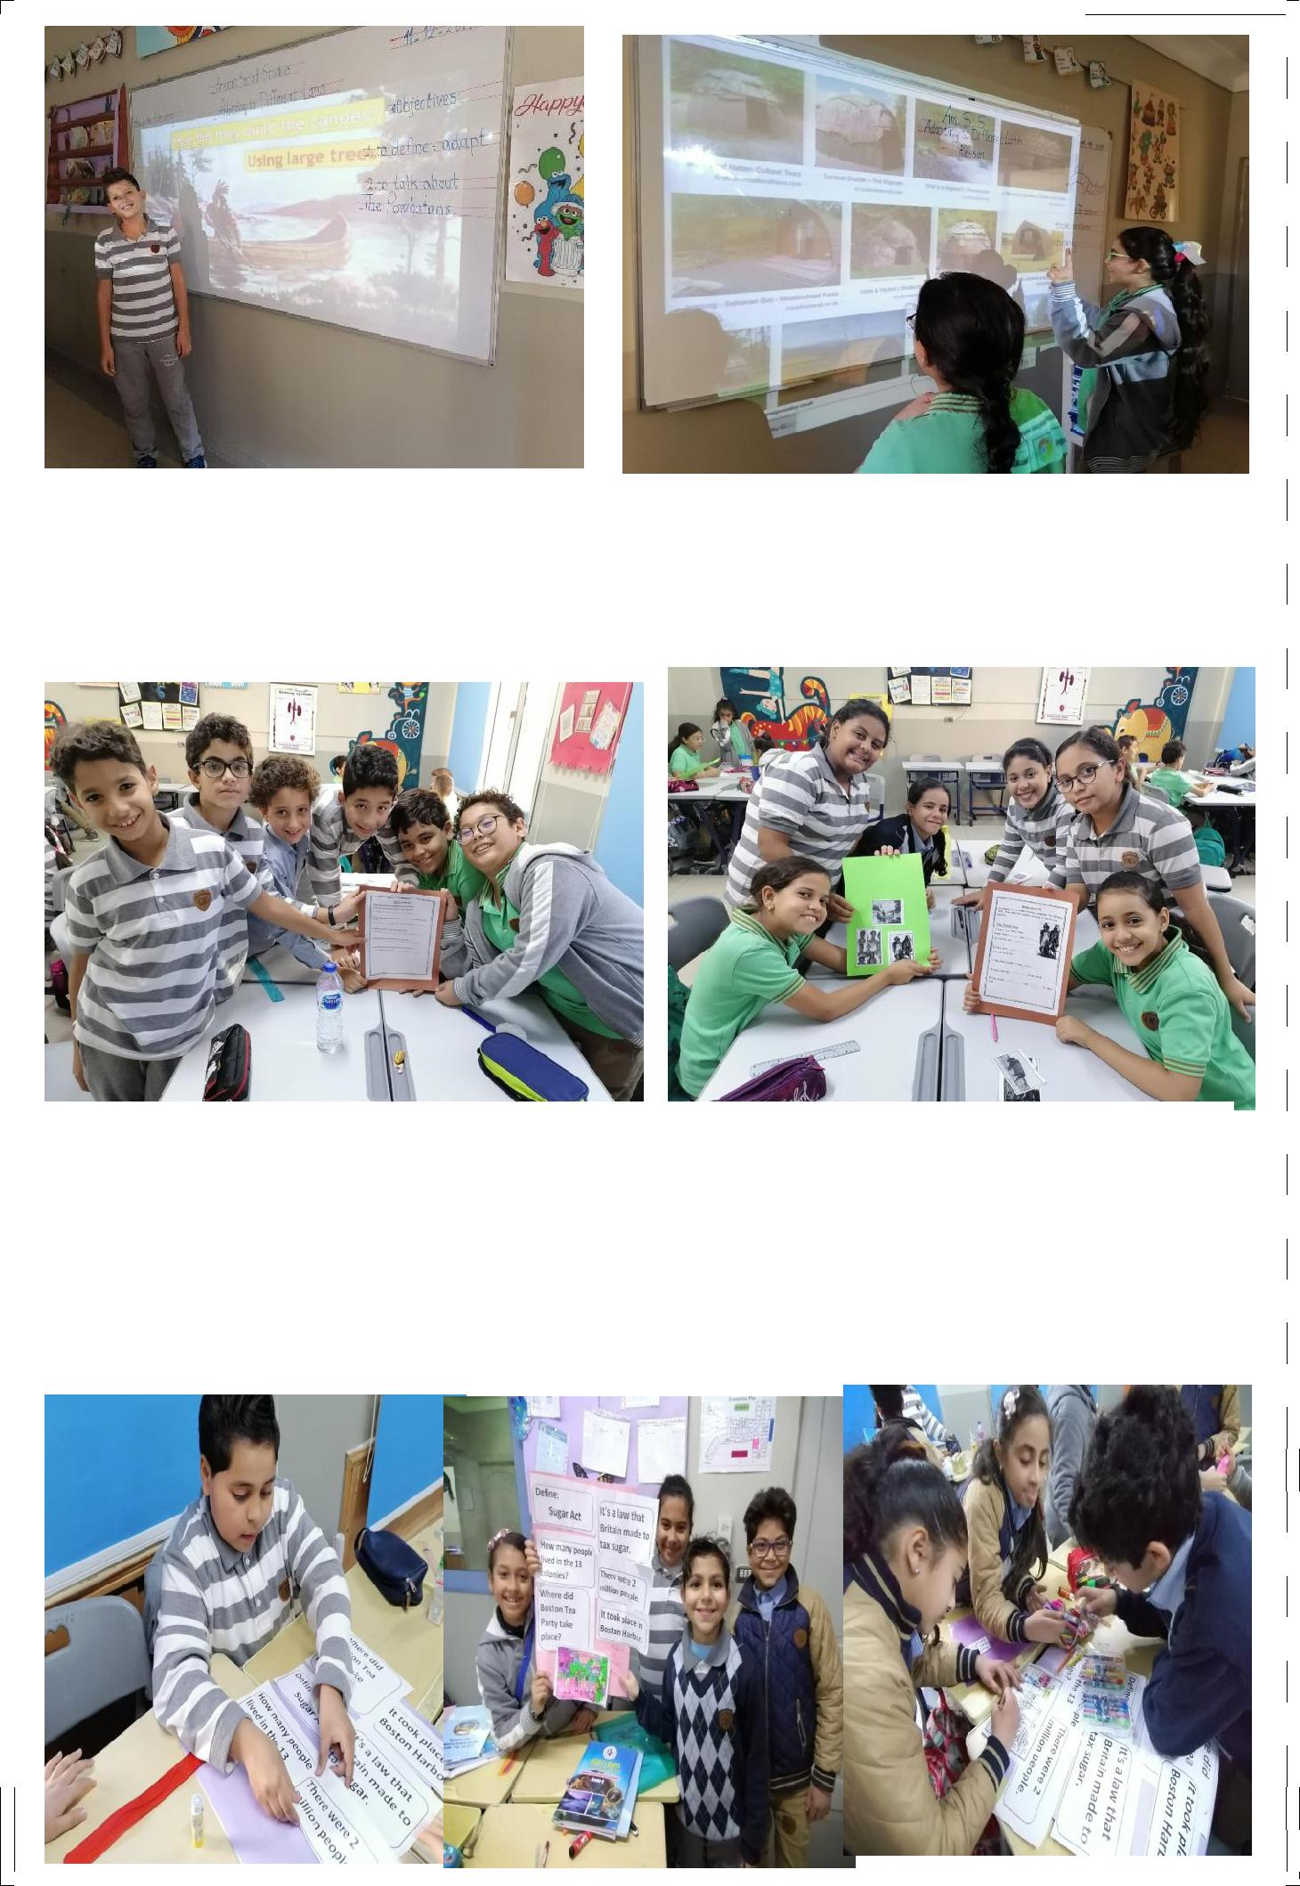

The students are presenting, explaining and discussing and my role is to guide, mentor and correct their mistakes.

Group work is an outstanding way to learn as the students explain to each other and my role here is give them enough instructions and encourage them, I also prepare each lesson as a bunch of different tasks: Worksheets , building models , making charts etc.

I am a promoter, organizer and controller in the classroom.

Notes

All the original copies, models of worksheets, videos or demos and other samples of lesson plans are ready to be sent whenever be needed.

