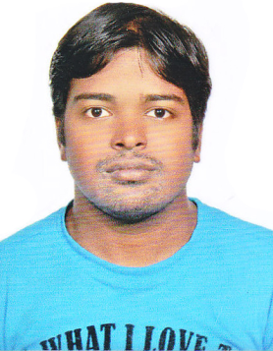
CURRICULUM VITAE

Rajkannan
E- Mail: rajkannan-397823@gulfjobseeker.com

Educational Qualification : +2 and ITI -electrical and electronics.

Working : Fire alarm system in simplex

system operator and fault rectification, PPM works.

Experience : 10 years in SIBCA (Fire Alarm system)

Worked at : Etihad towers
Central market
ADCO
Sun & sky tower
Galleria mall
Gate towers
Grand millennium alwahda
Adma, Adnoc.
Cleveland clinic
Abudhabi all school and hospitals and many more.

Grade : Advanced and senior technician

PERSONAL DETAILS

Date of Birth : 21.07.1986

Gender : Male

Marital Status : Married

Nationality : Indian

Languages Known : English, Tamil, Hindi, Malayalam and Teluge.

Strength

- Adaptive to new environment
- Effective Leadership Quality
- Excellent problem solving skills and a self-starter
- Takes initiative and works independently or as part of a group

Field of interest

- Electrical Maintenance, Instrumentation
- Industrial Automation
- Fire alarm maintenance
License
- Valid Uae driving license

DECLARATION

I hereby declare that the above-mentioned information is correct up to my knowledge and I bear the responsibility for the correctness of the above-mentioned particulars.

Place: Abu dhabi Thanking You
Date: RajKannan

