CURRICULUM VITAE
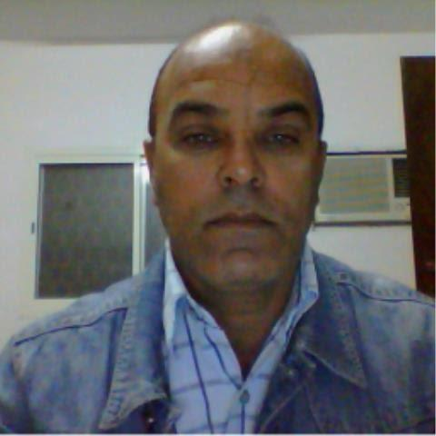
Name:- Nader
Email:- nader-397847@gulfjobseeker.com

Career Objective:

To gain career opportunity in respectful organization, to afford responsible income level, increase my experience growth, and a self-motivated person is seeking to find the kind of career where the challenging spirit of her, would find the suitable racecourse where I can develop my skills, where I can find my work appreciated in the proper way and where I can have real chances of promotions.
Personal Information:
Religion : Islam
Sex : Male
Marital Status : Married
Nationality : Egyptian
Education:

Graduation from the Alexandria Technical Industrial Institute as (Automobile Mechanical Diploma), Alexandria-1985, after secondary school.

Driving License:
Valid ARE, UAE, and KSA Driving License.

Work Experience:
- Jul. 2018 till now working as Transportation O & M Supervisor responsible for inspects all of mechanical works for different type of vehicle & equipment and report of all documentary process to the head office and as purchasing Supervisor to do all process of purchasing from PR to PO. Calculation of payment for the mechanical works costs. All necessary process for quality assurance and station store.
- Jan. 2017 – till Jul. 2018 working for Modern Concrete Company (Egypt- Cairo) as O & M Assistant manager responsible for inspects all of mechanical works for different type of vehicle & equipment and report of all documentary process to the head office and as purchasing Supervisor to do all process of purchasing from PR to PO. Calculation of payment for the mechanical works costs. All necessary process for quality assurance and station store.
- Aug. 2013 - Till June 2016, working for SaadKhafeer Al Mesaad Contracts & Trading Company (Ready Mix Concrete Group) (Saudi Arabia- Jeddah) as workshop supervisor responsible for inspects all type of maintenance work for different type of vehicle & equipment and report of all documentary process to the head office, troubleshooting of truck & equipment problems, and follow up all of maintenance programs of the different vehicle & equipment in patch ready concrete patch plant station and road project site. And management for all process of sites store.
- Oct.2011- Till June.2013 Working for Mohamed Ell Ali El Sewilem Contracts (Ready Mix Concrete Group) (Saudi Arabia- Riyadh) as Workshop Supervisor responsible for inspects all of mechanical works for different type of vehicle & equipment and report of all documentary process to the head office and as purchasing Supervisor to do all process of purchasing from PR to PO. Calculation of payment for the mechanical works costs. All necessary process for quality assurance and station store.

- Mar.2009 – Jun. 2011: CH2M HILL Co. American Company for construction consultant engineering Projects (UAE- Abu Dhabi) as Site Supervisor responsible for maintenance of different truck brands, different construction equipment, and surveying for different of mechanical works such as water supply circulations, drainage circulations, transfer pumps, poster pumps, fire system, and water tanks include quality assurance.

- Dec. 2001 –Mar 2009: Abu Dhabi National Hotels Company- Transport Section, as Workshop Advisor responsible for limousine services quality control and supervise for the fleet condition also report customer trips and fleet drivers and sort for fleet required and train for the driver.

- Jan.1990 - Aug.2001: Al Wasba Company,(ADWEA) Abu Dhabi Water & Electricity Authority as a workshop observer responsible for control all type of maintenance for different brand of track, vehicle, equipment, and all accessories of stationary compressors, Diesel Generators, and general maintenance of equipment . and frequency of store stock checking. And as purchasing Supervisor to do all process of purchasing from PR to PO.
- Jul.1988 - Jan. 1990: Abu Dhabi Dry Dock Company, Ships maintenance & building, as mechanical technician responsible for troubleshooting all required maintenance of different brand of vehicle, truck, equipment, and different accessories of workshop such as water pump, and air compressors.
- Oct.1985 - Jan.1988: Egyptian Military Forces as Mechanical technician responsible for Trucks & Vehicles Workshop, responsible for maintenance and overhauling of different vehicles brands.

Training Courses:

- Sledding Oil in ADNOC. Special course in different kind of vehicles sledding oil such as engine oil, gearbox oil, transmission oil, hydraulic, and grease.
- Spare Parts in Al Hamed Group. Special course in different spare parts of vehicles.
- Computer circle in Al Khwarizmi Centre. In Word, Excel, power point, and internet.
- Computer circle in Sara Centre. In Word, Excel, power point, and internet.
- Store checking stock in ADWEA. In spare parts store checking.
- Train the driving trainers Technical Program in Dubai International Driving Institute. In train the trainers for the safety driving.

Languages:

- English very good spoken & writing
- Arabic mother tongue.
- Little bed Urdu.

Skills:

Good interpersonal communication skills and Public relation, have team works sprite & ability to works under pressure.

Address:
Egypt- Cairo

