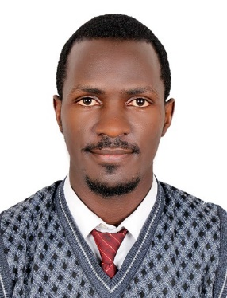
CURRICULUM VITAE
BIO DATA
Name Emmanuel
Sex Male
Country Uganda
Email address Emmanuel-397856@gulfjobseeker.com
PROFILE
Highly experienced electrical technician and power plant operator. Expert lamination machine operator with advanced skills / technical knowledge in food manufacturing company. Advanced troubleshooting and maintenance skills. Motivated team leader focused on quality and on-time delivery of product. Safety conscious with eye on continuous process improvement. Trusted and dependable worker with excellent performance record.
WORK EXPERIENCE
Abu Dhabi, UAE Feb 2018 – Present
Team Leader / Machine Operator
- Manages team of five technicians responsible for coating process
- Prepares / monitors machines during production process to ensure continuous operations
- Performs regular preventive maintenance, control adjustments, and repair
- Assures availability of supplies for continuous production; monitors overall process; directs adjustments as necessary to ensure on-time delivery
- Inspects product quality; assesses defects; continuously refines process

Rwenzori Bottling Company Limited – Kampala, Uganda 08/2016 – 10/ 2017
Junior Power Plant Operator
- Install improvements and major upgrades to electrical plant and subsystems
- Repair and replace defective components, generators, controllers, storage batteries, switchboards, conductors, switches and varied electrical components
- Evaluate electrical as well as operational problems within the power plant

Hyper Services Limited – Kampala, Uganda 01/2010 – 08/2016
Electrical Technician
- Perform site-specific analysis and evaluation of energy efficiency required for projects
- Design solar domestic hot water heaters and space heating systems for varied projects
- Give technical direction and support to installers

Kase Engineering Company – Kampala, Uganda Jan 2011 – 09/2011
Foreman
- Supervise daily activitieson high voltage construction projects
- Enforcesafety regulations, rules and working conditions on work site
- Report progress to project supervisors

Quality Electrical Company – Kampala, Uganda Jan 2011 – Dec 2011
Linesman
- Installhigh voltage transmission lines while using proper safety and setup measures
- Maintain and repair high-powered electrical lines and systems
- Ensure work completed in a safe and timely mannerand handed over to foreman

SKILLS
- Leadership  - Management  - Teamwork  - Collaboration  - Organization  - Complex Problem Solving  - Ability to with stand on high heights | - English  - Analytical  - Adaptability  - Innovation  - Equipment Trouble Shooting  - Safety Procedures  Ability and skill to use shop hand tools  With care

EDUCATION

Brigham Young University (BYU Pathway worldwide) 2019
Life Skills, English, Math and Writing
Buganda Royal Institute of Business of Technical Education 2010 – 2016

Certificate Electrical Installation (Part II) 04/2010 – 10/2012
Advanced Certificate Electrical Installation (Part III) 03/2014- 11/2014
National Diploma of Electrical Engineering 04/2015 – 05/017

Kakira Secondary School 2008-2009
Uganda Certificate of Education (UCE)

