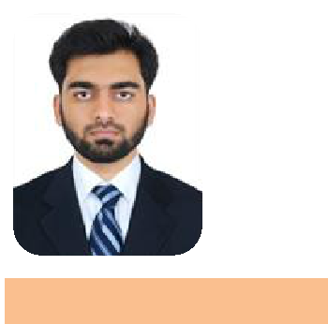

CONTACT

Email

Hesham-398045@gulfjobseeker.com

QUALIFICATIONS

BE Mechanical Engineering

MS Ramaiah Institute of Technology (MSRIT Bangalore) :2015

PERSONAL DETAILS

Marital status: Unmarried
Date of Birth: 02/02/1993 Linguistic abilities: English, ,Hindi,Malayalam Driving License: India

AVAILABILITY Available to join

HESHAM

MECHANICAL ENGINEER

EXPERT IN

Supervision of plumbing work | QA/QC | Material inspection | NDT |

WORK EXPERIENCE

Contracting company | Site Engineer 2019 Nov– Present

- Supervision of plumbing work

- Work include installation of water supply and drainage pipe line with testing.

- Ensure work is done as per the drawing by the main contractor.

- Ensure workers follow safety regulation

- Report job summary and progress with project manager.

- Receive instructions from main contractor engineer and foreman.

- Report main contractor to raise inspection when job completed

ACADEMIC DETAILS

Academic Project
- Fabrication of bucket wheel excavator

Project Summary: Fabricate the bucket wheel escalator in order to eliminate the process of manually carrying containers of plastic resin up and down a flight of offset space saver stairs. It found application in lignite mining, material handling.it reduces the human efforts.

Academic Project

- Won first place in inventor student design competition (South zone 2012)

- Won Second in National level inventor student design competition (IIT Madras 2012)

CERTIFICATIONS

- 2017: Level II in ASNT NDT Magnetic particle testing

- 2017: Level II in ASNT NDT Liquid Penetrant testing

- 2017: Level II in ASNT NDT Radiographical testing
- 2017: Level II in ASNT NDT Ultrasonic testing

- 2017: QA/QC(Piping and welding) and Piping Engineering

