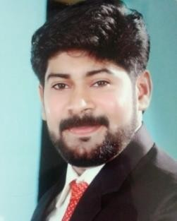SIBI

Visa Status: Visit Visa.

Accountant

Experience: 10 years (6 years Accounts & 4 years Accounts & Sales)

Objective

To work a challenging, friendly, organizing, offering job satisfaction, where my exposure and skill can be used in the best possible way, given me an opportunity for career development based on achievement and results. An accountant is mainly responsible for examining, analyzing, and preparing financial records and statements for a company/organization.

Educational History, Qualification & Other Additional Information
- S S L C, V H S E (Accountancy and Auditing)
- B.Com with Computer Application
Mahatma Gandhi University,
Kerala, India. (UAE Embassy Attested)

Computer Knowledge
- Tally ,ERP,VAT
- MS-Office, Data Entry,
- Diamond ERP (Accounting Software)

Work History & Experience
Accounts and Auditing works Nov 2018 to Nov 2019.
Freelance Accounts and Auditing works in Kerala

Accountant Cum Salesman
Dec 2014 to October 2018
AL. Waedhi Building Materials and Electricals, Manama, Kingdom of Bahrain
General Accountant
Jan 2011 to Feb 2013
Holy Angels’ Higher Secondary School
Kerala, India
Computer Tally ,Accounting Instructor
Jan 2010 to Dec 2014 (full time/part time)
Computer Center of India Kerala, India

Accountant cum Audit Assistant
Jul 2008 to Dec 2009
Jose Maruthathu & Co, Chartered Accountants, Pathanamthitta, Kerala, India

Duties and Responsibilities in Accounts
- Preparation of Debtors & Creditors Reports,
- Purchase Order, Quotation, Bills, Receipt , Payment,
- Trading & Profit and Loss A/C,
- Balance Sheet,
- Journal, Ledger A/C ,Cash book, Day book, petty Cash
- Accounts Reconciliation, cash flow, fund flow.
- Manuel A/C, Book keeping, Delivery Notes, Invoices, etc.

Personal Details

  - Date of Birth : 03/05/1987
  - Nationality : Indian
  - Sex : Male
  - Marital Status : Married
  - Language Known : Malayalam, English & Hindi
  - Personal Contact : sibi-398554@2freemail.com
  - Reference : Mr. Anup P Bhatia, HR Consultant, Gulfjobseeker.com 0504973598

Declaration
I hereby declare that all the details furnished above are true to the best of my knowledge and belief.

Place: Dubai
Sibi

