Curriculum Vitae
Sumeet  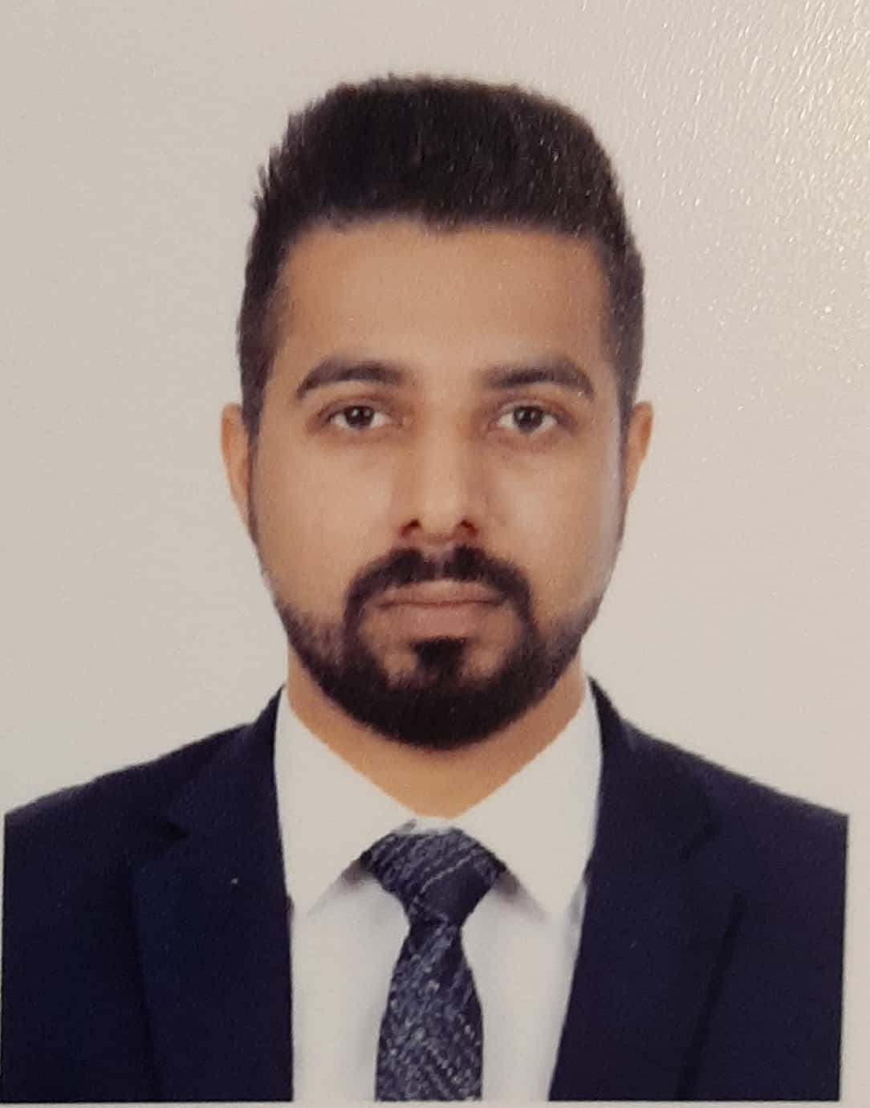  CONTACT :  Email:  Sumeet-398991@2freemail.com  LANGUAGES  English  Hindi |  | OBJECTIVE  Seeking a position of responsibility, where I can utilize my education and work experience towards the achievement of growth and organization/institution objectives, thereby enabling the reﬂection of the same in my profession.  COMPUTER SKILLS  MS SUITE  TALLY ERP9  WORK EXPERIENCE  rana polycot ltd INDIA ( 2013 july-2014may)  - Clerk for handling export documentation, coordination with shipping lines.  - Maintaining the Inward-Outward reports of material.  - Practical work knowledge of Import documentation and export documentation in a trading environment.  Bikanervala Foods Pvt Ltd (2014june-Sep2016)  - Handling the quotation.  - Distribution relationship.  - Inventory management and marketing process.  - offer new schemes  - To keep in contact with the company wholesalers and retailers.  - Track record of regular customers.  - Take appoints and schedule interviews with the potential clients.  - Plan and Perform channel distributions.  - Target the audience as per the location and behavior.  - Visit to more and more potential audience, explain them about the products.  - Train the new joiners.  - Collecting feedback from the clients and customers.  - Look after demand and supply chain.  - Monitor the procurement process.  HALDIRAM foods International pvt ltd (2016nov –2018 dec)  - Billing and quotation handling.  - support after sale  - Target oriented approach.  - Organizing sales visits.  - Demonstrating and presenting products.  - Establishing new business.  - Maintaining accurate records.  - Attending trade exhibitions, conferences and meetings.  - Reviewing sales performance.  - Negotiating contracts and packages.  - Aiming to achieve monthly or annual targets  HYUNDAI GROUP INDIA (2019 FEB - 2020 FEB)  - Implemented customer satisfaction procedures and dealt with customer issues..  - Maintained first-hand knowledge of all vehicle features and spec  - Worked with sales staff to implement sales and marketing strategies  - Assist with reviewing of expenses, payroll records etc. as assigned.  - Update financial data in databases to ensure that information will be Accurate and immediately available when needed.  - Worked with customers to arrange for financing options.  - Maintained updated database on all available vehicles.  - Representing the company at trade exhibitions, events, shows and demonstrations.  - Preparing sold vehicles for customer delivery by having them serviced & cleaned up.  - Negotiating the terms and conditions of a sales agreement with prospective clients  EDUCATION& CERTIFICATIONS  - Masters of Business Administration from Punjab Technical University (Major- MARKETING Minor-HR)  - Bachelors Of Business Administration from Punjab Technical University.  - Senior Secondary Education (COMMERCE) From DIPS DHILWAN (CBSE), Punjab ,INDIA  - Matric(CBSE) from KENDRIYA VIDYALYA SANGHATAN Dalhousie Himachal INDIA  ADDITIONAL SKILLS  Time management  Documentation  Organization & Prioritization.  Collaboration  Team Leadership  STRENGTHS:  Hard working and Committed.  Easily Adaptable person who is always willing to learn.  Takes initiative and work individually or as a Group  I am Friendly with people and an Excellent Team player.  PERSONAL INFORMATION:  Date of Birth: 18-06-1987  Sex : Male  Nationality : Indian  Marital Status: Unmarried  Visa status : 20/12/2020  Interests : Reading Books, Music  Language known : English ,Hindi, Punjabi
DECLARATION:

I do hereby declare that the above-mentioned information is true to the best of my knowledge and belief.

