Click here to Buy Cv Contact:
http://www.gulfjobseeker.com/employer/cvdatabaseservice.php

Admin cum Accounts
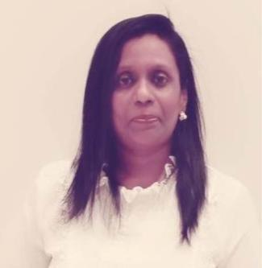

SHEEBA

Whatsapp No : +971 504 75 36 86

Email ID :- sheeba-399010@2freemail.com

Career Summary :

- Experience of managing complex administrative and clerical activities of organizational settings.

- Proficient with business English, punctuation, spelling, and grammar.
- Excellent coordination, supervisory, and communication skills.

- Experience of managing complex administrative, good typing speed with 40 wpm and manage office operations.

- Ability to maintain high level of confidentiality and manage office operations.
- Skilled in maintaining records and supervising functions of other departments.

- An analytical and honest professional with 5 years of work experience in Dubai and expert knowledge in Tally, Account Data & other Statutory Accounts.

- Expert in interacting with other group companies for accounts purposes.

- Proficient in team member, determined & quick learner with good interpersonal skill.

Key Responsibilities :

- Composing letters, emails, answering telephone, taking and distributing messages, and overseeing incoming and outgoing mail.
- Participating in meetings, taking minutes, and preparing summary.

- Handled clerical, secretarial, and organizational tasks.

- Assisted in hiring, training, and performance tracking of employees.

- Coordinating with the dealers, Suppliers and vendors for contract of technical services.

- Maintain books of accounts in Tally and Preparation of Tax Invoices, Delivery Note, Vouchers, Purchase, Sales Order and Agency Payment.

- Enter posting of purchase, sales, payment, receipt collection & journal voucher.
- Maintain petty cash book, day to day cash & bank transactions.

- Verification of Petty cash bills & General expenses, Bank, Debtors
  - Creditors Reconciliation.
- Preparing outstanding list of Debtor & making Payment follow-up.

Work Experience:

➢ Proactive Excel Safety Consultancy, Dubai as Admin

Officer cum Accountant from January 2019 to December 2019.

- Focus Home Care Services LLC, Dubai as Admin. Secretary cum Assistant Accountant from June 2017 to January 2019.

- Eurotech Gas Services L.L.C, Dubai as Admin coordinator cum Accounting Assistant from June 2015 to May 30th 2017.

- MIOT Hospitals Ltd, Chennai as Secretary and General Admin from May 2007 to January 2014.

- AUE Motors Ltd, Chennai in Administration as Accountant cum Office Manager from June 2002 to April 2006.

Education Background:

- PGDCA graduate from Annamalai University in year 2004.

- Master of Commerce graduate from Annamalai University in year 2002.

- Bachelor of Commerce graduate from Bharathidasan University in year 1993.

- Diploma in Computer applications 2016.

Professional Skills:

- Knowledge of Tally 9 ERP.

- Knowledge of Ms-Office, MS Excel, MS Word, Internet Operations & E-mail handling.
- Expert Knowledge in computer related operations.

- Windows XP, Vista, Windows 7.

Personal Qualities

- Excellent communication skills.

- Hardworking.

- Positive attitude.

- Excellent team player.

Personal Details:
Date of birth | : | 16.06.1972
Languages known | : | English, Tamil, Hindi, and Malayalam.

Declaration:

I hereby declare that the particulars mentioned above are true and trustworthy.

(Sheeba)

