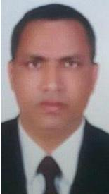

Click here to Buy CV Contact:
http://www.gulfjobseeker.com/employer/cvdatabaseservice.php

RESUME

SALIK
Whatsapp no: +971504753686
Email- salik-399029@2freemail.com

OBJECTIVE

Seeking a challenging position. As benefit my qualification and experience and the opportunity to progress in my career path by virtue of my skill and dedicated performance in the service of my profession. A professional environment where my knowledge and skill can be shared and further enriched

ACADEMIC QUALIFICATION

- Master of Art’s (M.A.)

- Diploma in Computer Application (DCA) MS-office exele.internet email.

EXEPRINCE

*Best collecting wastes company

Working as a Cleaner starting from Jan 2017 to 28 Feb 2019

*Al Ain farms for livestock production starting 17 march 2019 till date

LANGUAGE SKILLS
 | Hindi. | Fluent speaking & writing
 | English | speaking& writing

PERSONAL DETAILS

Full Name.

Salik

Dob.

28 August 1974

Gender

male

Civil Stats.

Married

Nationality.

Indian

Key skill

- Capable of working independently

- Excellent problem solving skills

- Interpretation skills

- Oral and written communication skills

- Good administration skills

