Click here to Buy CV Contact:
http://www.gulfjobseeker.com/employer/cvdatabaseservice.php

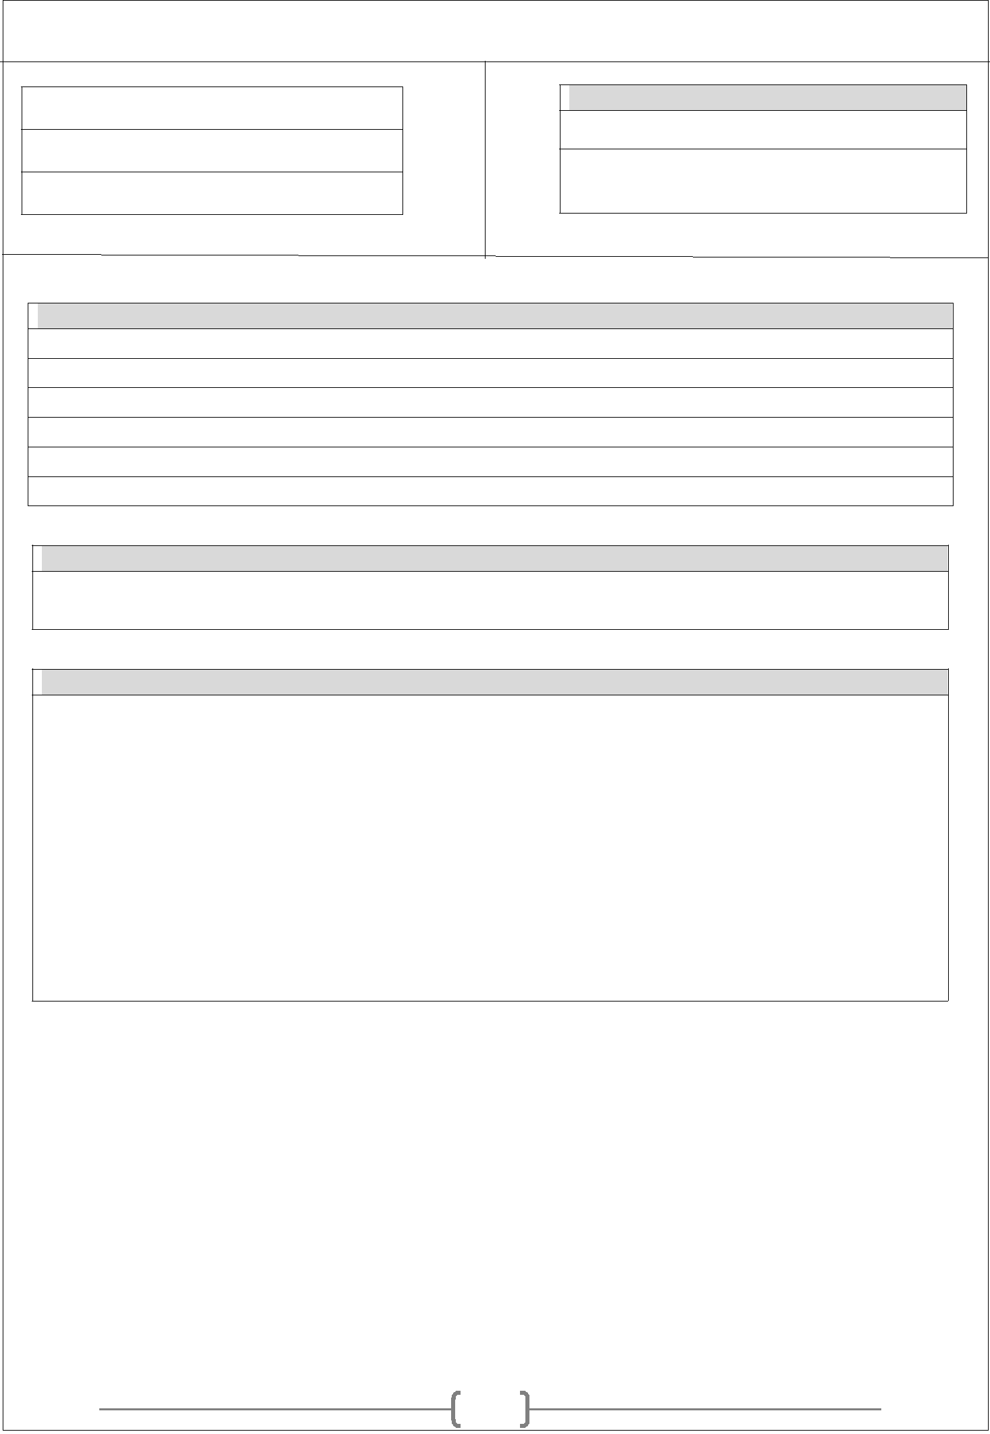
RESUME

Name: Tanmay

Date of Birth: 01 Nov 1997

Nationality: Indian

Contact :

Whatsapp No.:+971504753686

E-mail ID : tanmay-399040@2freemail.com

Personal details:

Name: Tanmay

Date of Birth : 01 Nov 1997

Education : B.Sc. (Industrial Drug Science) , M.sc. Appearance (Biochemistry)

Marital Status : Unmarried

Language Known : Able to Speak, read & write English ,Marathi & Hindi

Career Objective :

To be part of a professional organization, contributing towards the achievement of the desired Organizational goals and build a career that promises growth with responsibilities.

- Present Experience: [ API’s (Medicines, Generic)]

The company has World Class GMP Compliant Manufacturing Facilities approved by international regulatory agencies and also having Strong Global Footprint in USA, India, Japan, Australia, UK, and Germany. The company is also WHO and USFDA certified,

Faced Audit: USFDA Audit, ISRS Audit, PMDA & other vendor audit.

Faced Internal Audit: QA and CQA.

Total Experience: 5 year 1 month.

1

RESUME

Role & Responsibilities :

As ‘Production Officer’ in multipurpose plant

- Primary responsibility is to plan and manage overall plant Commercial batch activities, Man power allocation, follows Standard operating procedure as provided by company to achieve required specification for respective product.

Other responsibilities include:-

- Documentation work Like Change control, Deviation handling & CAPA as well as other documents like Quality Risk Assessment & Impact Assessment also preparing of investigation report of deviation.Preparaiton of Equipment Qualification document and other non-routine document activities.

- To manufacture the known compounds efficiently using in-house procedures.

- Conduct operations in a safe manner.

- Keep accurate, legible and complete records of all Commercial batches and observations.

- Performing the all kinds of SAP Activity.

- Conducting and imparting cGMP training to employees.

- Performing the labelling, sampling and packaging activity.
- Maintain familiarity with the Hygiene Plan.

- Commercial safety awareness and safe work practices.

- To ensure recording of the manufacturing parameters in SCADA or C-DAS system.

- Performing the labelling, sampling and packaging activity.

- Review-of in-process BPR for correctness and completeness and review of executed BPR wherever applicable before submitting to QA.

- To maintain Departmental file as per the SOP. Updating of Plant layout, equipment list, List of finished product, Job responsibilities of all employees, organogram, Specimen signatures of plant employees. Making Training need identification (TNI) of Production Groups.

- Ensure current versions of SOPs / BPRs / ECRs/BOM/Recipe are used.

Technical Skills:

- Well exposure to following manufacturing processing equipment’s: Reactors, Centrifuge, Dryers, (VTD & RVD) & spray dryer, Sparkler Filter ,Miltimill,Sifter, Blender, Microniser , Labelling and Packing activity etc.

Computer Skills:

Extreme Proficient or familiar with a vast array of programming languages, concepts and technologies, including:

- Windows

- MS Word

- MS Excel

- MS Power point

2

RESUME

Communication Skills:

- Can communicate effectively with friends and colleagues across various age groups, cultures and backgrounds.

- Have actively participated in Group Discussions and Presentations at college and occupational levels.

Education details:

Sr. | Course | Passing Year | Passing of University Name | Grade | Percentage
No
 | B.Sc. Chemistry |  | Yashvantrao Chavan
01 | ( Industrial Drug | 2015-2018 | Maharashtra Open University | 1st Grade | 67.36%
 | Science) |  | Nashik
 | Higher
 | secondary |  | Tarapur Vidya Mandir & junior
02 | certificate | 2014-2015 |  | 2nd Grade | 55.69 %
 |  |  | college (TVM)
 | examination
 | (HSC)
 | Secondary
 | school
03 | certificate | 2012-2013 | Boisar Militry School | Distinction | 76.40 %
 | examination
 | (SSC)

Interest & hobbies:

- Reading.

- Playing various Musical instruments.

- Cycling.

Declaration :

I hereby declare that all the information in this application are true, complete and correct to the best of my Knowledge.

Yours Faithfully,

Tanmay

3

