Umaiz

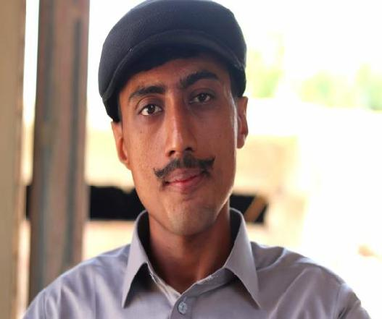

Contact

Whatsapp no: +971504753686
Email:

Umaiz-399051@2freemail.com

Languages

English
Urdu
Sindhi

Hobbies

- Reading Books

- Playing badminton
- Photography
- Vloging

Click here to Buy CV Contact:
http://www.gulfjobseeker.com/employer/cvdatabaseservice.php

Summary

Proficient in MS Word,MS Excel ,MS Powerpoint

Knowledge about social media and internet

Personal Infermation

Education

 | Bachelor Of Science | 2019
 | Intermediate | 2016
 | Matriculation | 2014

Experience

1 years working as salesman in karachi

6 months working at envision call center as sales man in karachi

