Click here to Buy CV Contact:
http://www.gulfjobseeker.com/employer/cvdatabaseservice.php

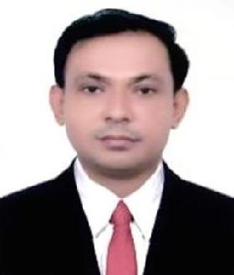
AREFIN

Email : arefin-399059@2freemail.com

Whatsapp no : +971504753686

Location : Abu Dhabi, UAE

PERSONAL INFORMATION
- Full Name : Arefin

- Date of Birth : 26th Sep 1973
▪ | Nationality | : | Bangladeshi
Marital Status : Married

Professional Summary:

Highly-motivated, personable Public Relations Professional with 13 years’ experience in Public relations. Recognized for public image projection methodologies and activities. Efficient communicator with exceptional time management, problem-solving, and analytical skills. Flexible and adaptable to changing priorities.

Experience:

- Currently working as a Snr Clerk-Admin Public Relation Office
- March 2007 to Present.

Responsibilities:

- Receiving and releasing all AJC employees passport for going and coming from vacation or any other associated purposes.

- Releasing AJC employees passport any emergences cases & as directed by Management.

- Submit and ensure the processing of all types of applications and paperwork to the Management.

- Assist employees in the process of renewing visas and medical check process.

- Assist the company and the employees with visa arrangements in Embassies.

- Assist employees in the process of Passport renewing and arrangement in Embassies.

- To maintain database of all passports and residence visas by scanning all documents and directly.

- Updating the database when details change.

Educational Qualification:

- S.S.C (Secondary school certificate) 1989.

Board of Intermediate and Secondary Education Dhaka Bangladesh.
- H.S.C (Higher secondary certificate) 1994.

Board of Intermediate and Secondary Education Dhaka Bangladesh.

- B.S.S (Bachelor of Social Sciences)1996 ( Appear) National University, Bangladesh.

Computer Skills:

Diploma in Computer Office Management.

- Basic Networking.

- Operating systems and installation.

- MS Excel, MS Word, MS Power Point, MS Access, MS Outlook & Internet Application.

Additional Skills and Capabilities:
- Exceptional communication and interpersonal skills.

- Proven ability to manage social media metrics.

- Excellent leadership skills.

- Ability to manage multiple tasks at the same time.

- Able to operate computer and perform basic arithmetic calculations.

Languages:
- English.

- Arabic.

- Hindi.

- Urdu.

- Bengali.

Declaration:

I clearly declare that all my information has given above is totally unadulterated and submitted for your kind consideration.

Arefin

