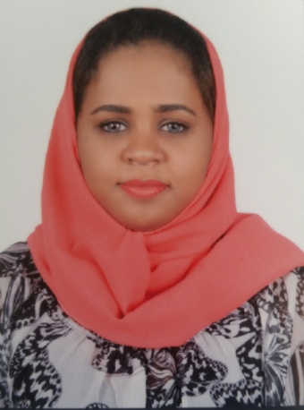

Click here to Buy CV Contact:
http://www.gulfjobseeker.com/employer/cvdatabaseservice.php
Samah
Dubai, United Arab Emirates

Whatsapp no: +971 504753686

Email: samahe-399067@2freemail.com

EMPLOYMENT EXPERIENCE

customer servies operation (customer care strategic department -licensing section)
- Work closely with cross functional partners to ensure collaboration and process efficiencies are maintained
- Creates and maintains an environment with intense focus on customer satisfaction and professional customer support balanced with consistent achievement of standard business objectives
- Proactively lead, motivate, and develop high performing teams within a time-sensitive and exciting environment to deliver on operational KPIs
- Perform all personnel-related activities, including problem solving disciplining, developing, coaching, providing work performance evaluation, and termination.
- Managed transactions including new accounts, customer service and operations
- Oversaw customer service functions and resolved problems within authority range
- Acquired and retained clients through positive and efficient customer service
- Assisted managers with various assigned tasks.

Call Center Customer Service Representative
- Responded to 75-100 inbound calls per day in high call volume environment.
- Registered candidates seeking professional certification in various fields for national exams
- Processed credit card and electronic check payments utilizing company database and software
- Established rapport with clients while providing information concerning test requirements
- Responded to and handled customer complaints and inquiries in a timely manner
- Maintained a polite and professional telephone manner.
- Developed personal organization and multitasking skills in a fast paced environment.

- Courses in:
- IOC ATHLEE CAREER PROGRAMME from INTERNAIONAL OLYMPIC COMMITTEE (2018).
- LABROTARY SAFTY,Noble Center for Training and Skills Development(2017).

- ISO/IEC 17025-2005Noble Center for Training and Skills Development..(2017).
- Proposal writing. Voluntary work managing. SPHERE project. THE SUDANESE RED CURCENT SOCIETY (2014).
- Marketing andBusiness planning (certificate from PUM Netherlands seniorexperts) (Holland)(2013).
- Violence against children, IADS.Female genital mutilation.Human rights.Women rights at YOUTH FOR CHILDREN (2005)

MEMBERSHIP & PARTICIPATION
- Participation in archery championship and representing Sudan in UAE Arab Women Sport Tournament – Sharjah (Feb 2020)
- Representing RTA in GITEX booth for the smart government standers and assist using the new enhancement on RTA applications ((November)
- Participation in the qualification Archery Championship for presenting Sudan in UAEin Arab Women Sports Tournament Sharjah. ”winning the first place” (2018).
- Awareness presentation about Child Rights in the schools, (2016 to 2018).
- Certificates of proficiency in Italian (CELI), issued by theUniversità per Stranieri di Perugia,(pass the oral exam)(November2017)
- Participation in YOUTH and SDG6 in SUDAN YOUTH PARLIAMENT FOR WATER (2017).
- Organization of THE 7TH GRADUATE STUDIES AND SCIENTIFIC RESEARCH CONFRENCE in UNIVERSITY OF KHARTOUM.
- Chief account manager of UM TURKY ORGNIZATION (2015-2017).
- Organization of membership data and translator in SUDANESE BUISENISSWOMEN DEVELOPMENT CENTER (2014) .
- Personal assistant for the General Manager of SUDANESE BUISENISS WOMEN DEVELOPMENT CENTER (2014) .
- Participated in THE FIRST FORUM OF ARAB ORPHANS (JORDUN) (2009) for 10 days workshop: communication skills.
EDUCATION AND MEMBERSHIP

- COMBONY ITALIAN CENTER_level A1 and A2. 2016_2018.
- KHARTOUM UNIVERSTY - MAIN LIBERARY _ ITALIAN LYBARERY (Italian courses) Level A1. 2014_2016.
- KHARTOUM UNIVERSITY FUCALTY OF SCIENCE DEPARTMENT OF CHEMISTRY 2011 -2016.
- Test of ENGLISH as a Foreign Language (TOEFL) 2010.

SPECIAL SKILLS
Computer & IT –
- Microsoft Office™ (Word™, Excel™ PowerPoint™)
- Windows™ (7™, Vista™, XP™)
- Adobe™

Language:
- Arabic–Native
- English – Fluent (writing, specking, listening)
- Italian _ level A2.
- French _ basics.

