DANIEL
Whatsapp no: +971504753686

Email: daniel-399089@2freemail.com

Click here to Buy CV Contact:
http://www.gulfjobseeker.com/employer/cvdatabaseservice.php

Date of birth : 21 -10 -1963
Sex : Male

Nationality : INDIA
Marital Status : Married

Languages Known: English, Hindi, Tamil and Malayalam.

Passport Details

Passport No: K 7968211

Date of Issue: 24.10.2012

Valid up to: 23.10.2022

CURRICULUM VITAE
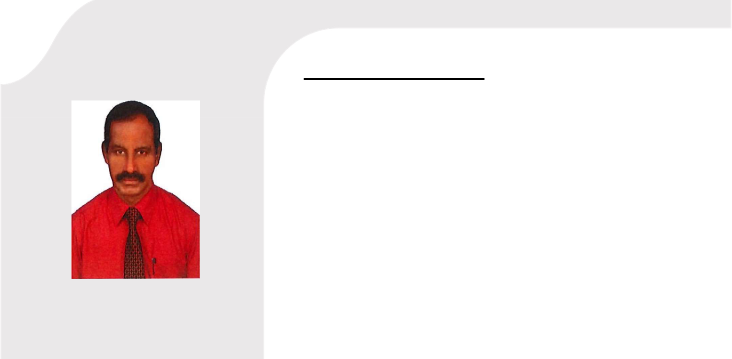

Seeking for a position to utilize my skills and abilities in Warehouse management, Accounting and Storekeeping that offers professional growth while being resourceful, innovative and flexible

Career summary

- 15 years of Gulf experience as, Accounts Assistant cum Warehouse-in-charge/Store Keeper

- Knowledge of Electrical Switch Gear Items Timers, Bus bars, Contactors, Capacitors, Coils, Push Button and related items.

- Managing the day to day activities in the warehouse Inventory Control, Invoicing, preparation of Delivery Notes, Verifying the stock in and out.

- Knowledge of Tally Accounting software. Working Knowledge of Microsoft Office Applications. Maintaining the Accounts and Petty Cash.

Educational qualification

- DCFA - Diploma in Computer Financial Accounting

- H SC (Plus Two)

- DTP (Desk Top Publishing

➢ MS Office, (MS word, Excel, DOS, Power point, Tally 7.2 and 9).

Experience

- 12year experience as Accounts Assistant cum Warehouse-in charge/Storekeeper Trading LLC . Dubai, UAE - May 2008 to November 2019.

- Storekeeper cum Timekeeper with M/S. Hafeera Contracting Company, Bahrain from February 1994 to October 1995.

- Accounts Assistant cum Storekeeper with M/S. Arabian Printing & Publishing House in Manama, Bahrain from November 1995 to March 1998.

- Accounts Auditor cum Tax practitioner with M/S. Thanu Pillai &Co. Chartered Accountants, Nagercoil, India from November 2006 to May 2008.

  - Accountant cum Inventory Controller with M/S. Raja Jewellers, Nagercoil, India from April 2000 to September 2006.

JOB PROFILE

TRADING ,LLC(Germany) DUBAI

Accounts Assistant cum Storekeeper: Maintaining Accounts Ledger, Computer Handling, Inventory Control and stock Maintenance of Electrical Switch Gears. Dealing with Electrical manufacturing companies like DOEPKE, ORBIS. TELE, FTG, BENEDICT & JAGER, TERASAKI, RTR and SCHUCH EXPLOSION LIGHTINGS.

M/S. ARABIAN PRINTING & PUBLISHING HOUSE ,W,L.L ,BAHARAIN

Filing and Maintaining Office files, Recording and checking the inward and outward material transactions, Cash Sales dealings, Stock maintenance & Inventory controlling.

M/S. HAFEERA CONTRACTING COMPANY, W.L.L, BAHRAIN

Store keeper cum Time keeper: Inventory controlling and Attendance maintenance of employees, salary calculation and disbursement.

M S. THANU PILLAI & CO. AUDITORS, NAGERCOIL, INDIA

Assisting the Auditors, preparing vouchers, maintaining Accounts Ledgers, Bank Transactions, checking Capital and depreciation details, Stock verification, preparation and submission of sales and income tax returns, assisting Clients to submit annual tax returns.

M S. N. S. RAJA JEWELLERS,TAMILNADU, INDIA

Maintaining daily sales and purchase records, Accounts ledgers, cash transactions, stock and inventory control etc.

DECLARATION

I here by declared that the information furnished above is true to best of my knowledge and belief.

DANIEL

DUBAI,

07.05.2020

