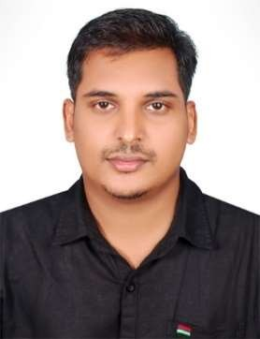RANJITH ACCOUNTANT

E-mail: ranjith-399126@2freemail.com

Profile Summary
Proficient and detail oriented accountant with almost 5.8 years of GCC work experience & 7 years of Indian work experience.

GCC Work Experience

Abu Dhabi (Jul 2018 – Mar 2020)
➢ Accounting up to Finalization
➢ Preparation of In House statement on quarterly basis.
➢ VAT return filing.
➢ Preparation of cash flow statement.
➢ Preparing MIS report for management.
➢ Payroll preparation.
➢ Preparing bank reconciliation statement.
➢ Interacting with banks.
➢ Interacting with customers.
➢ Interacting with overseas suppliers.
➢ Maintaining petty cash.
➢ Coordinate with other department for resolving customer, supplier and employees related issues.
➢ Ensure entries are proper done by the colleagues in tally.
➢ Ensure accounts department in proper for resolving other department’s requirement.

North Tours LLC, Dubai (Nov 2013- Oct 2017)
➢ Assist Accounts Manager in preparation of Financial Statements.
➢ Preparing MIS report for management.
➢ Payroll preparation.
➢ Prepare aging of receivables.
➢ Preparation of bank reconciliation statement.
➢ Daily update of data in tally related to creditors invoice & petty cash.
➢ Customer payment follow up.
➢ Handling & management of accounts payable.
➢ Checking traffic fines, online salik recharge, telephone bill payment.
➢ Perform banking transactions like cash deposit and cheque deposit.

E x p e r t i s e

Tally ERP 9 Quick Books Microsoft Word Microsoft Excel
Microsoft PowerPoint

S t r e n g t h s

➢ Quick learner
➢ Excellent Communication skills
➢ Willingness to take up responsibilities

Languages

➢ English
➢ Hindi
➢ Malayalam

Indian Work Experience

Novatek Electro Engineers Pvt. Ltd, Chennai (Jun 2009 – July 2013)
➢ Preparing profit & loss account and trial balance.
➢ Verifying and signing sales invoices.
➢ E-filing of monthly sales tax return.
➢ E-filing of quarterly excise return.
➢ Responsible for handling both Accounts Payable as well as Accounts Receivables.

Kerala Transport Co. Chennai. (Jan 2006 – May 2009)

Academic Qualification

Bachelor of Commerce(Finance):
University of Calicut, Kerala, India

Nationality : Indian

Date of Birth : 12th May 1985 Marital Status : Married
Visa Status : Visit Visa

Validity : 06-09-20 to 01-12-20

